03 Your first React App

install npm i -g create-react-app

Create your app with the above global package

## npm i create-react-app react-app

It will install react and all the 3rd party libraries.

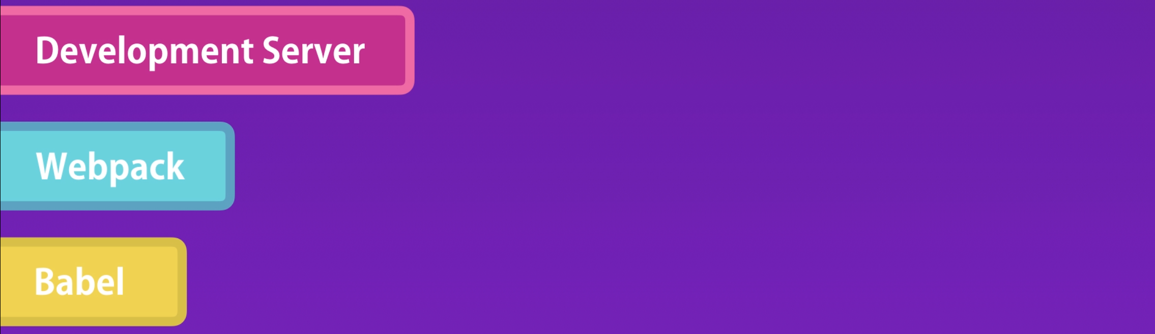

if you want to customize your configuration for your production environment, you can always eject by running

this command.



04 hello world

To convert JSX code, we need 

To render the JSX in DOM, we need



05 Custom Configs

react-scripts: it is a library which takes care of start, build, test, eject scripts in package.json

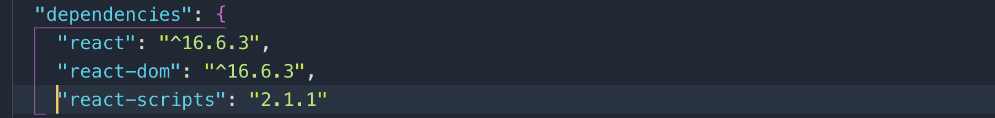

09 var, let, and const

let: use it only when you need to reassign value

const: is a block scope also like let. Use it always unless you need to reassign values

10 Objects

This is the old way of defining a function in an object.

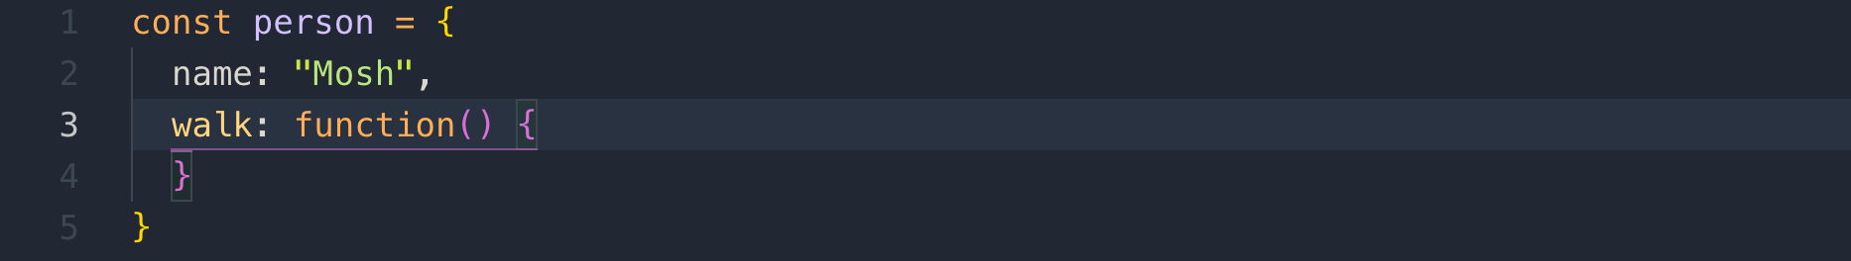

in ES6, you can define function in an object like this

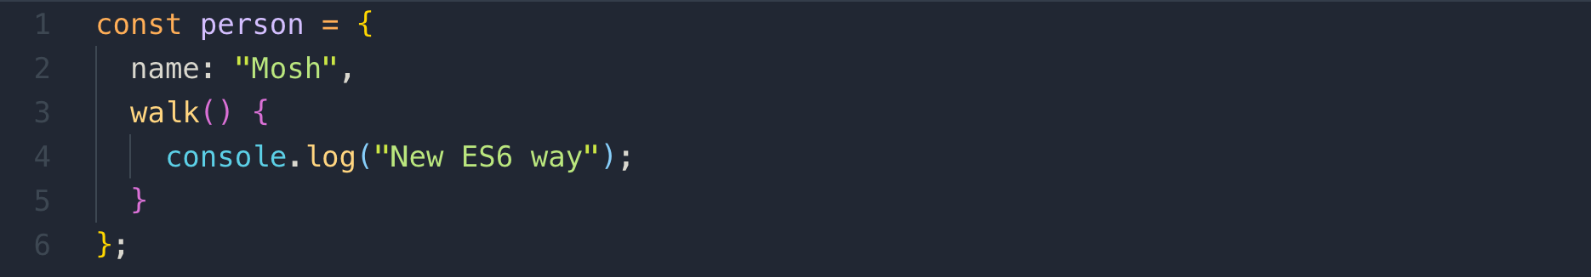

11 The "this" keyword

This is a reference to the current object.

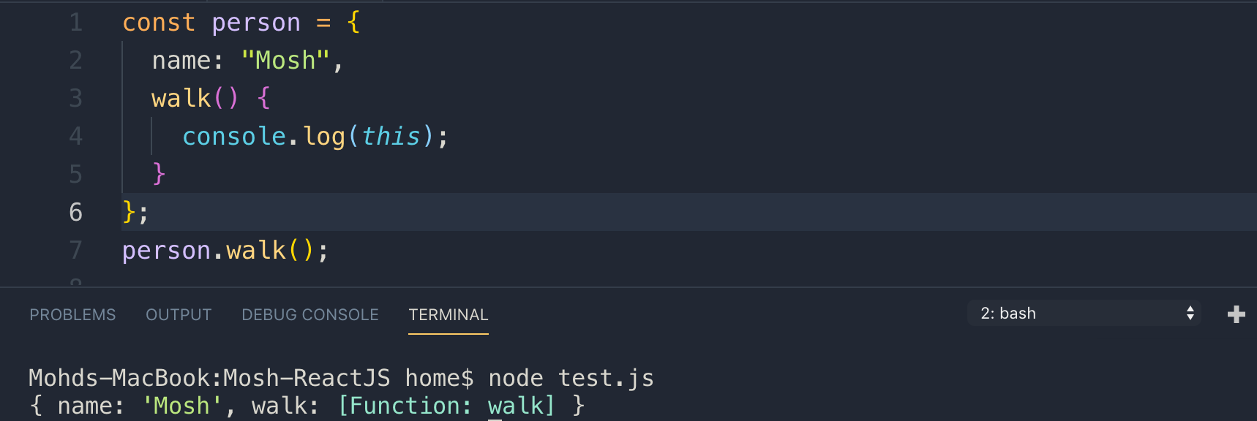

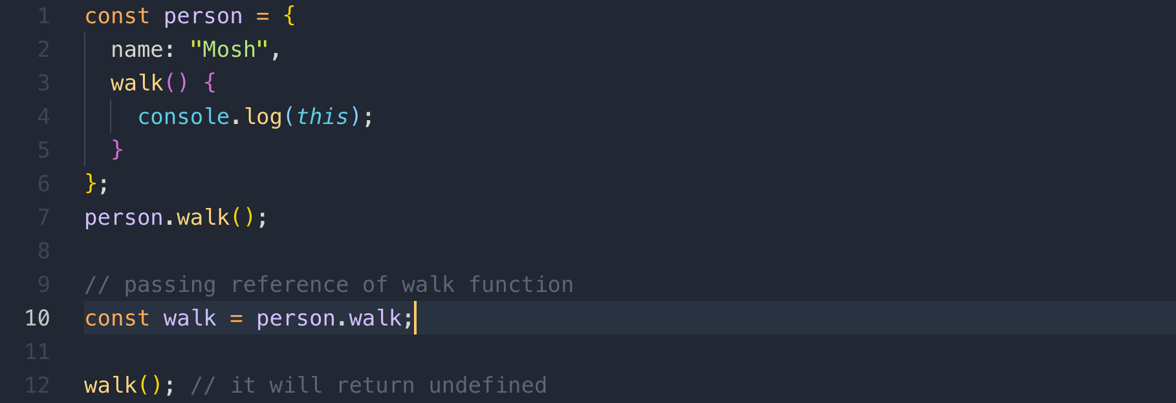

The reason of the above “undefined” is that the values of “this” is determined of how a function is called.

If it calls a function as a method in an object, “this” will always return a reference.

If we call a function as a stand-alone object, or outside of an object, this will return a global object which is a window object in browser

12 Binding "this"

When we call a function as a stand-alone function outside of an object, “this” by default returns a reference to a global object.

What we pass in the bind() function, will become the value of “this”

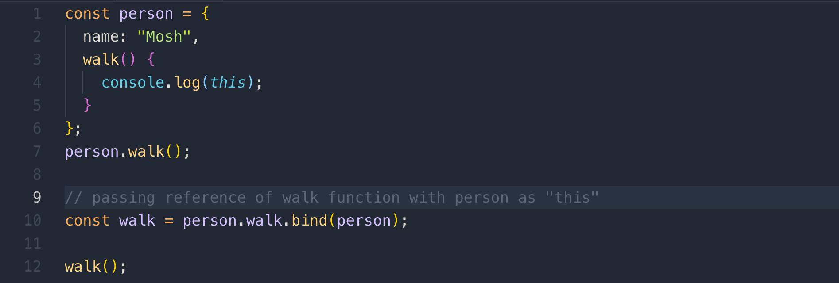

Functions in JavaScript are objects, and they have methods and properties we can use.

13 Arrow Function

Example of arrow function with normal function

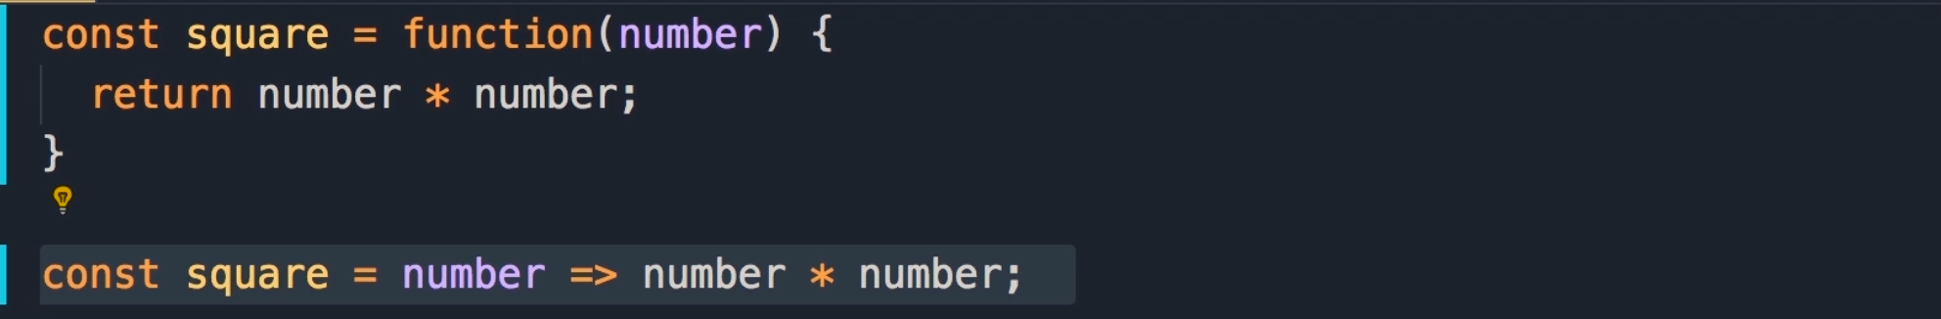

Example 2: arrow function, and normal function with filter() function.

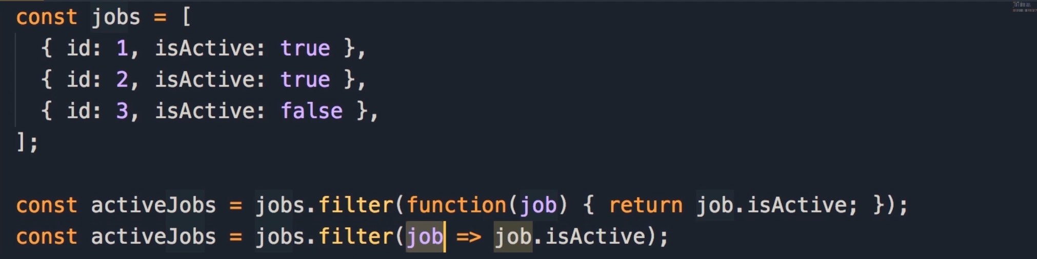

14 Arrow function and this

When we call a function as a stand-alone function outside of an object, by default “this” returns window object.

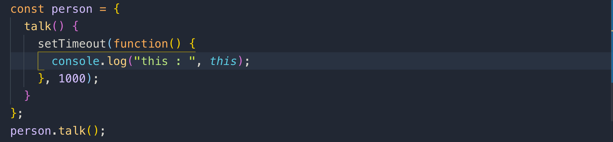



The solution to the above is to use arrow function, because Arrow functions don’t bind “this”

It inherits the “this”

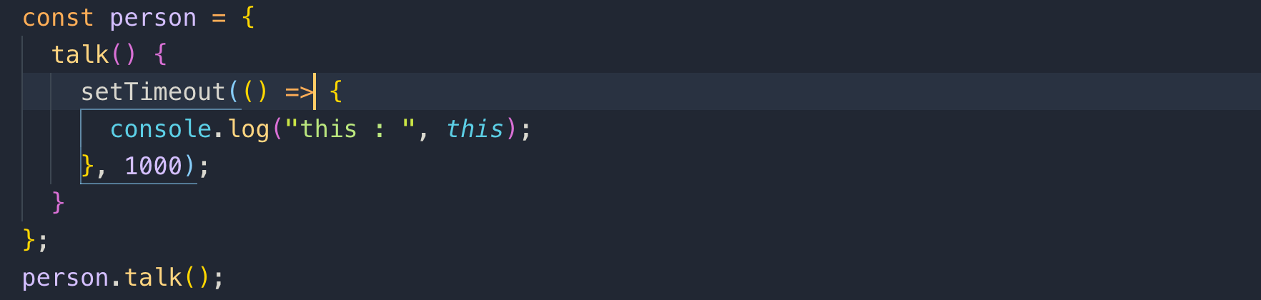



15 Array.map()

ES6 introduces a map() function in Array. In React, whenever you want to list items, you use map() method.

Note: it doesn’t change the original array

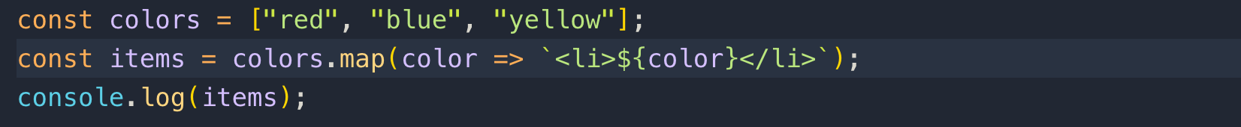

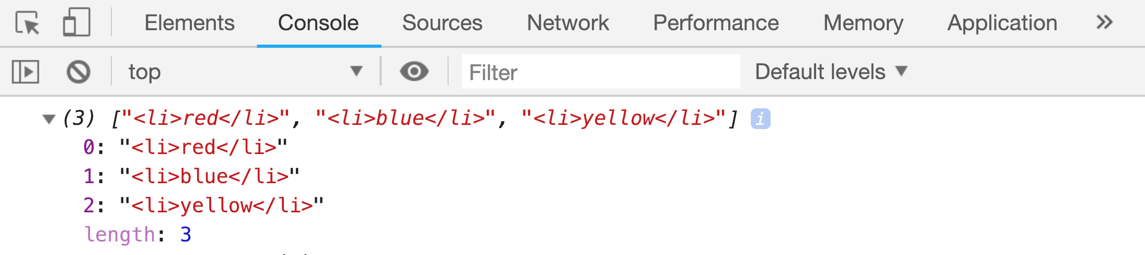

16 Object Destructuring

The problem with this code is that we have repetitive address.street, address.city and so on. We are repeating address for every object property.

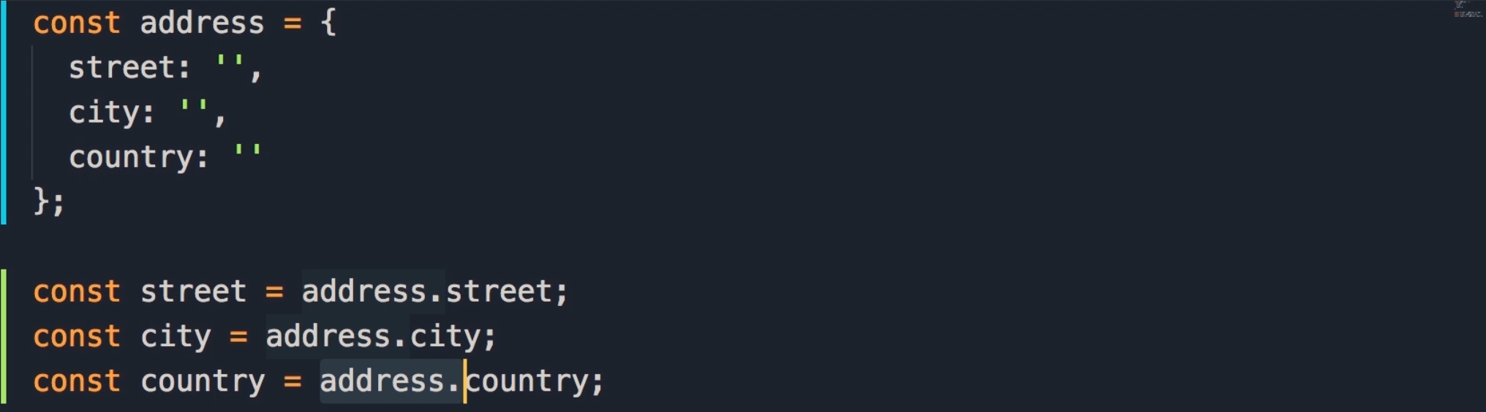

Object Destructuring solves this problem.

Just in one line without repeating address, we get what we want.



You may get a property you are interested in. you don’t have to mention all the properties.



you can even change the name of your variable by alias using:



17 Spread Operator

The old way of combining array is to use concat() method

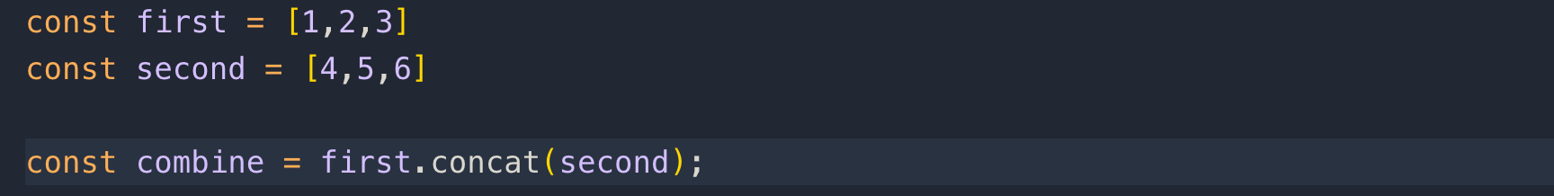

The newest way is to use spread operator. We can even add array element, between these arrays which is difficult with concat() method



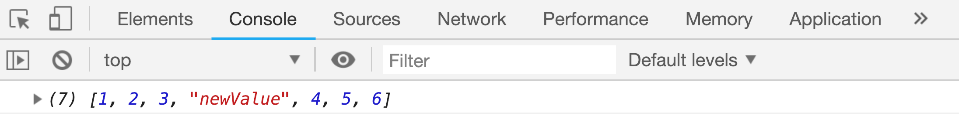

Using spread operator, we can easily clone an array

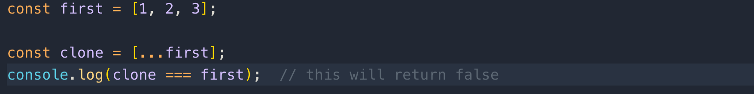

if the array has primitive values like numbers, string, or Boolean, this trick will clone the array, but if you have objects in the array then this will not clone, it will still give you a reference.

The best and easy trick to clone an array is

## Let clone = JSON.parse(JSON.stringyify(array));

We can also apply spread operator to an object

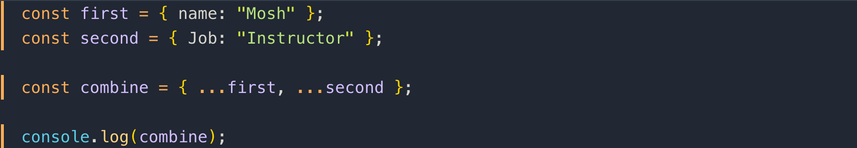

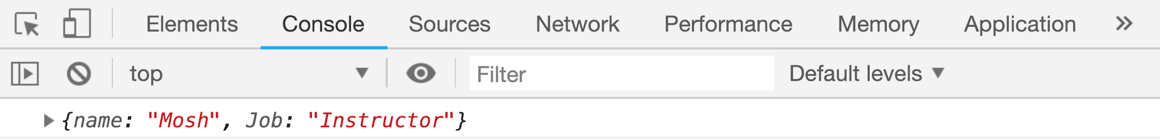

To clone an object



Whenever we add constructor in a child class, we have to call constructor of its parent class. We call it with super()

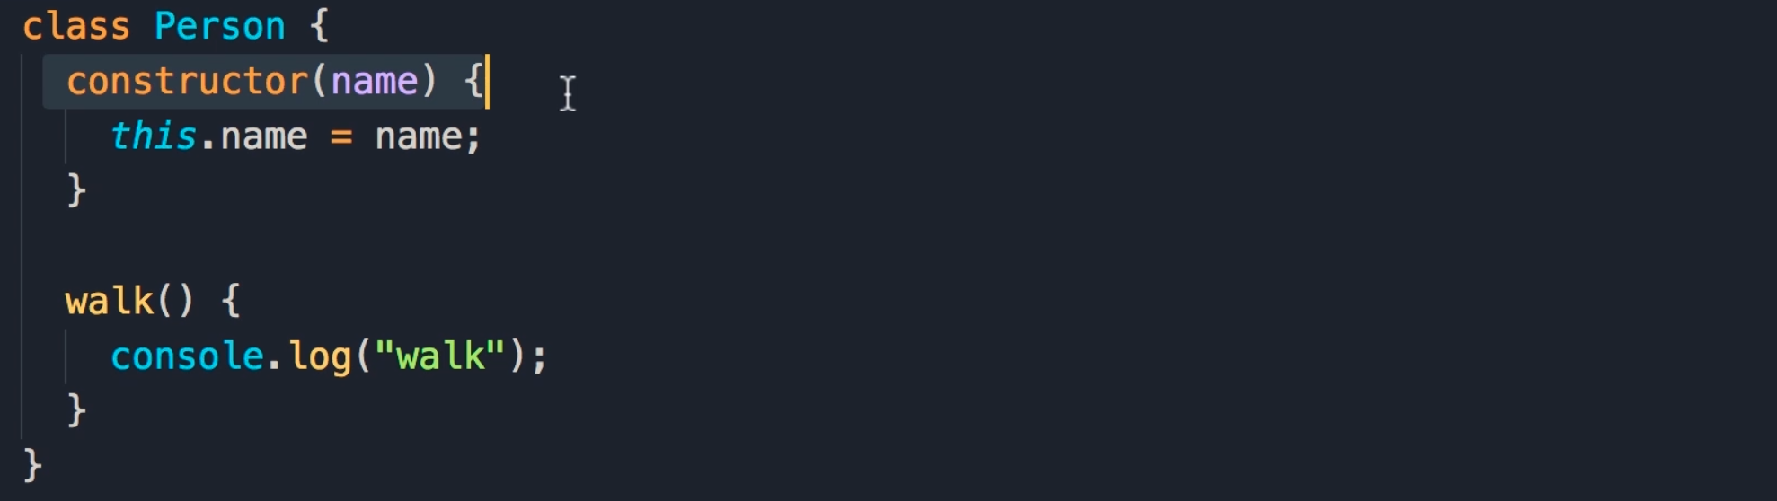

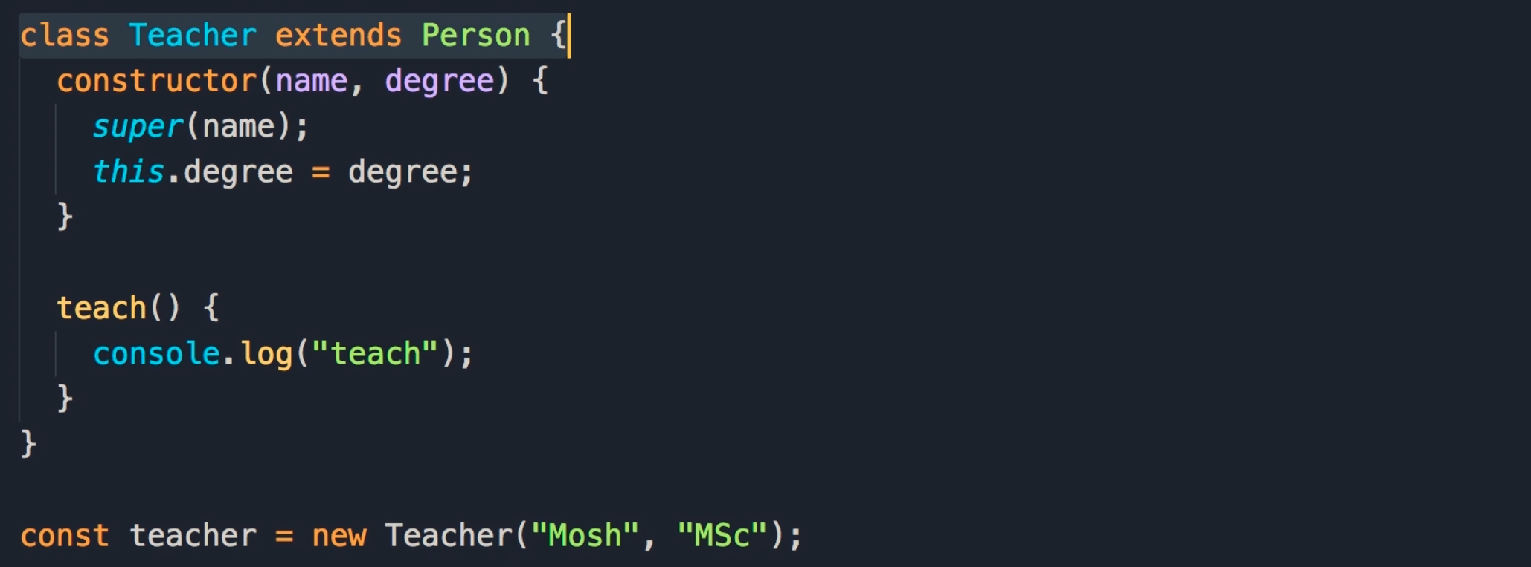

20 Modules

in ES6, we have a concept of module natively in JavaScript.

To export a class, simply prefix the class with keyword export



To import a class



We use default object, if there is only a single object that we want to export.

This is the way we import named and default export



Default export



22 Components

This is the application we are going to build in the next sections. It is like a shopping cart to add or remove products from the list.

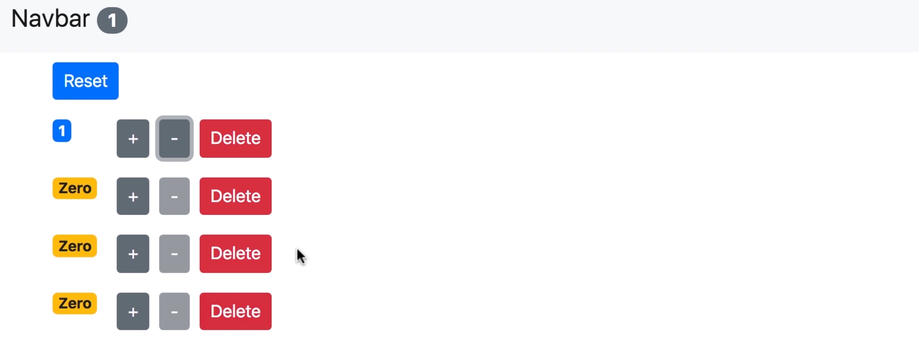

23 You first react component

installing bootstrap



This is how we import bootstrap in index.js

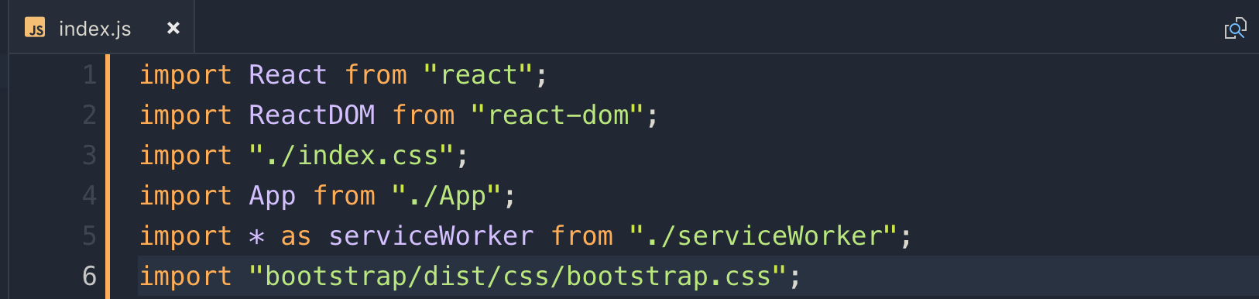

24 Your first react component implementation

1. Create a components folder in src folder
2. Create a file counter.jsx

Keeping the file extension as JSX, because with this, you will get better code completion

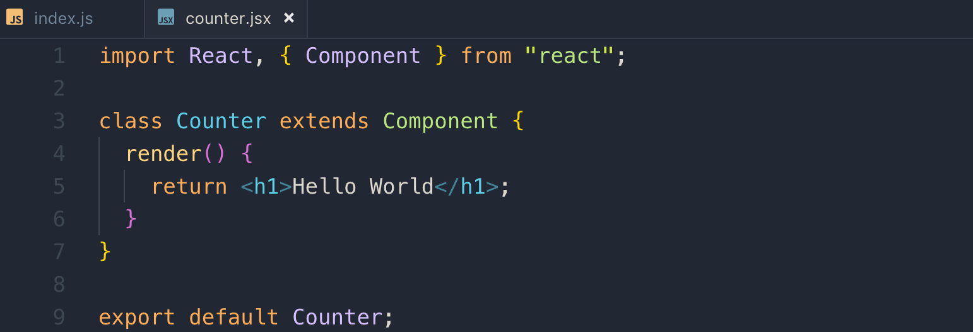

This is the way we import this component into index.js

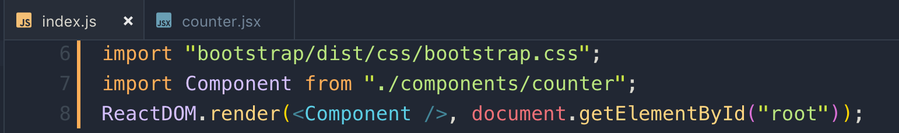

25 Embedding Expression

if you want to return multiple elements in render() method, and don’t want to show the root element for example we used <div> as root element, we can use <React.Fragment> component

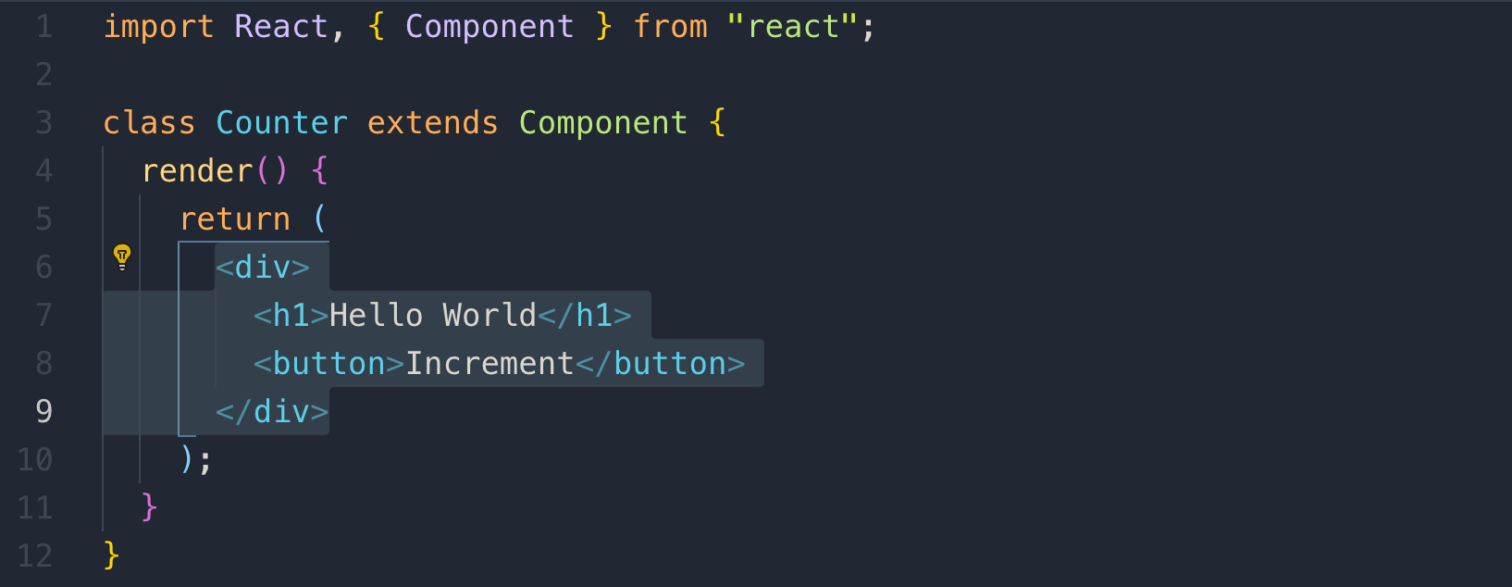

Let’ use <React.Fragment> component as root element

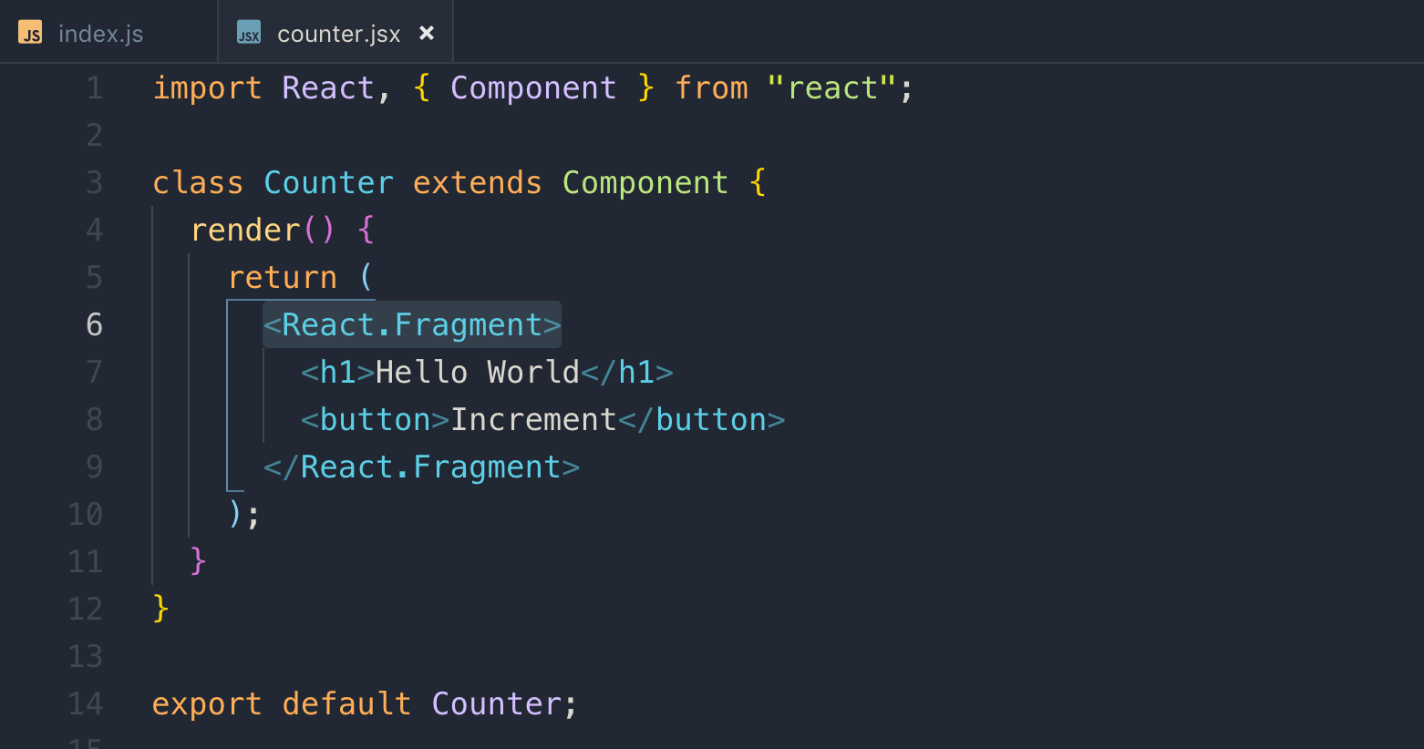

Note: it is not showing the root element.

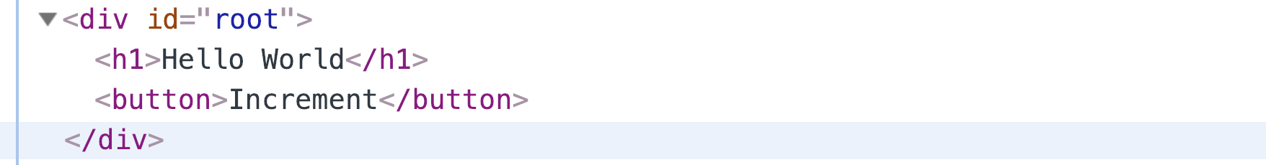

26 Embedding Expression Display value dynamically

Passing values dynamically using state property instead of hard coding.

We used count property and format it by formatCount() function

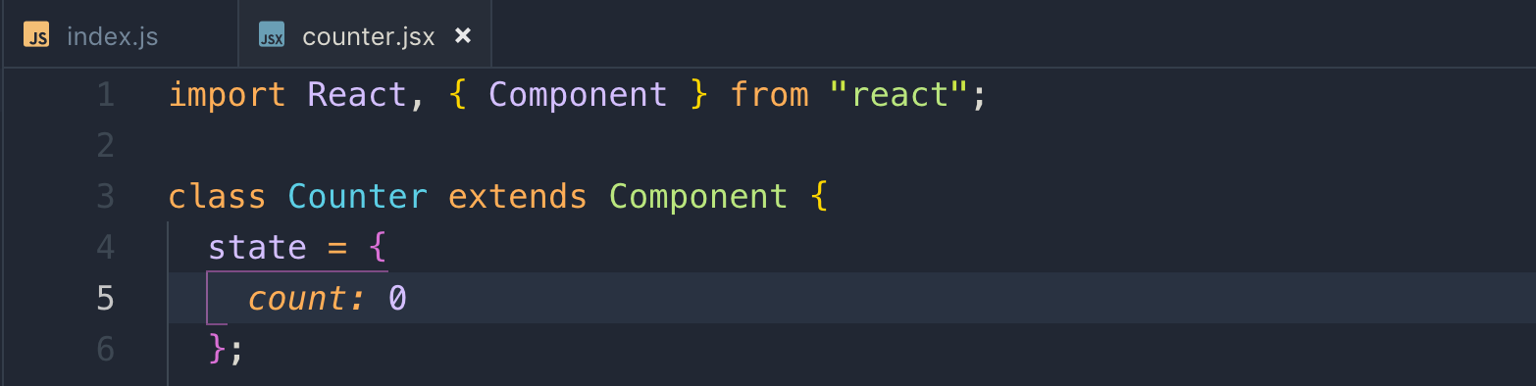

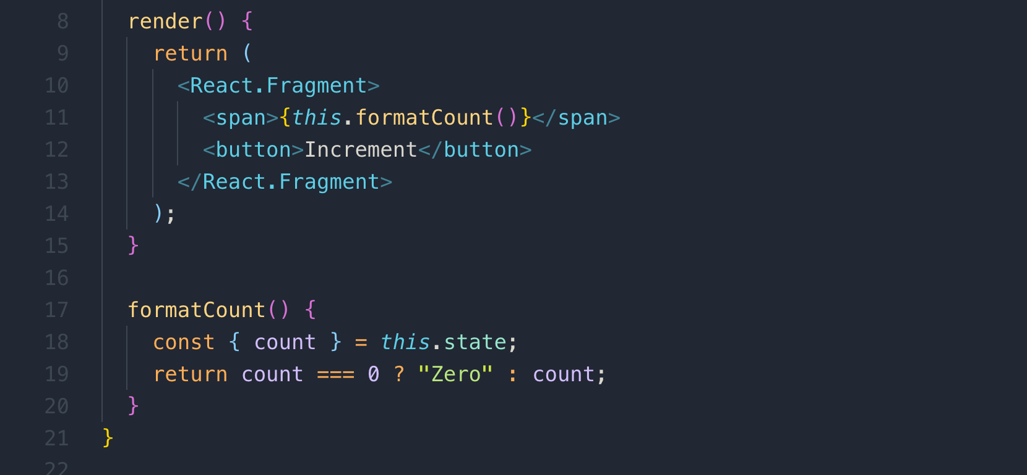

27 Setting Attributes

This is the way we add classes and styles

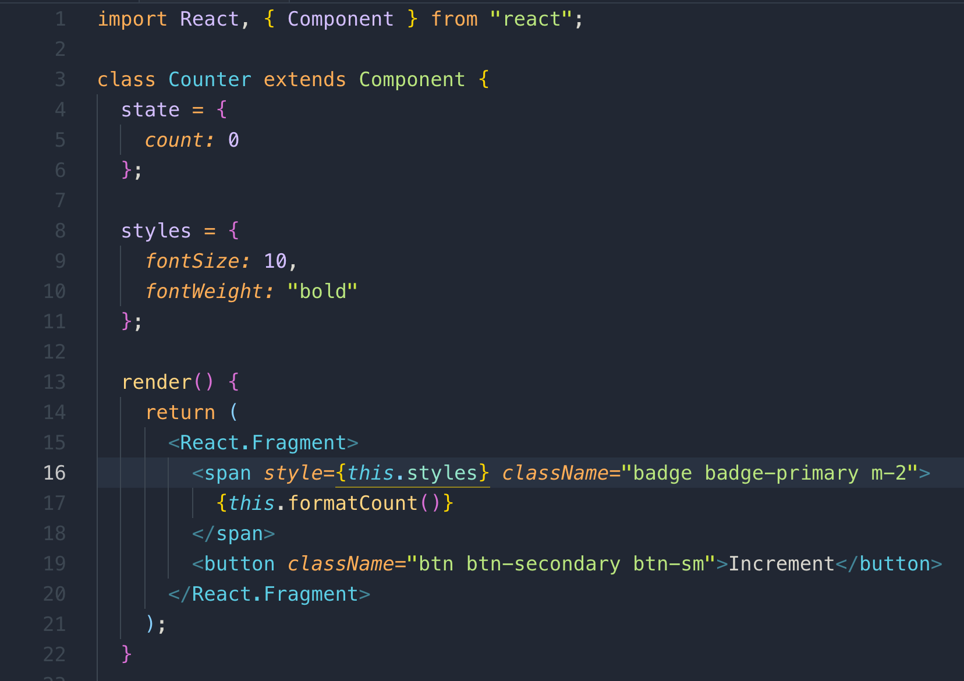

An example of inline style



28 Rendering Classes Dynamically

The proper way is to use dynamic classes using a function like this.

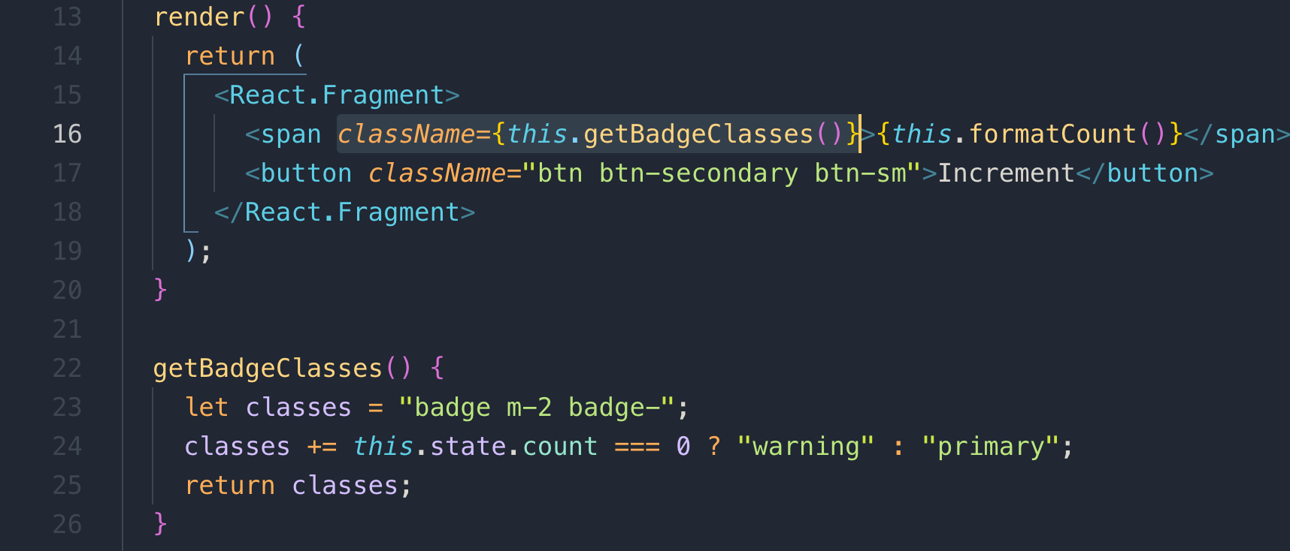

29 Rendering Lists

React forces us to add unique key to list items as if the item in the React’s virtual DOM changes, react quickly figures out what item has changed and where in the DOM it should change it to keep the DOM in sync with the Real DOM.

Whenever you use the map() method to render a list of items, you need to set key attribute for each item.

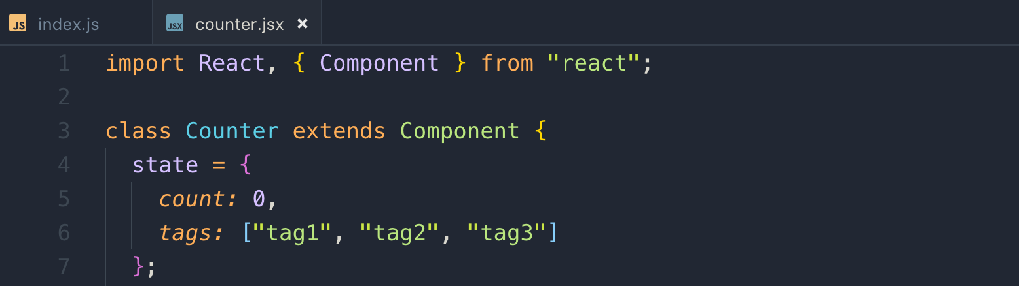

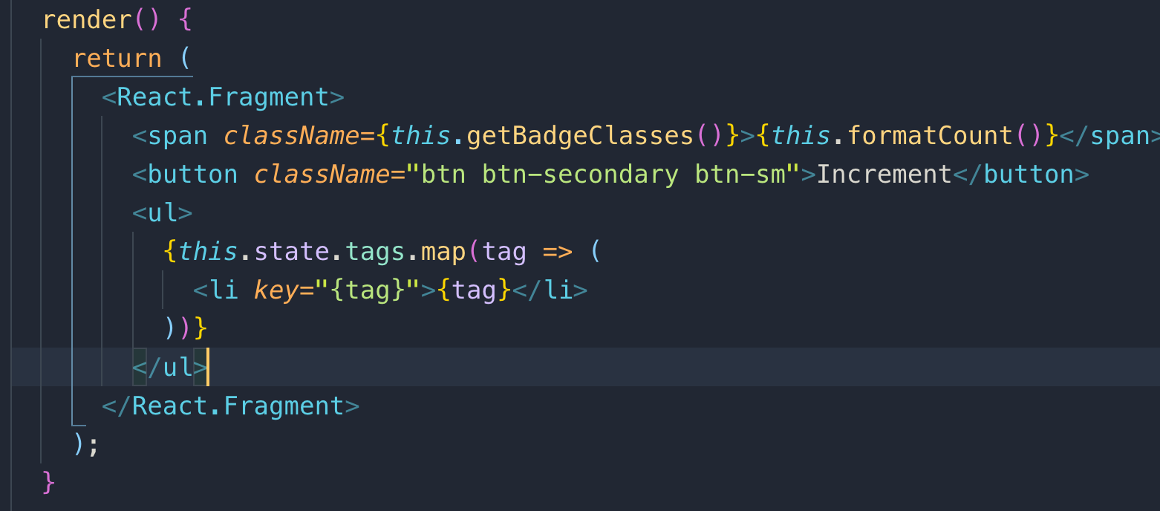

30 Conditional Rendering

if the tags array has at least one element, render list items else display message, no items in tag array

This is the one technique to render code conditionally

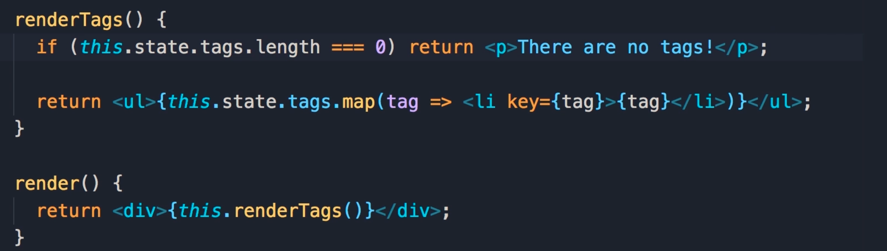

This is another technique to render code conditionally. Let’s see the use of conditional &&

The result of the logical && is the last operand

## Example:

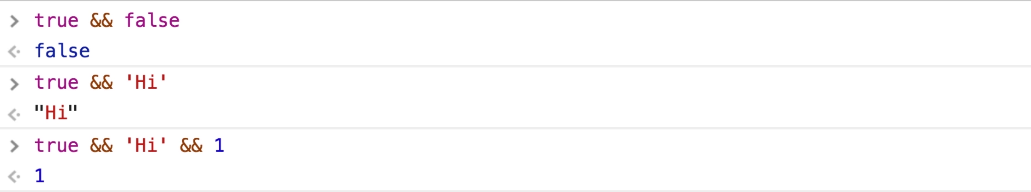

31 Handling Events

React element has case sensitive event for example onClick

This is the way we handle event

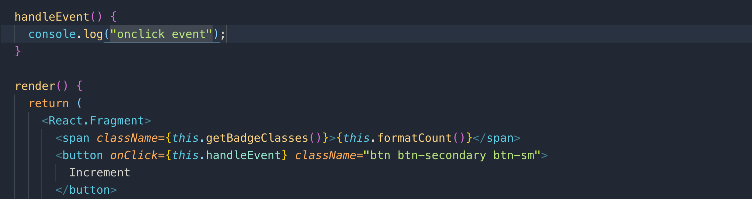

There is a problem with the above handling function as we cannot use “this” in this function, hence cannot use state properties. Let’s fix it in the next section.

Note: if the strict mode is enable then “this” returns undefined instead of window object

32 Binding Event Handlers

We will use arrow function as it doesn’t have “this” to the above solution.

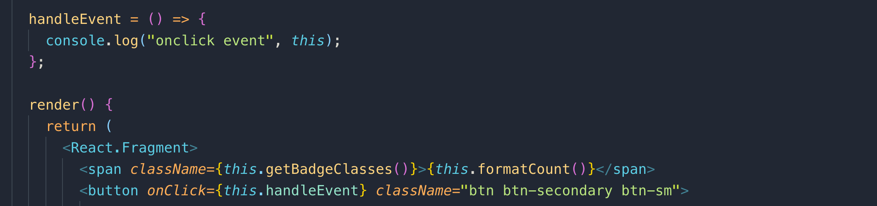

33 Updating the State



setState() tells the react to update the DOM based on the state

34 What happens when state changes

setState(): this method tells react that the state of this component is going to be changed and React will then schedule a call to the render() method sometime in the future this method is going to be called, we don’t know when. setState() is an asynchronous call which means it is going to happen in the future. It may have 5ms later or 10ms later.

35 Passing event arguments

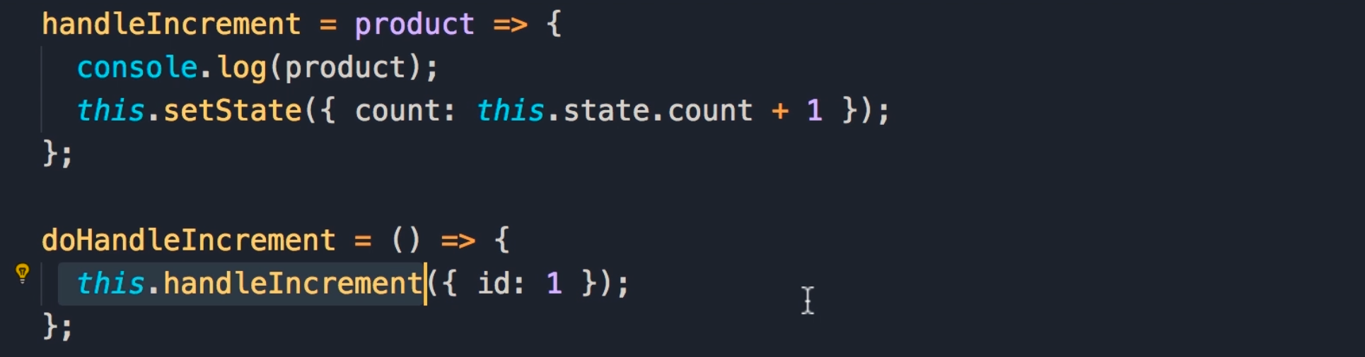

Instead of passing values directly on the onClick function, we can pass function and call another function which has the value.

## onClick={this.doHandleIncrement}

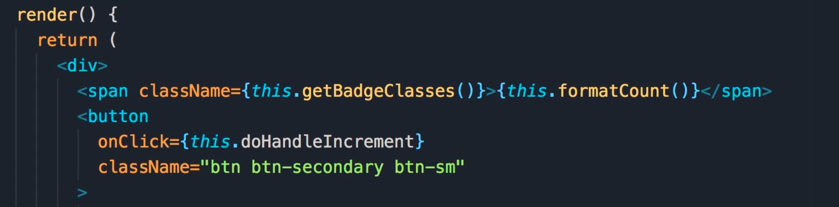

Above approach is not good, we can directly pass a function instead of defining and passing it to onClick() as we did above.

## This is a good approach

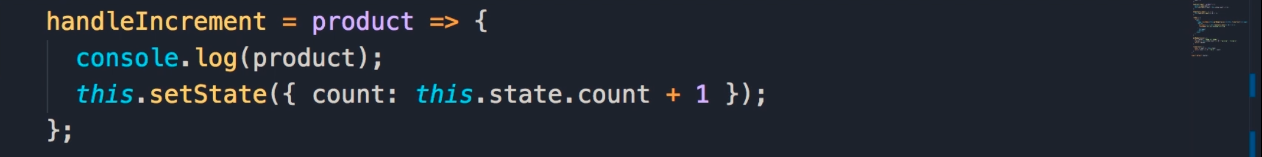

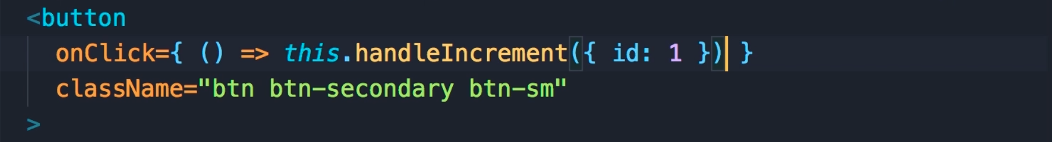

36 setting up vidly project

Creating react App



Install the required libraries



import CSS in the vidly project

## index.js

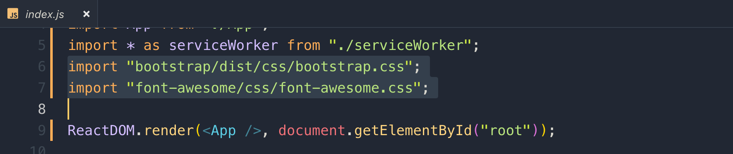

When we build this application, webpack which is the build tool to bundle our JavaScript, and CSS files will pull in these CSS files and put them in the final bundle.

For the few lessons, we are using fake services

## fakeGenreService.js

## fakeMovieService.js

Let’s build this table data

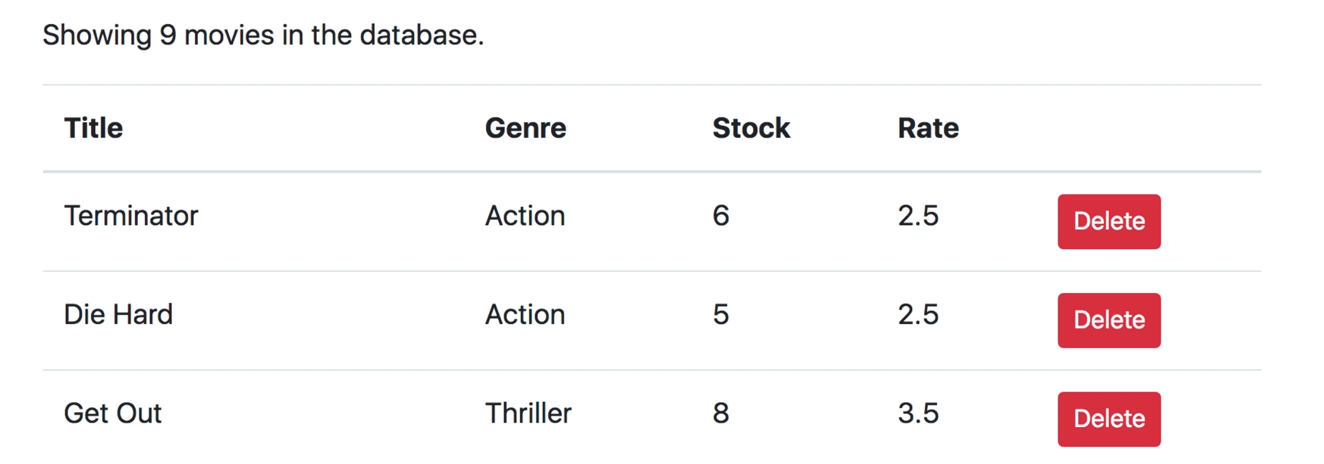

38 Building the Movies component

Creating a file components/movies.jsx

imrc => shortcut for importing react component

cc => shortcut for create class component

We will create a Movies.jsx component and add a bootstrap table into it.

Emmet shortcut for adding row and columns

## table.table*>*thead*>*tr*>*td*4;

To get the Bootstrap table, just go to bootstrap site =>documentation then search for “table”

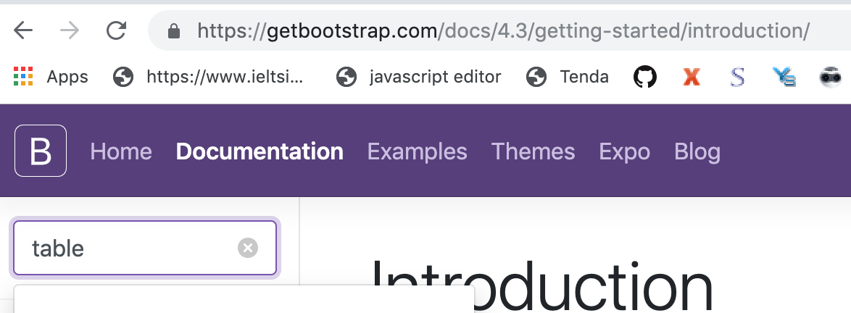

importing fake movie service and listing the table.

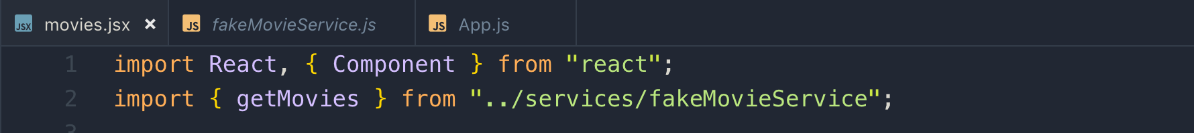

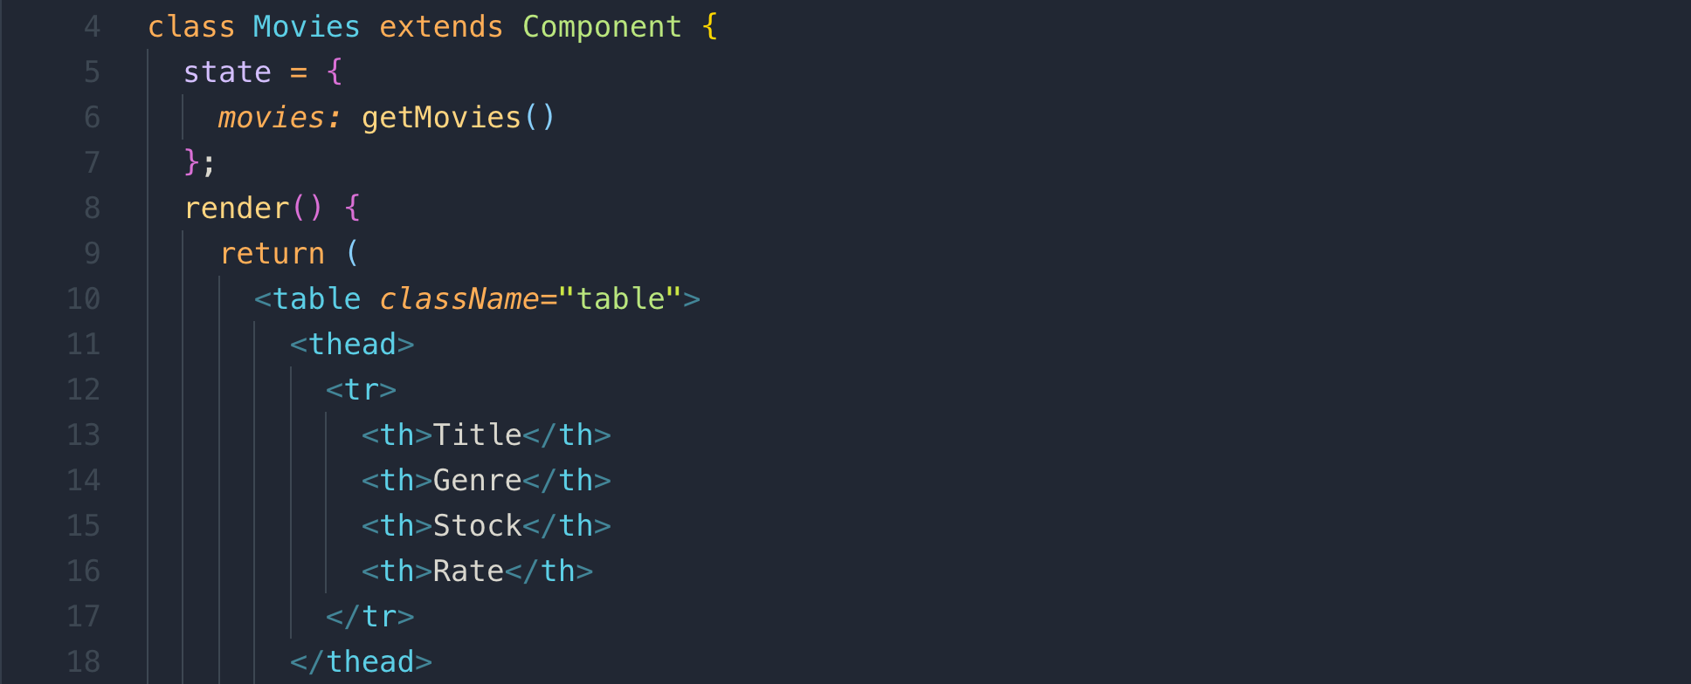

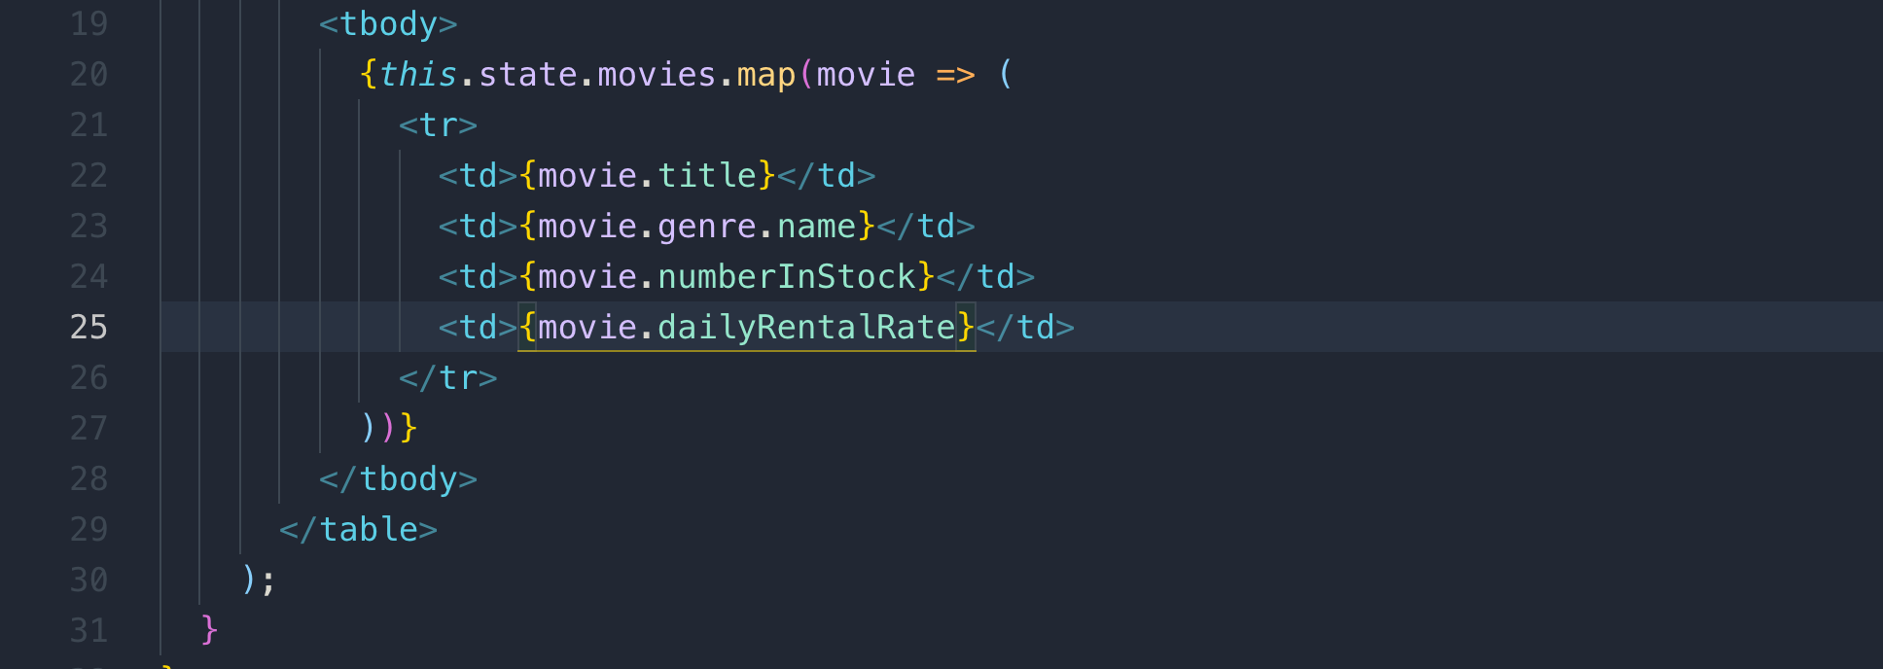

39 Deleting a Movie

We need to add a delete column in the table to delete a specific record

in the Modern JavaScript, if the key and value is the same, we can use the below code like this



Creating Deleting record function

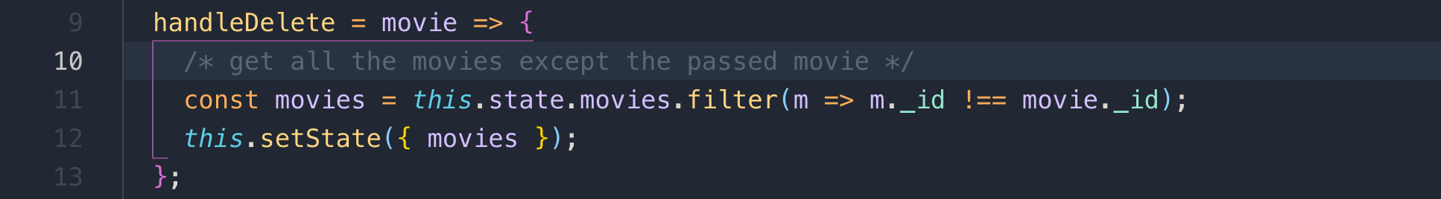

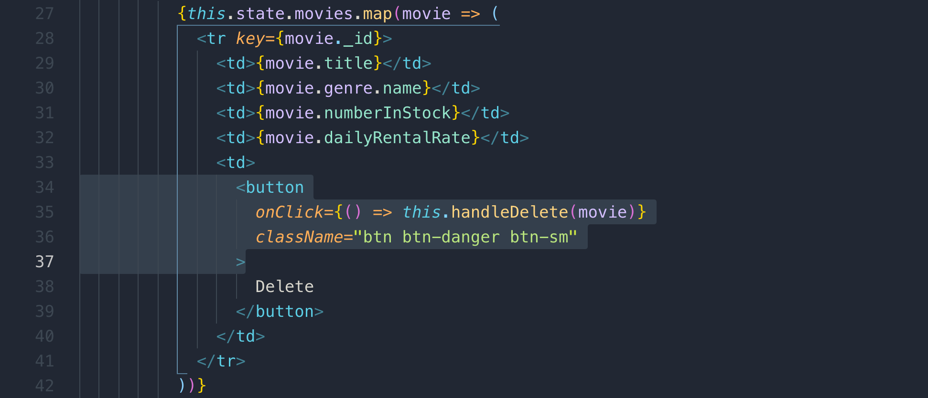

40 Conditional Rendering

We used <React.Fragment> as we are returning multiple statements.

We also used destructuring and alias name as count

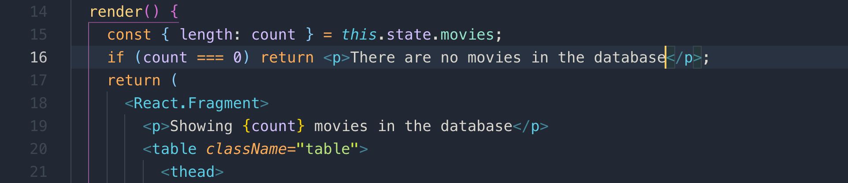

42 composing components

## This is what you will learn in this section

1. Passing data between components
2. Raise and Handle event
3. How to have multiple components that are in sync
4. Functional components
5. Lifecycle hooks

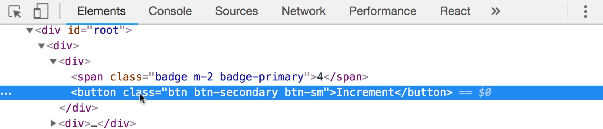

you can get the value of the above selected element. You can even call click() function like this

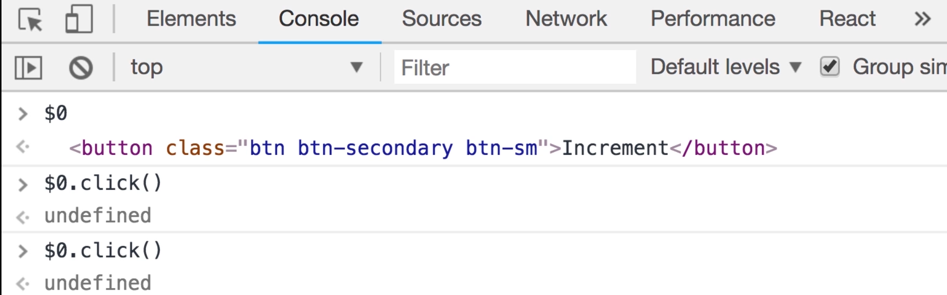

43 composing components

We will create a counters component and use it as a root component in index.js

index.js

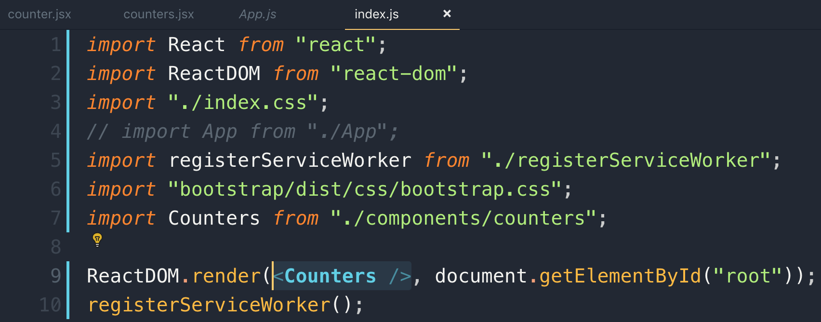

Components/counters.js

We created an object and loop through map function and print the <Counter> component multiple times

Note: each <Counter> is a separate component and has its own state

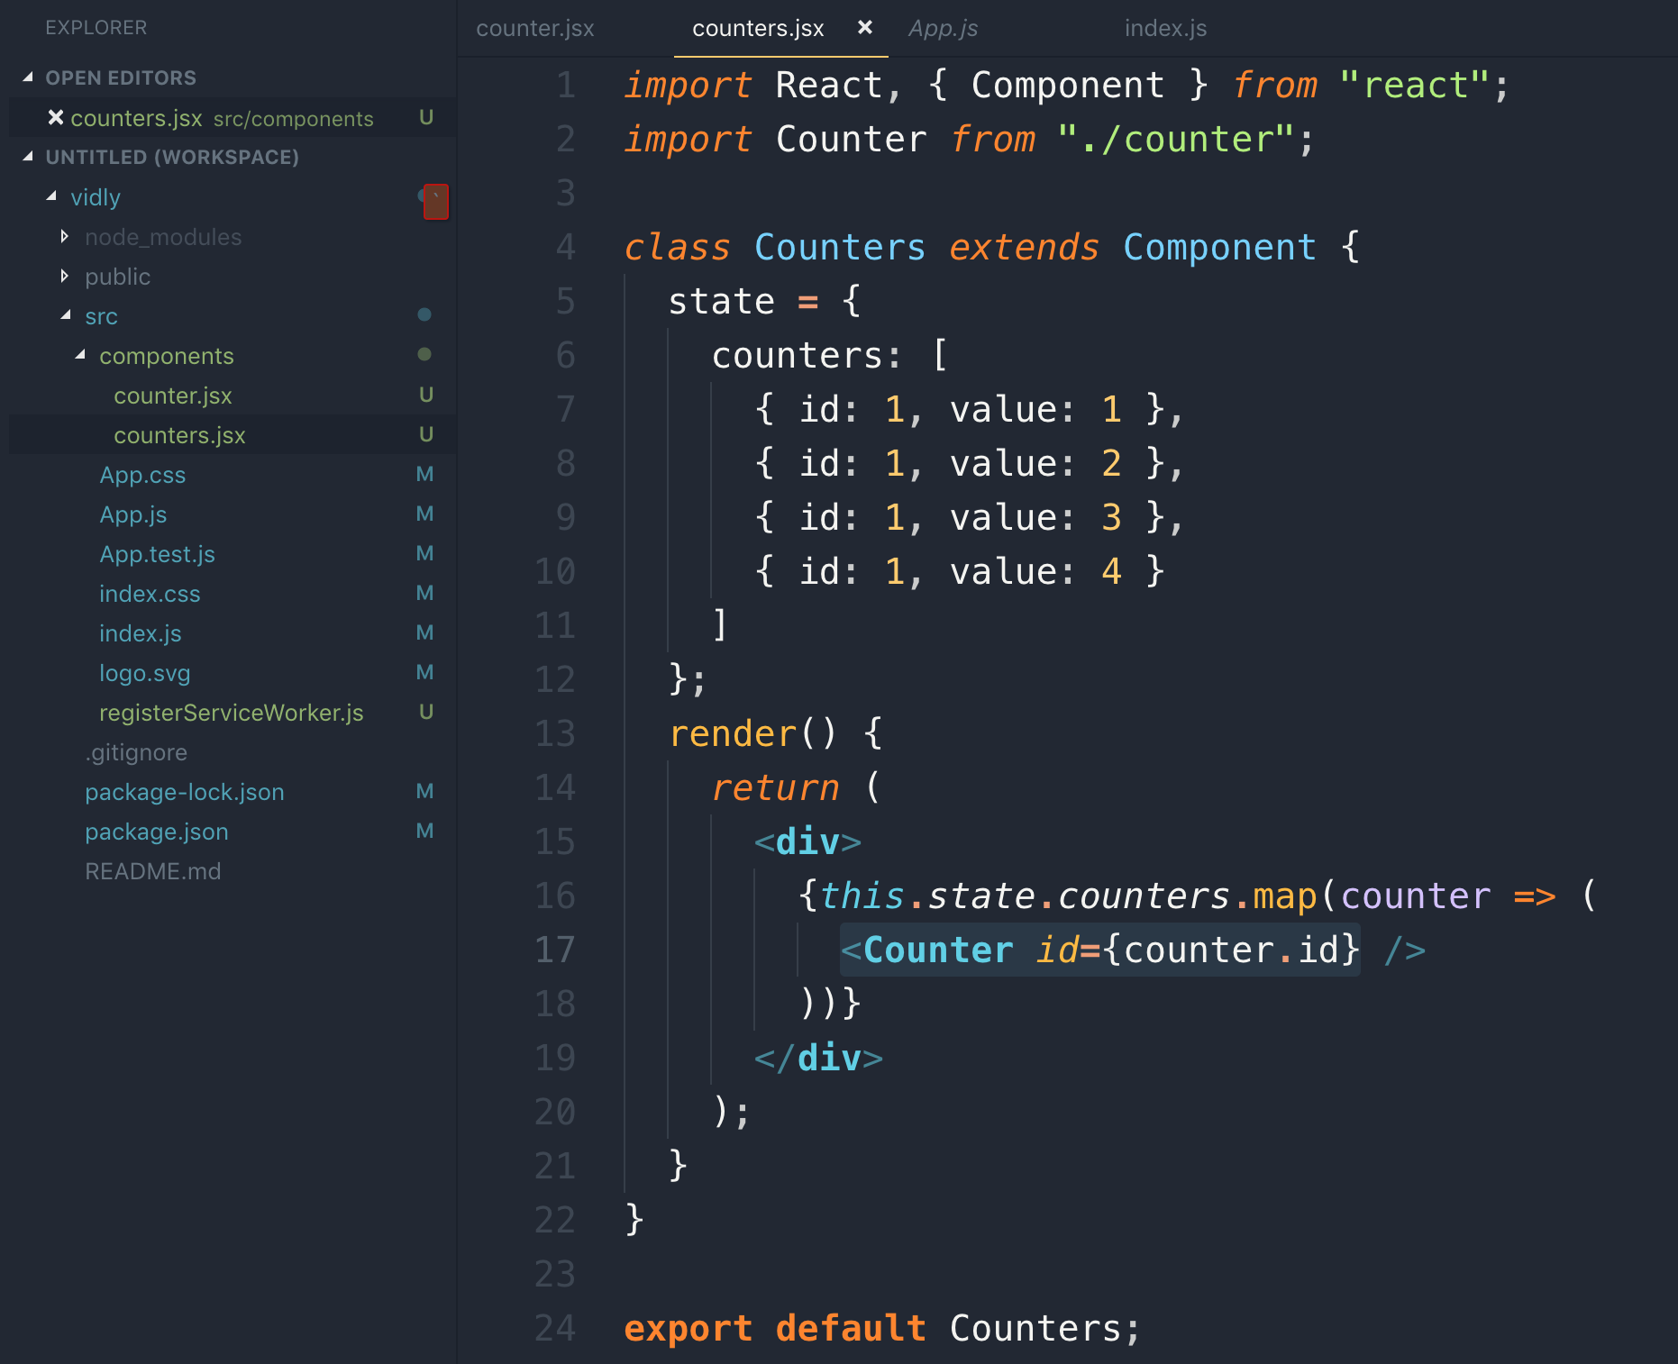

44 passing data to components

47 props vs states

Props: it includes data that we give to a component whereas State includes data that is local or private to that component so other components cannot access that state. It is completely internal to that component.

The attributes we set on a component is parts of props.

React does not allow you to change any properties of the props object.



Counter will raise an event and counters will handle this event.

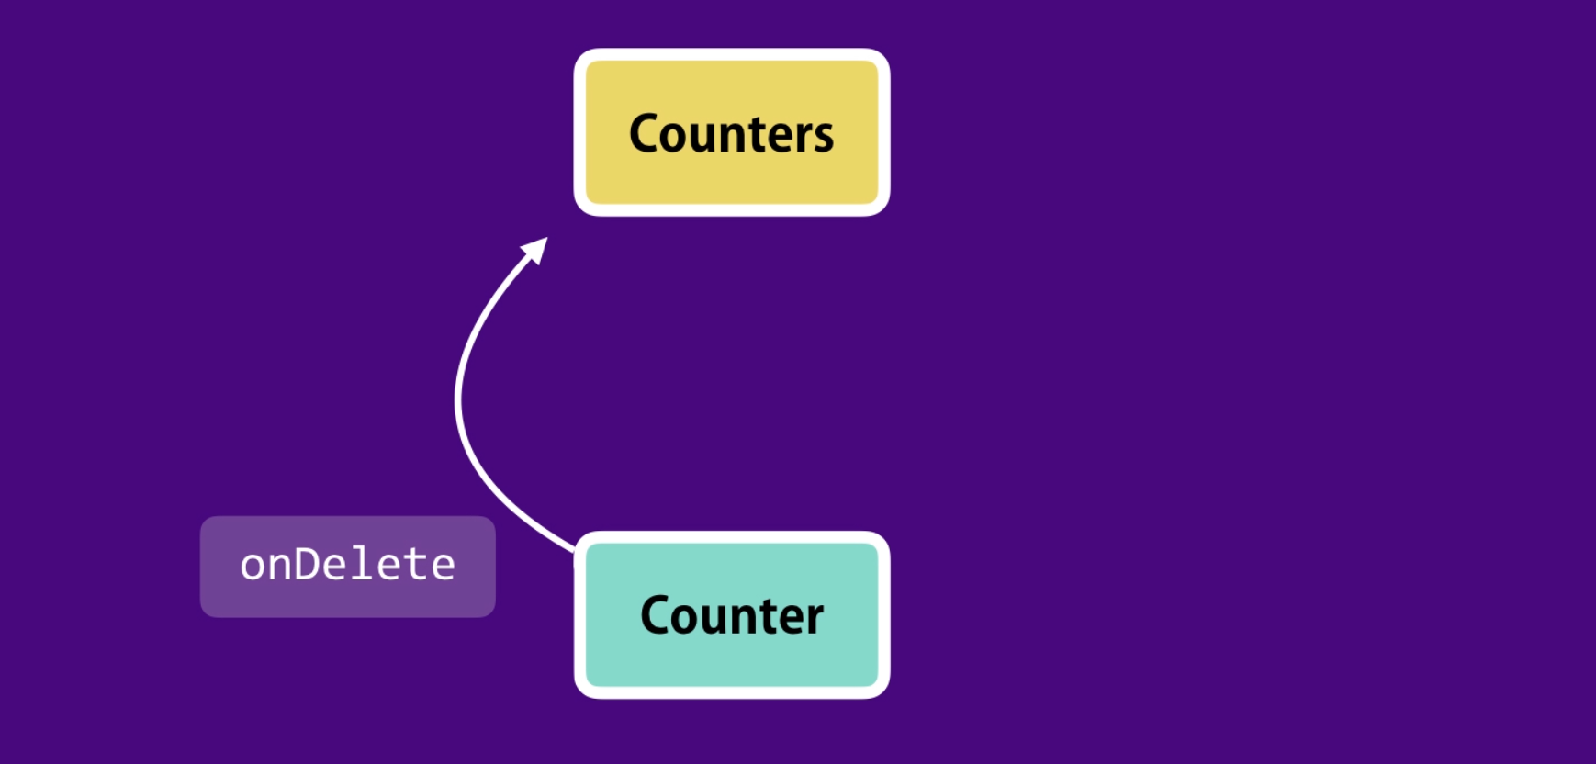

49 Updating the State

We are passing a function reference to child element and there we are passing id to delete the object from state component.

Handling function in state component

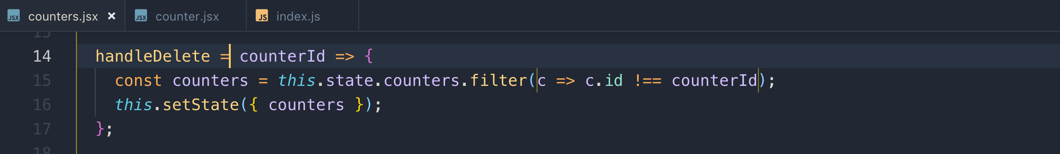

passing function reference to child component <Counter>

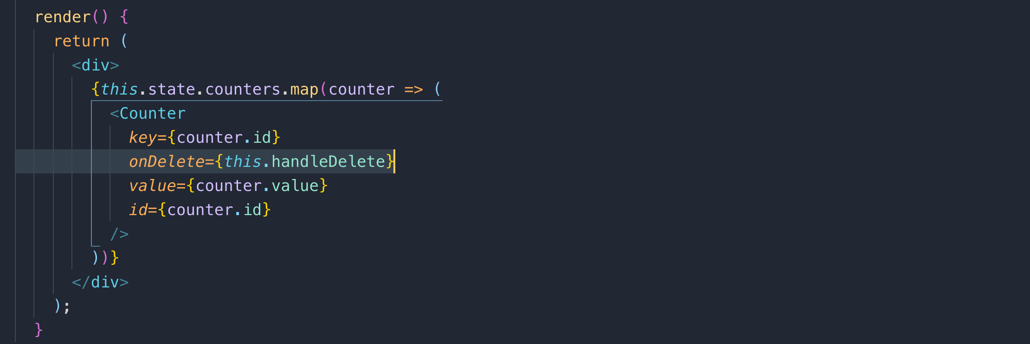

calling passed reference function with passing id

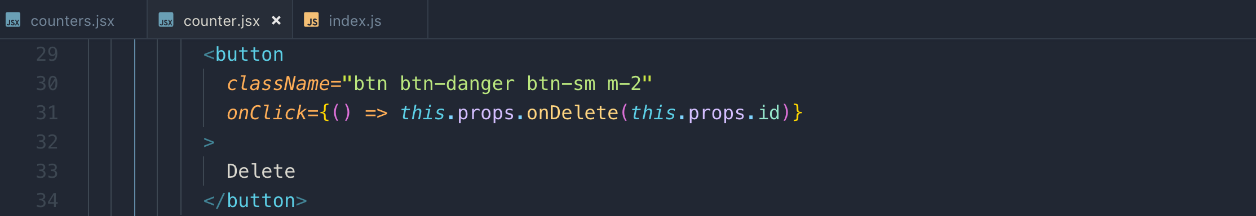

50 Single Source of Truth

Single source of truth: State is local to a component and does not update from any other component whether it is a parent component.

State property is of child component is only executed once when an instance of a component is created.

If parent state is updated, it does not allow to change child state as it is local to child component

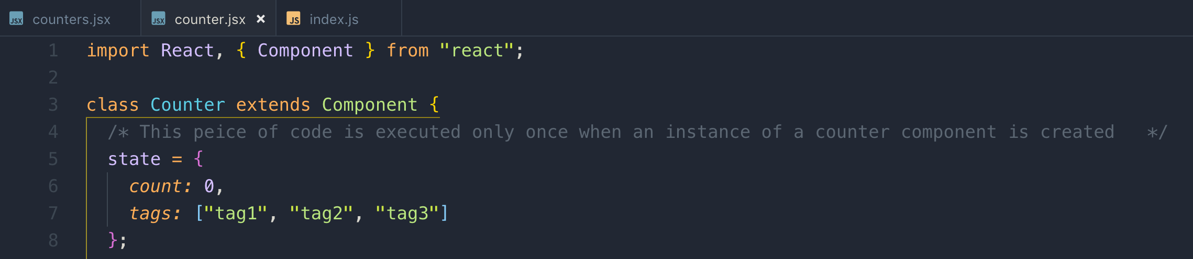

51 Removing the local state

Controlled component: it doesn’t have its own local state. It receives all the data via props and raises events whenever data needs to be changed. It is completely controlled by its parent.

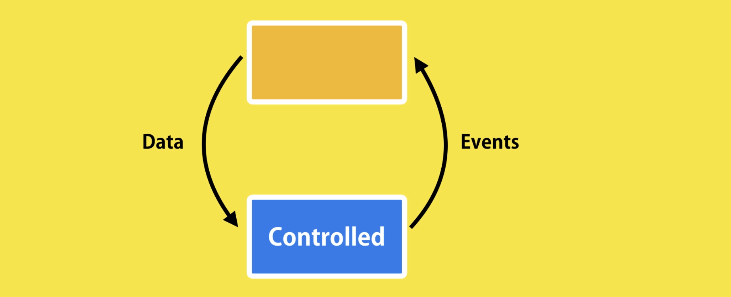

Remove all the state properties and use props instead.

To update an object with state array, just clone the specific object not the entire state array.

Example:

## handleIncrement()

1. Cloning the state array
2. Finding the index of the object that needs to be updated
3. Change the value
4. Update it with setState()

This is the way we handled events

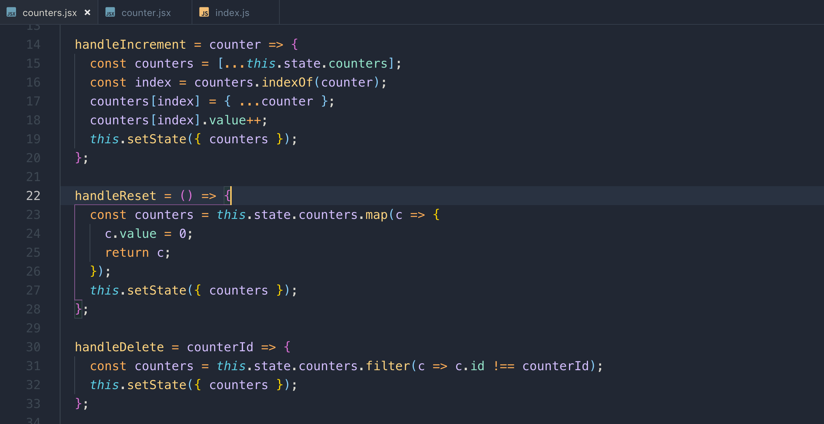

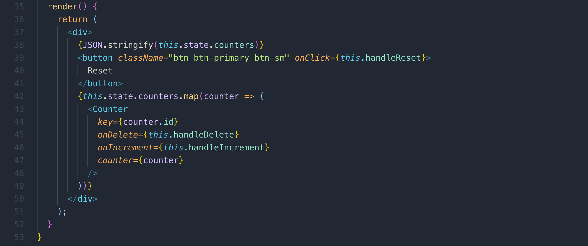

52 Multiple components in sync

When there is no parent child relationship between 2 components and you want to share data between them, you need to lift the state to parent component like below we moved state from <Counters/> to <App/> component.

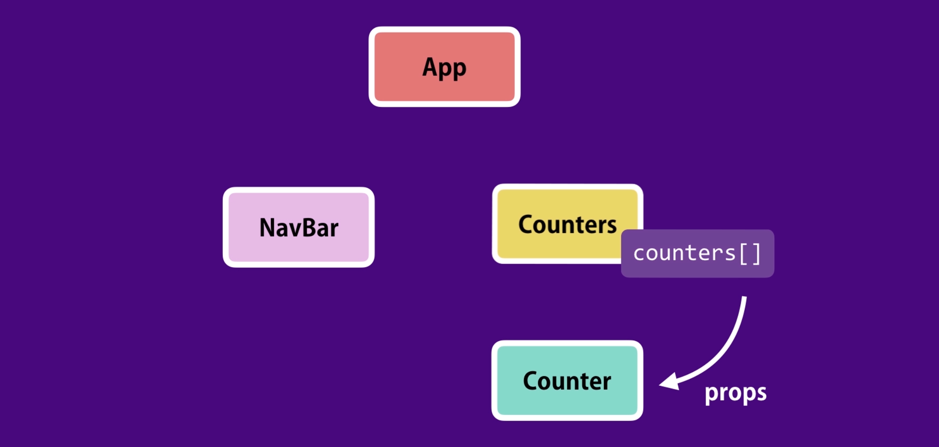

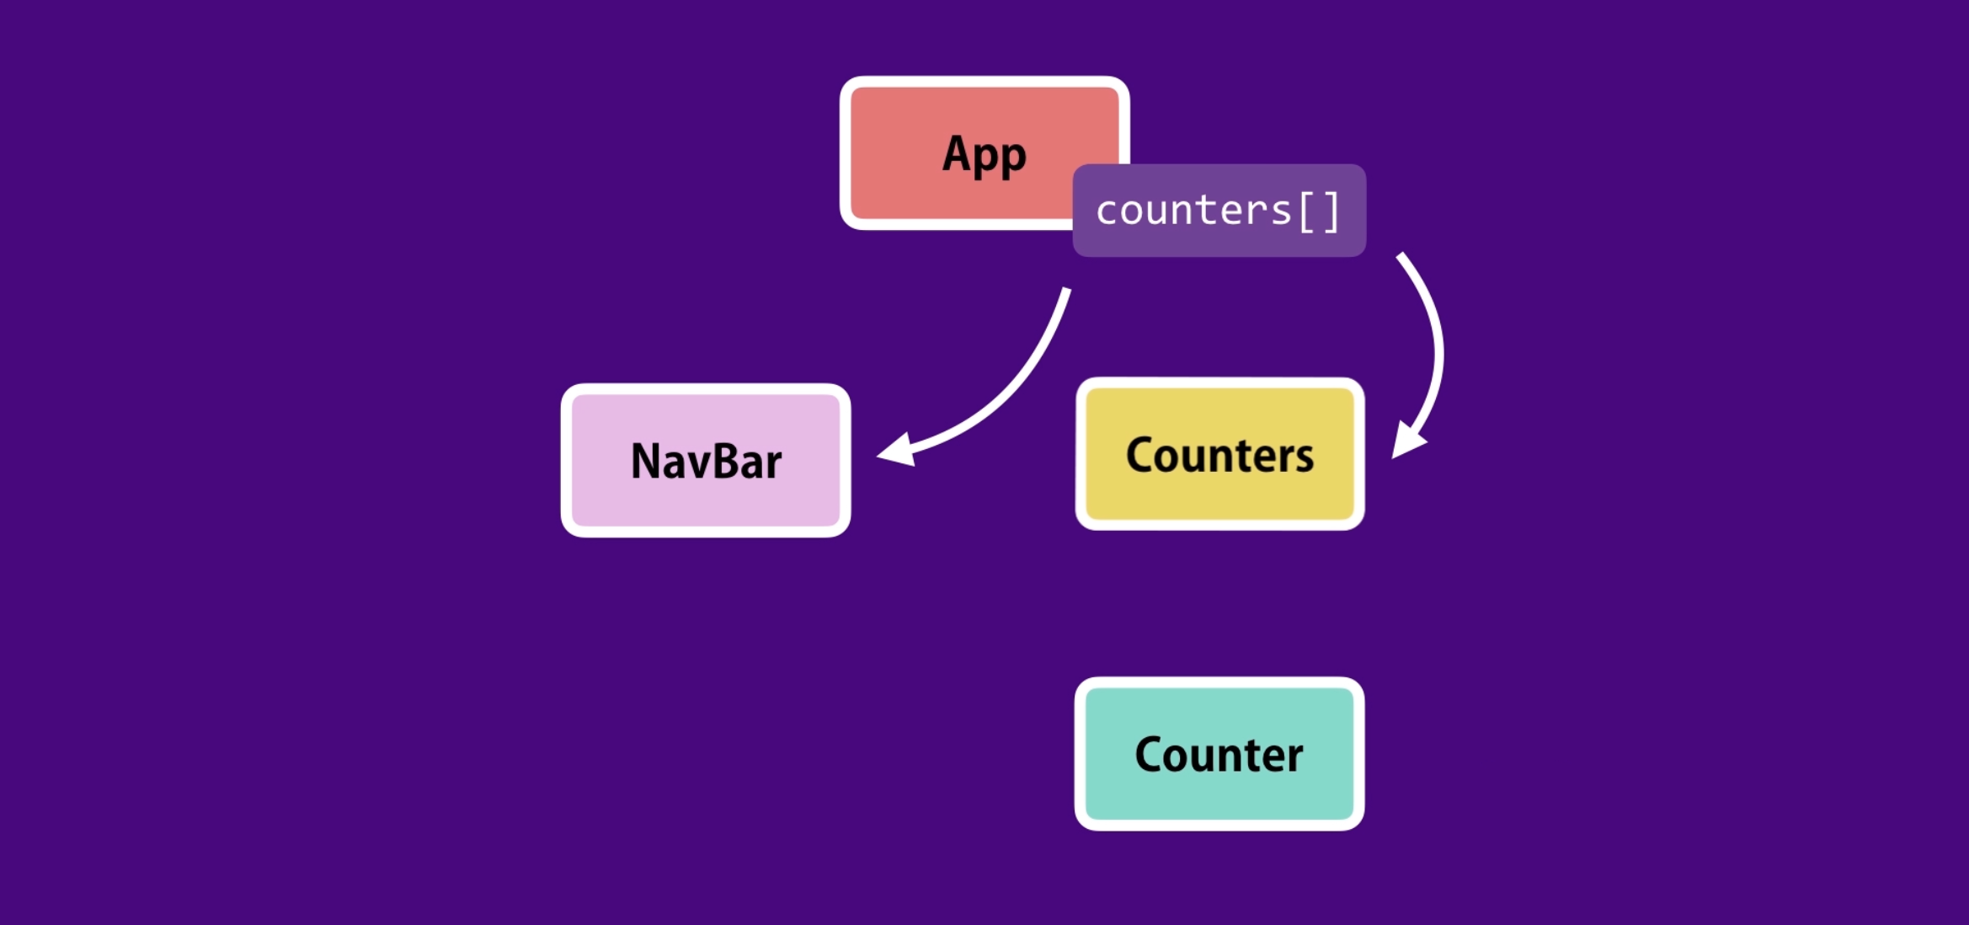

53 Lifting State Up

With the states, we also need to move the state modifier functions to the parents.

Now <Counters> component is a controlled component which simply returns data, because it doesn’t have any state so it is entirely controlled by its parent.

We are passing functions and counters from <App> 🡺 <Counter> 🡺 <Counter> which is where we raise event and it handles back in <App> component 🡸 <Counter> 🡸 <Counter>

This is the way we can filter counters if value is not 0



54 Stateless functional component

in <Navbar> component, we don’t have state, or calculated values. We only have render method. We are getting all the data via props. In a situation like this, we convert the component into stateless functional component

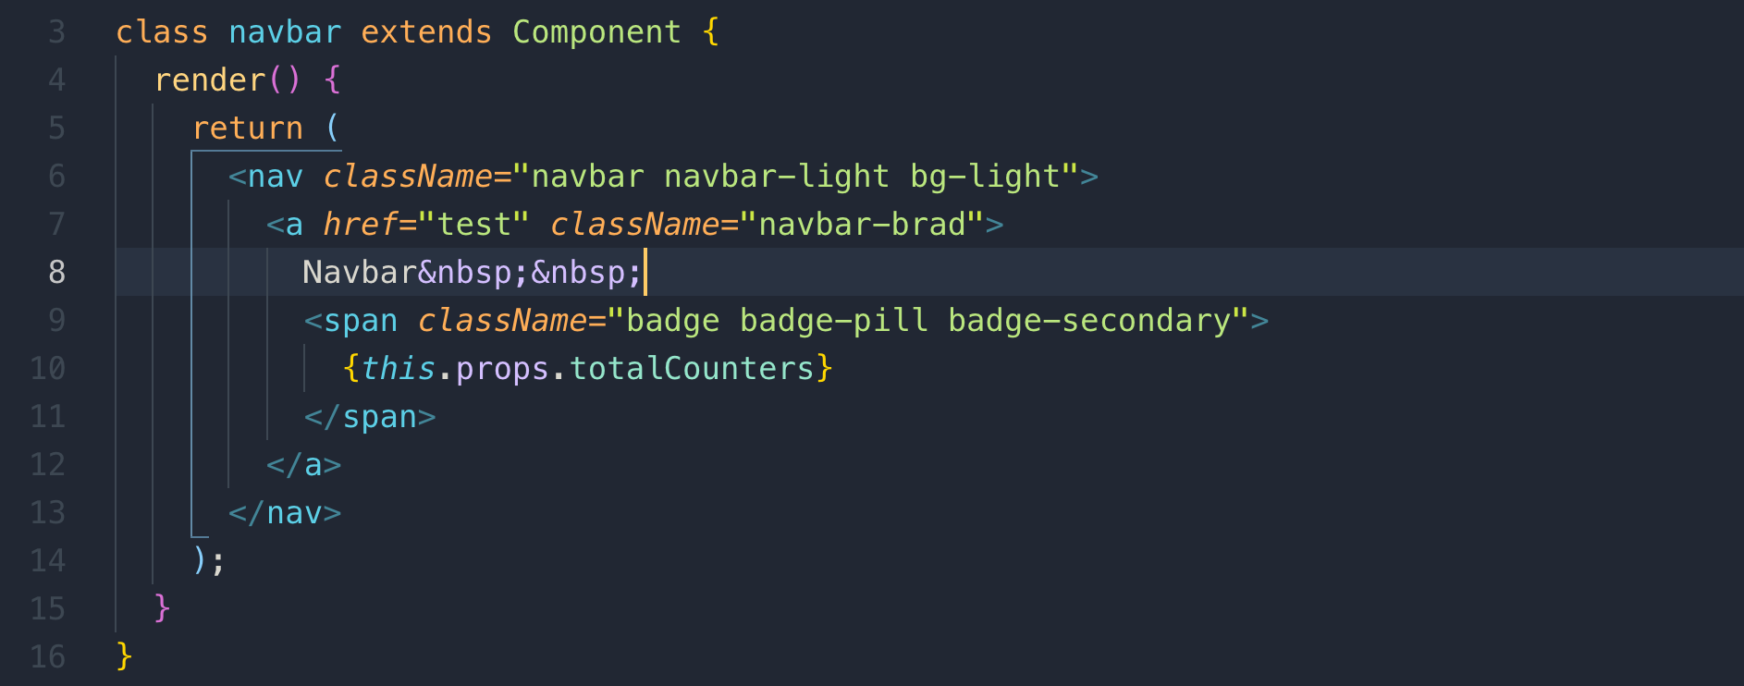

In stateless functional component, we simply define an arrow function that returns a React Element

sfc => is the shortcut for creating stateless functional component.

React pass props as an argument to functional component at runtime.

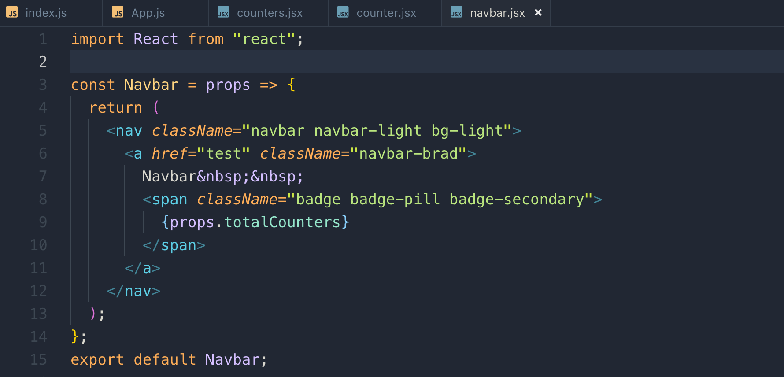

55 De-structuring Arguments

We don’t want to repeat props. several times so we can use Object de-structuring to de-structure the props argument

in functional component, we can directly de-structuring while in the function like this.

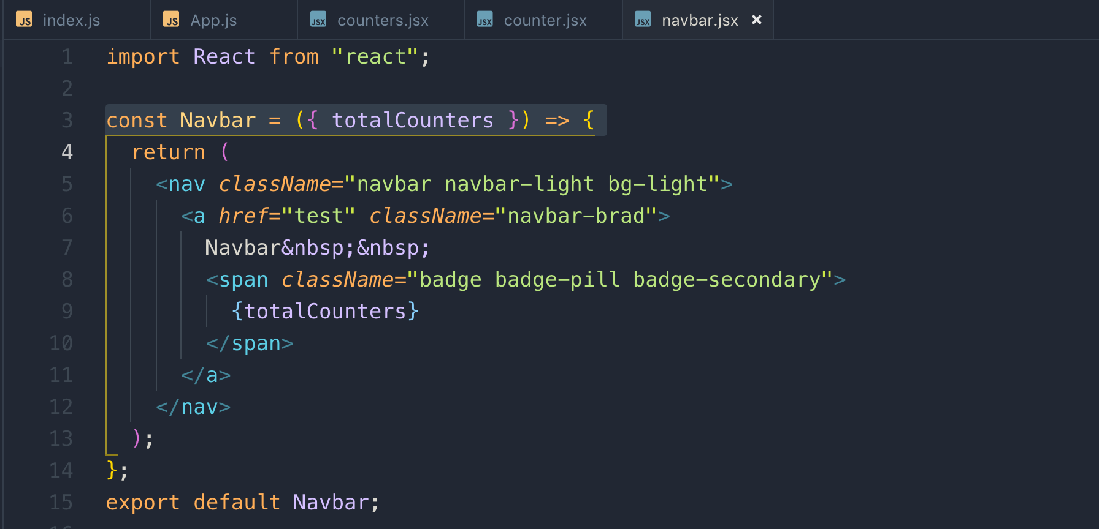

In class component, we need to define a constant in the render method for de-structuring

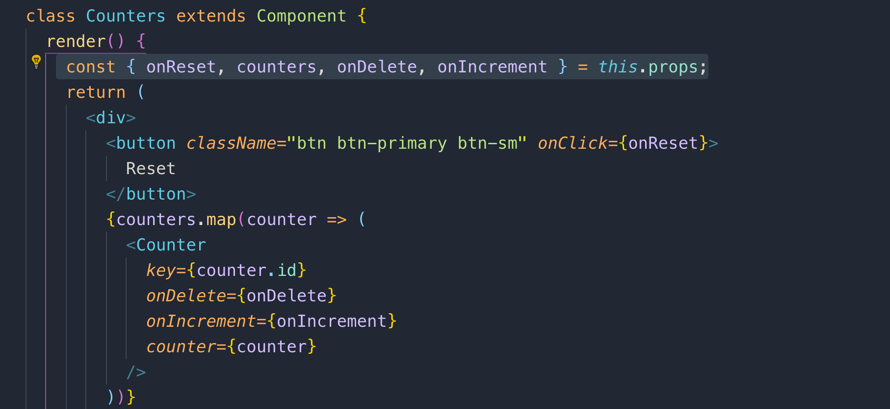

56 Lifecycle Hooks

Our component go through a few phases during their lifecycle.

1. **The first phase is the mounting phase and this is when an instance of a component is created and inserted into the DOM**

In Mounting phase, we have 3 lifecycles hooks. React calls these methods in order.

1. **constructor**
2. **render**
3. **componentDidMount**
4. **The second phase is the updating phase and this happens when a state or the props of a component get change.**

In Updating phase, we have 2 lifecycles hooks. Whenever we change the state of component or give it new props, these 2 methods are called in order

1. **render**
2. **componentDidUpdate**
3. **The last phase is the unmountin phase and this is when a component is removed from the dom.**

In Updating phase, we have 2 lifecycles hooks. Whenever we change the state of component or give it new props, these 2 methods are called in order

1. **render**
2. **componentDidUpdate**

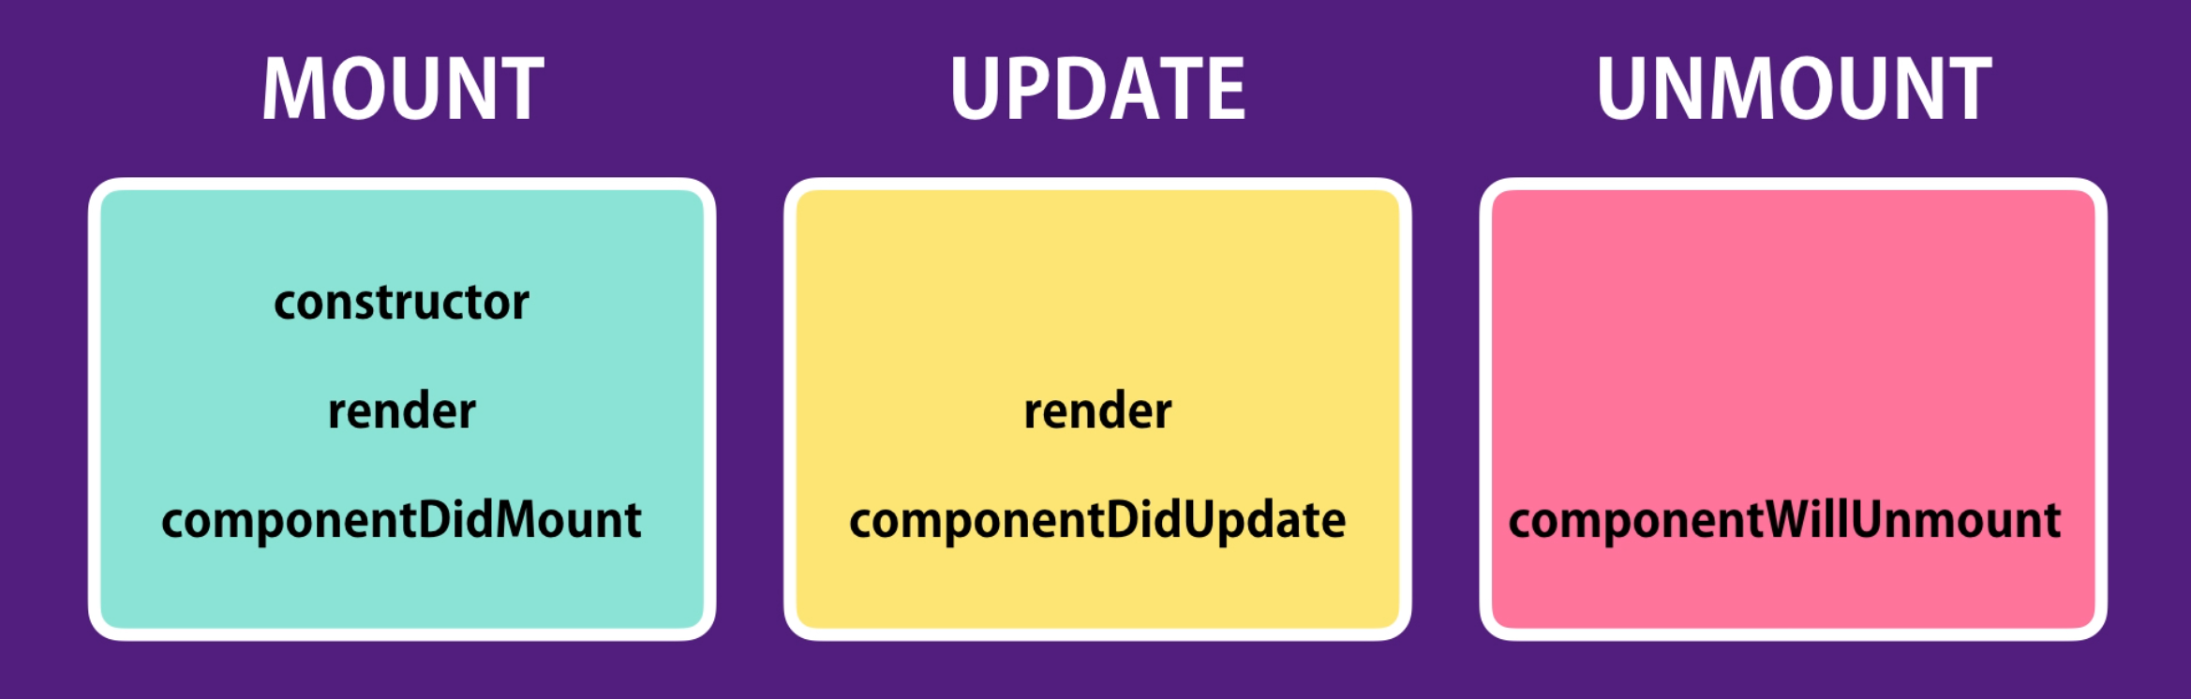

57 Mounting Phase

constructor:

This is called only once when an instance of a class is created. This is the great opportunity for initializing the properties in that instance.

One common use case is to set the state based props that we receive from the outside.

Note:

setState() can only be called when a component is rendered so we cannot call setState() it inside constructor, but we can initialize state with outside props. We need to pass props to constructor(props) method and also in super(props)

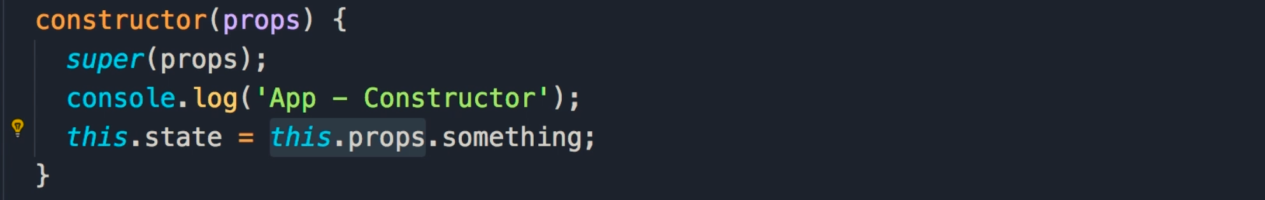

componentDidMount:

This method is called after our component is rendered into the DOM. This is the perfect place to make Ajax calls to get data from the server and update the state with new data.

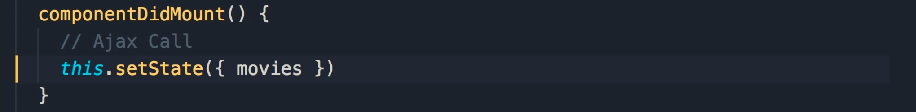

render:

When a component is rendered all its children are also rendered recursively. This is the way our counter app lifecycle method rendered

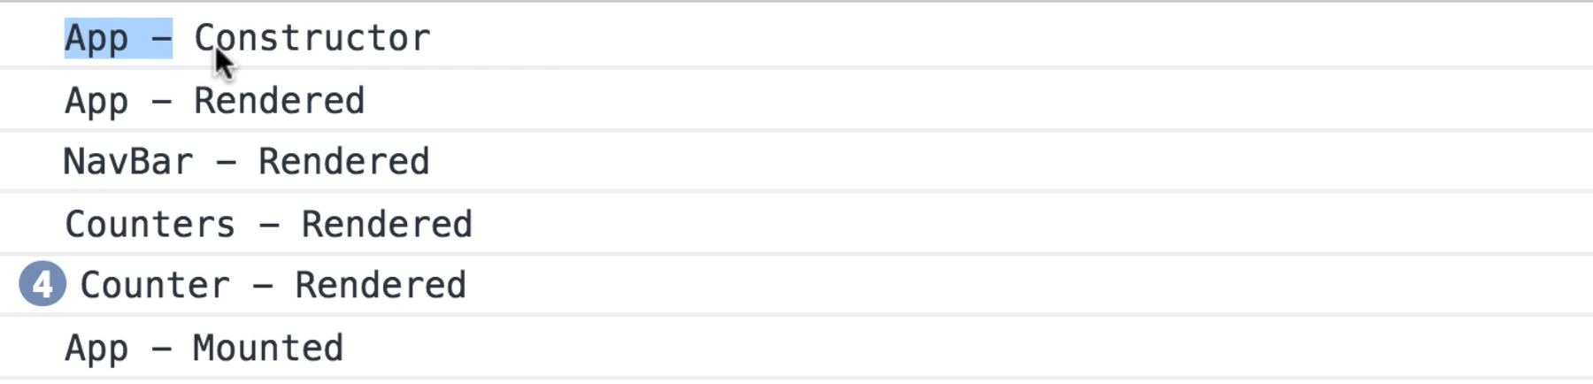

Note:

It rendered 4 instances of <Counter> component is rendered.

58 Updating Phase

This phase is happened whenever the state or props of a component is changes.

componentDidUpdate:

This method is called after a component is updated which means we have new states or new props so we can compare this new state with the old state OR with new props with old props.

If there is a change, we can make an Ajax request to get new data from the server. If there is no change, we don’t have to make an additional ajax request. This is an optimization technique. We have a condition in the below for Ajax request.

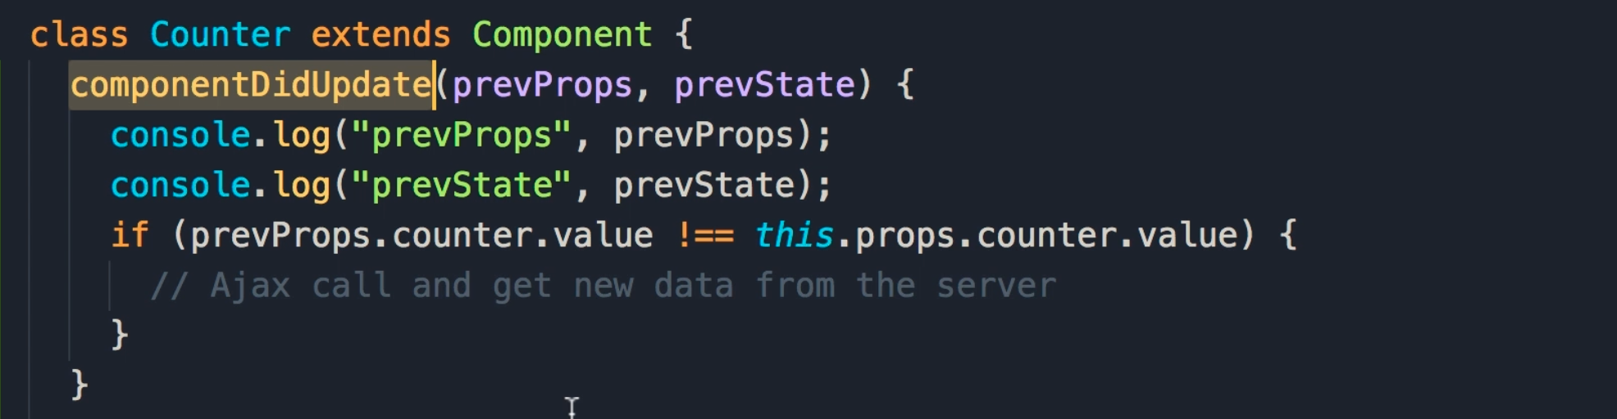

59 Unmounting Phase

componentDidUnmount:

This method is called just before a component is removed from the DOM. This gives us the opportunity to clean up timer, or listener, we can clean those up before this component is removed from the DOM otherwise we will end with a memory leak.

<https://www.youtube.com/watch?v=CRoR_0K586I>

60 Exercise

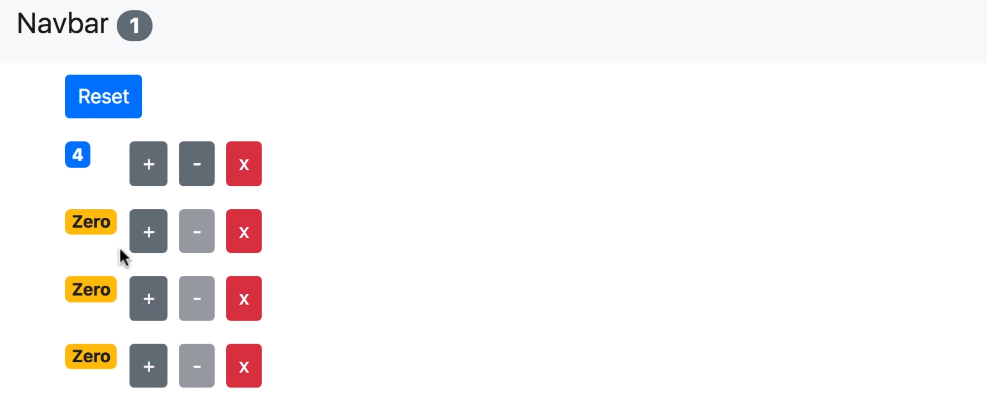

61 Solution

This is the way we disabled button on the counter value

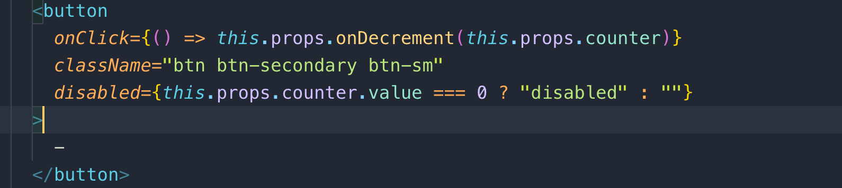

62 Exercise

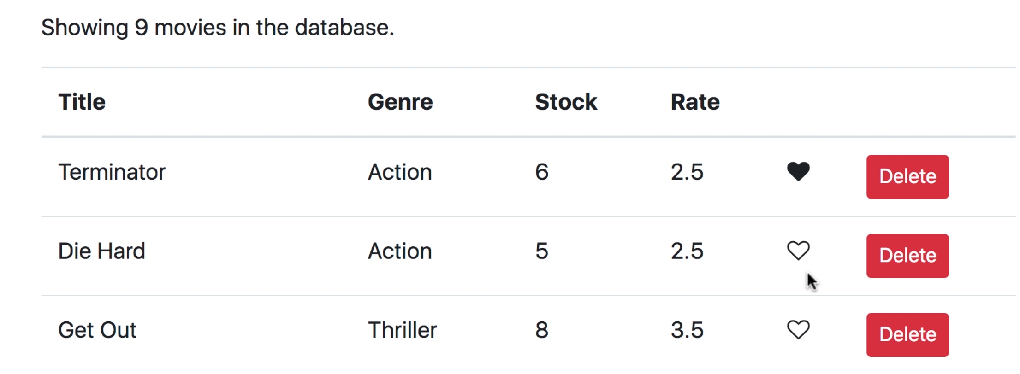

63 Solution

We create a folder in components folder called src/components/common which is not specific to the application.

Here we will create common components like pagination, likes, table, and forms, and so on.

Create a new file src/components/common/like.jsx

Note: we have to keep in mind that what is the input and output of a component.

Example:

In the “like.jsx component” we have input and boolean and output is also boolean and we have event as “onClick” to make heart (like icon) empty or fill

Heart icon from font awesome

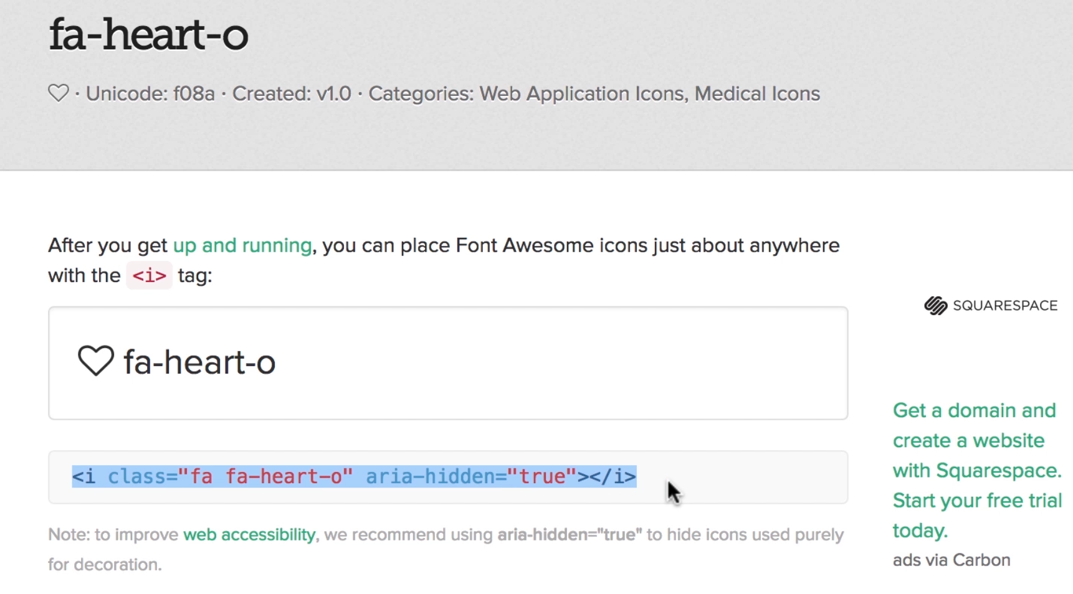

Here how we used conditional classes and onClick handler that is passed from child component(Like) to parent component (Movie)

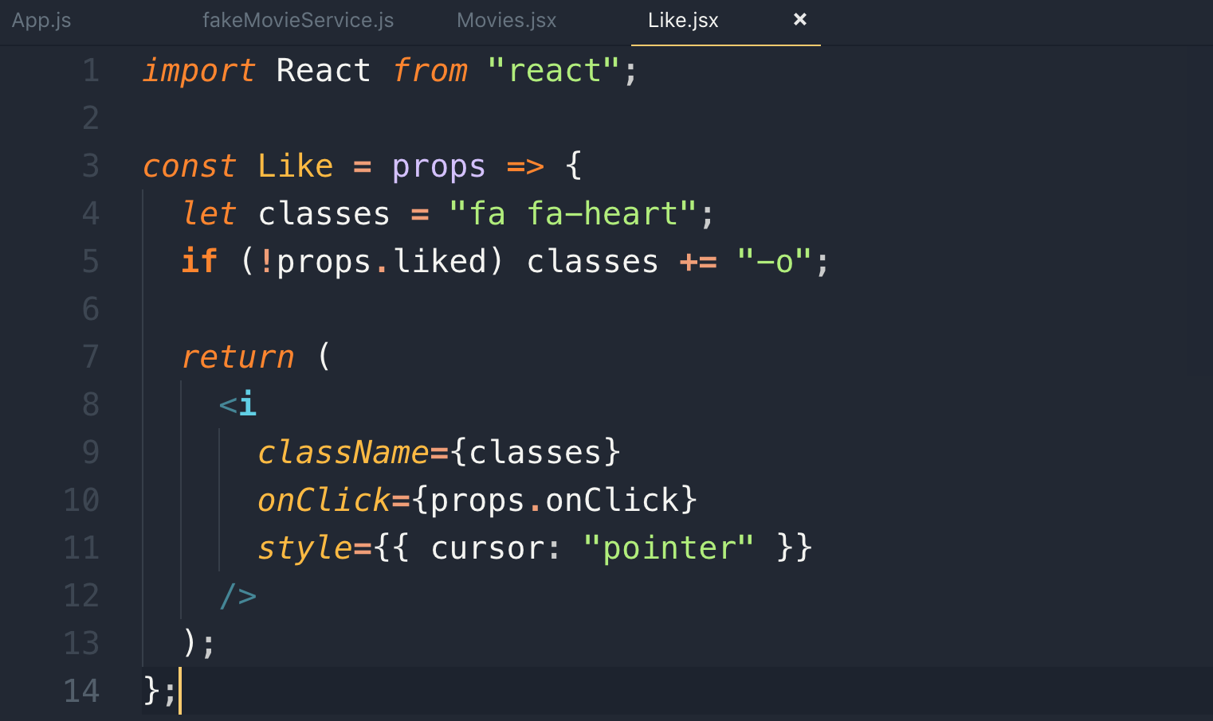

Now let’s see how to handle the event raised from child component(Like.js) and update the state obj.

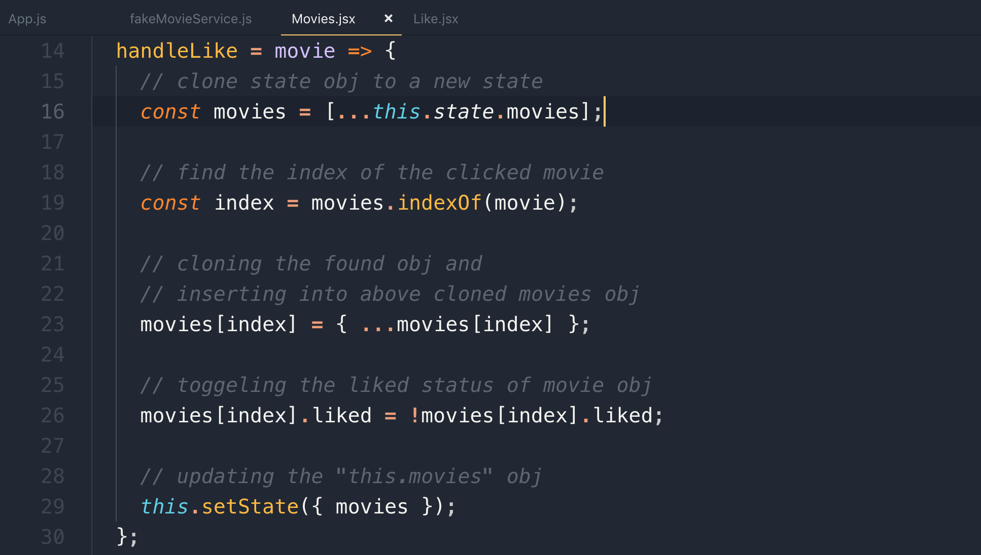

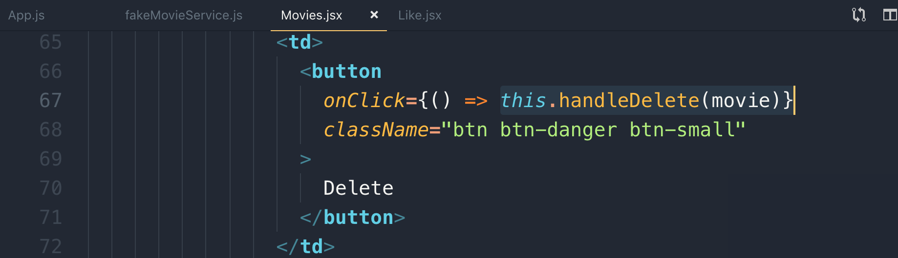

65 Pagination, filtering, sorting

Whenever you want to use a reusable component, before implementing that, you should think about the interface of that component.

What are the inputs that the component is going to receive?

What are the events it’s going to raise?

Note: The best way to decide an interface of a component is to use it before implementing it.

The minimum required props for <Pagination> component are:

1. Total number of items
2. Page Size
3. onClick event = onPageChange

This is the interface of the pagination component

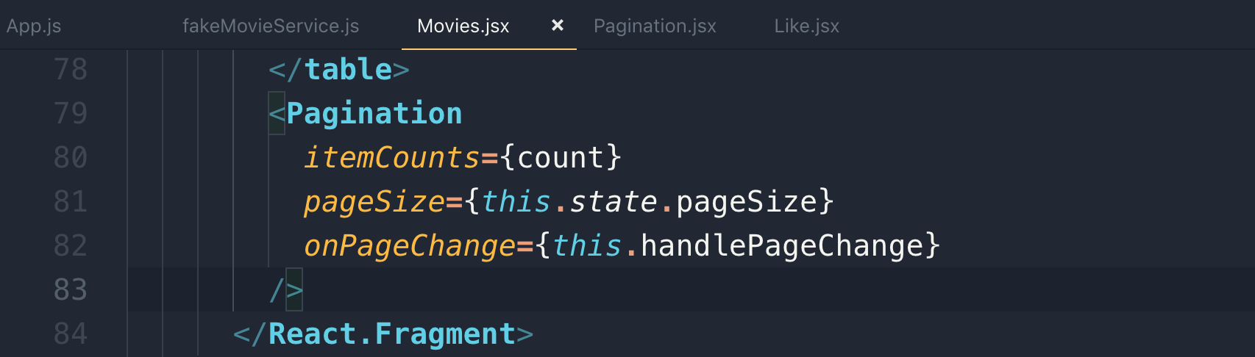

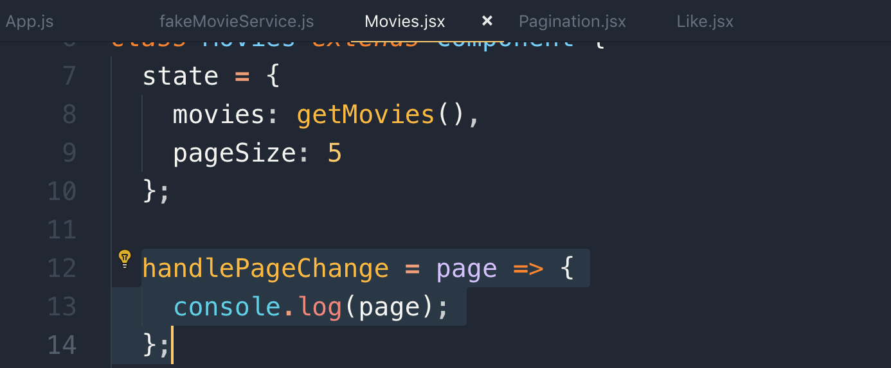

68 Displaying Pages

To render a pagination, we will use Bootstrap pagination

const pageCount = Math.ceil(itemCount / pageSize) // it will return the number of page, but to convert it into an array like [1,2,3], we will use lodash

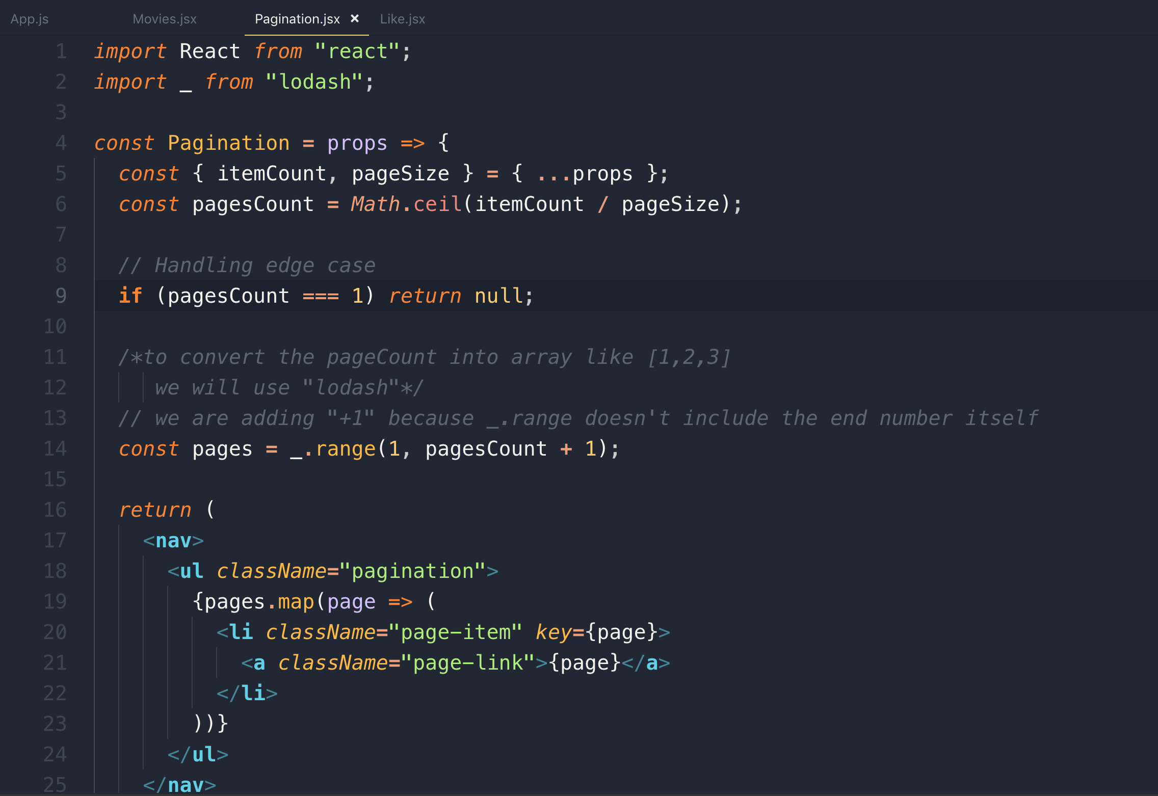

69 Handling Page changes

Let’s add the onPageChange(page) to Pagination.jsx

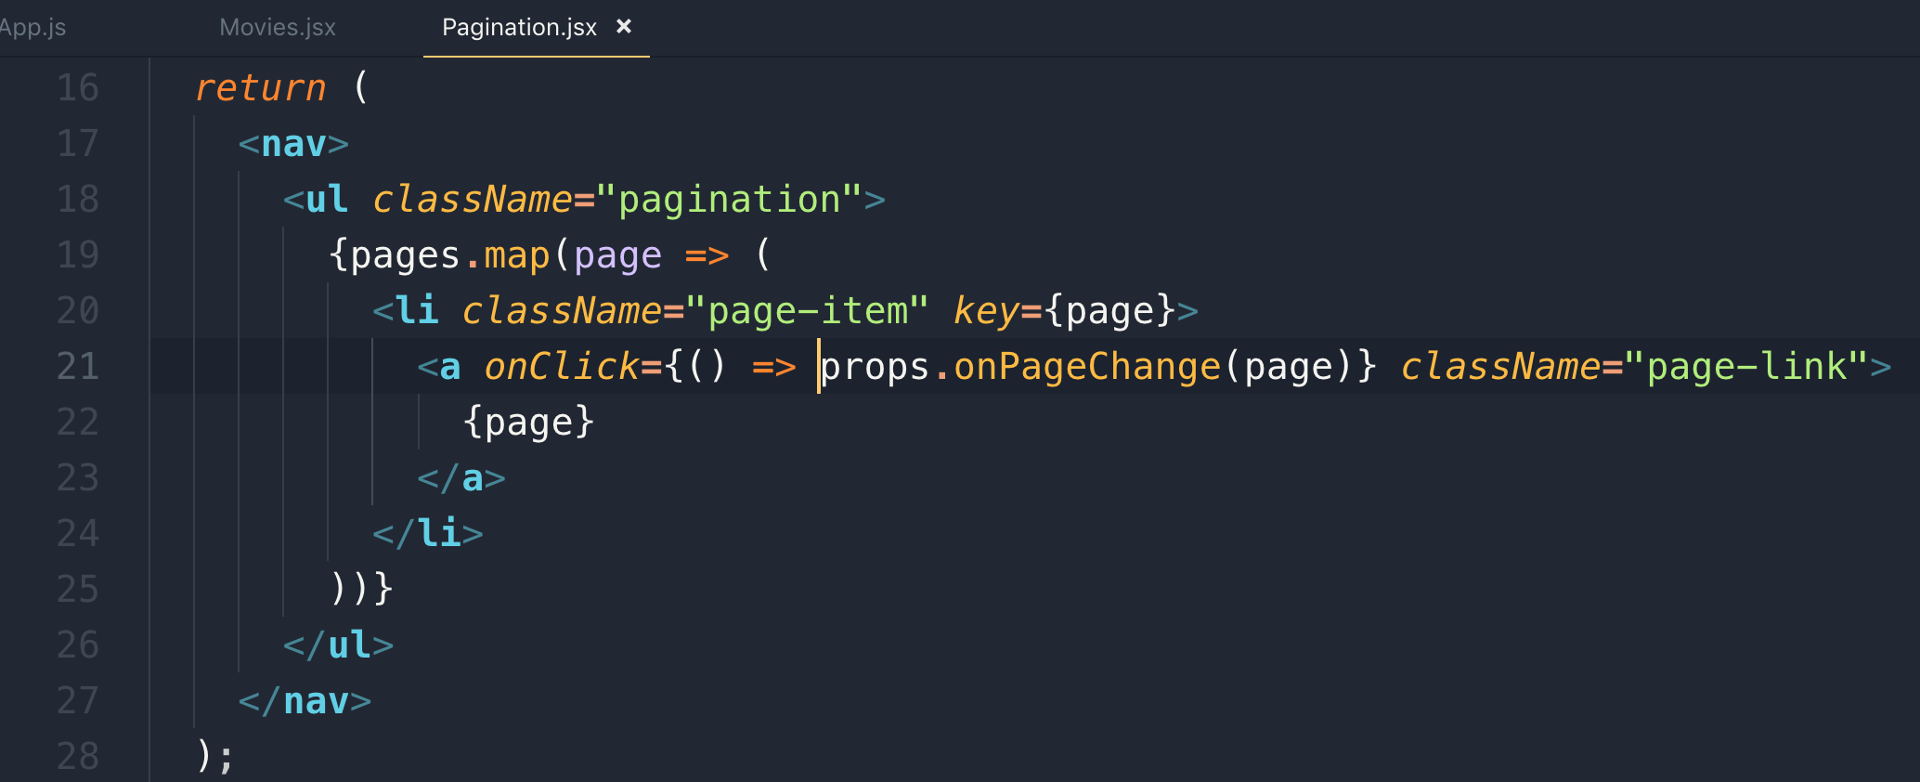

We can even de-structure “onPageChange” in the above code like this.

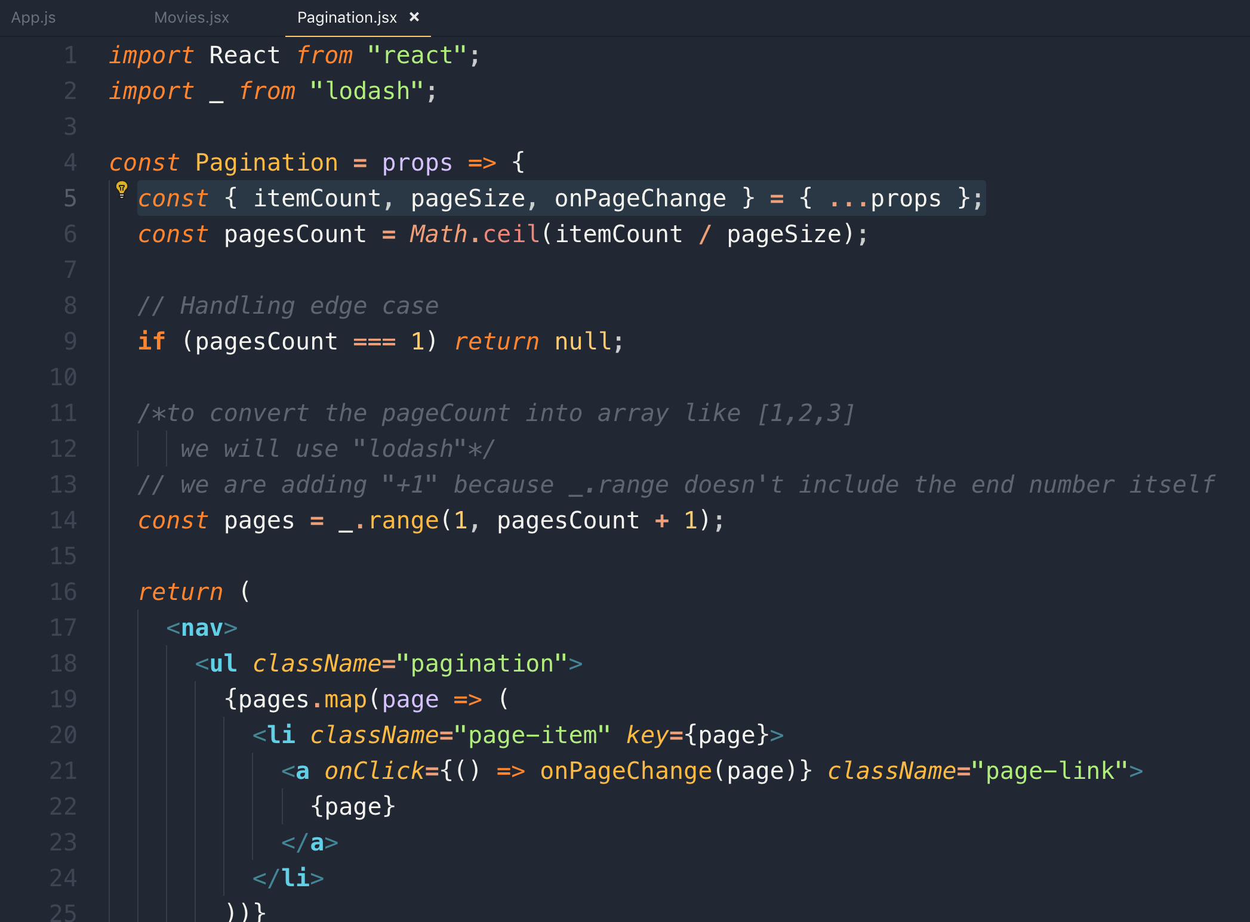

Now let’s highlight the current page. To do this we need to add active to the Pagination.jsx conditionally like this

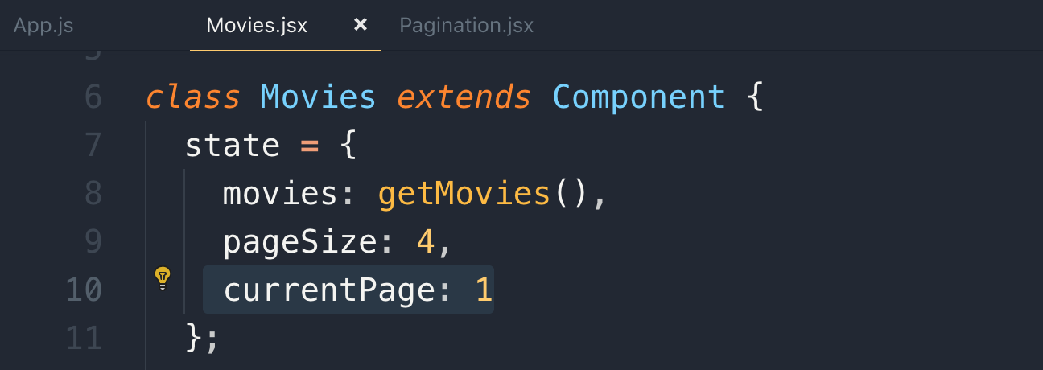

De-structuring

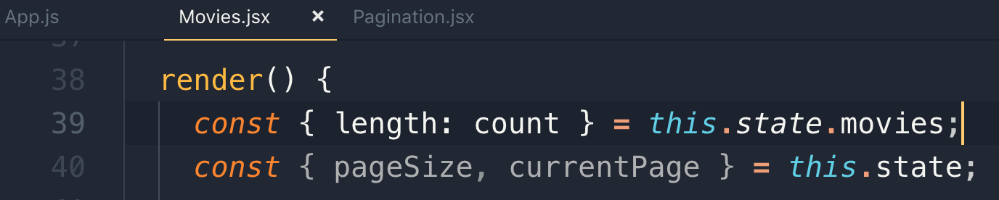

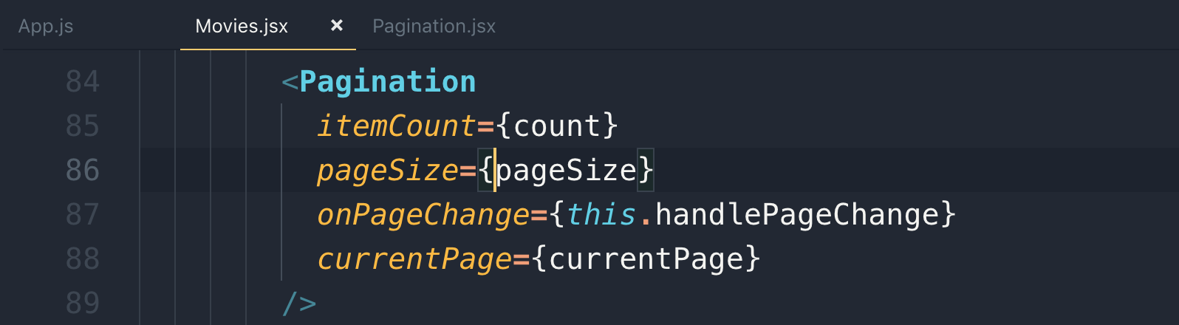

To get to a function in the same file here is a shortcut

MAC : command + p and then @functionaName

Windows : ctrl + p and then @functionaName

Updating current page with clicked page

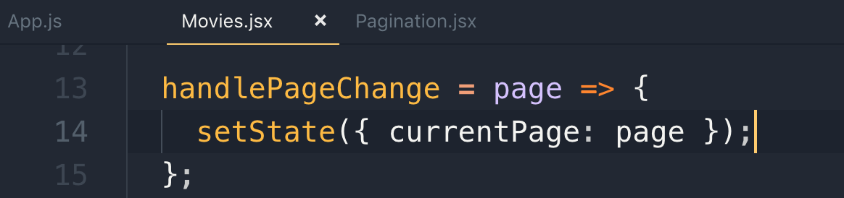

Making current page as active and highlighted

We are passing {itemCount, pageSize, onPageChange, currentpage} from Movies.jsx and we are extracting in Pagination.jsx

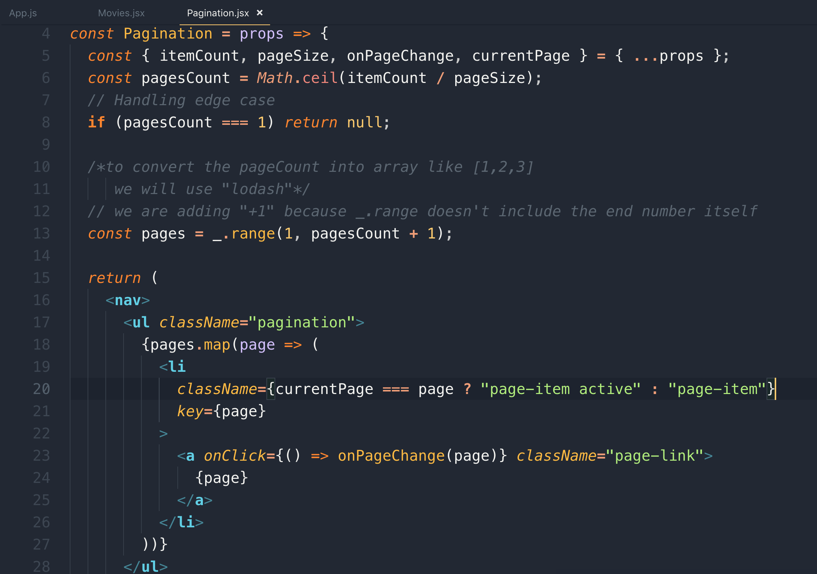

Once you click on the page, the page should re-render with the clicked page data. This is a utility functionaliy so we keep it in a util folder as a helper function so we can re-use it.

src/utils/paginate.js

to paginate, these are the parameters we need,

items, pageNumber, pageSize

To paginate the data first we need to calculate the starting index of the items of the “clicked page”

Here is a formula!

const startIndex = (pageNumber - 1) * pageSize;

Now go to this startIndex and take all the items for the current page

Note: To call all the lodash methods in chain, first we need to wrap it into lodash wrapper

value() : value method is to convert the object into array

This is the way we paginate data on the client side

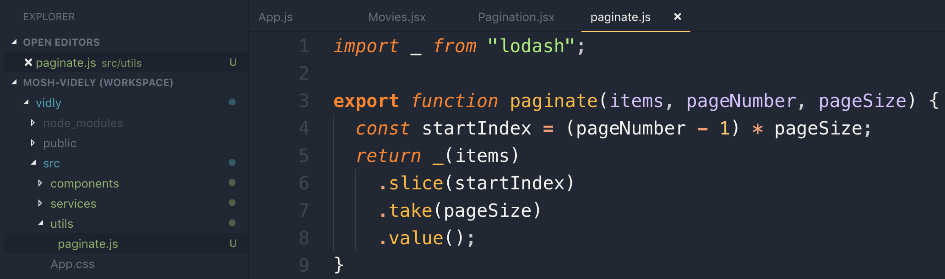

Let’s use the paginate util function

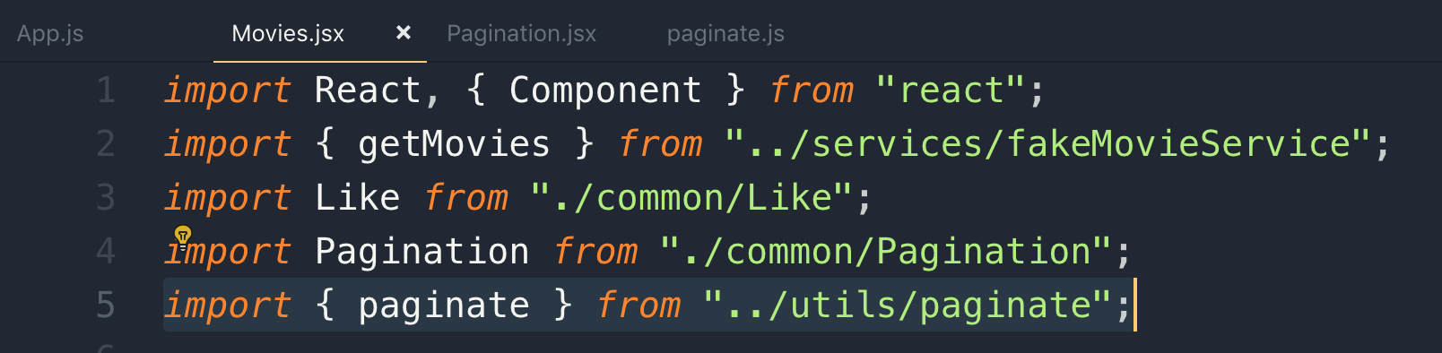

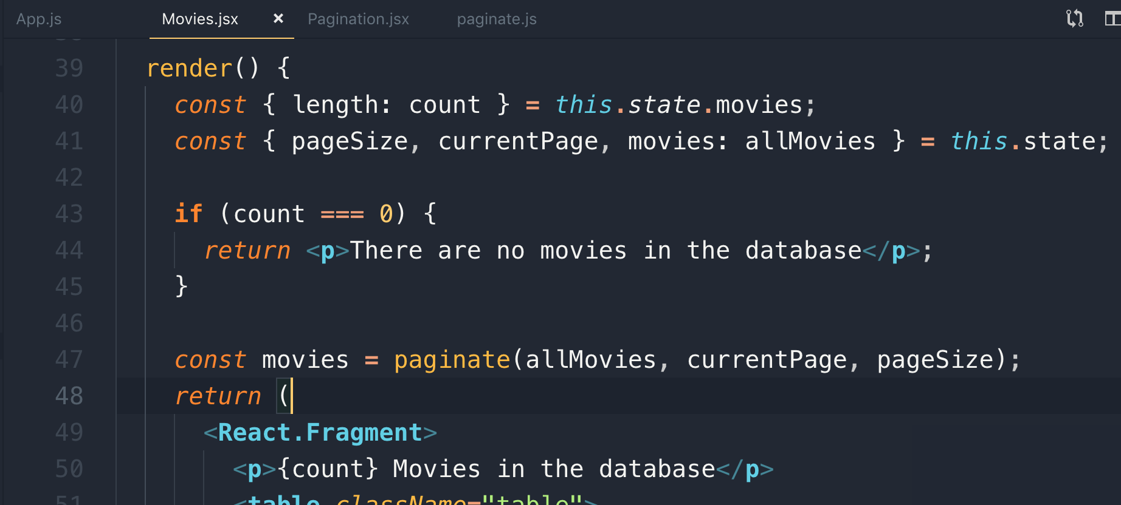

70 paginating data

The pagination is what we need to use in multiple places so keep it in a separate place like in utils folder.

In order to call lodash methods in a chain, we need to convert array into lodash wrapper

_(array) => this returns a lodash object and with this we can chain all the lodash methods with it.

console.log(

_(items)

.slice(startIndex)

.take(pageSize)

.value()

);

71 Type checking

We have an issue with <Pagination> component is that currently we are assuming that consumer of this component is going to pass the required props, but what if we forget to one of the props, or pass the invalid type of value.

What will happen if we pass “itemCounts” as string like “abc”.

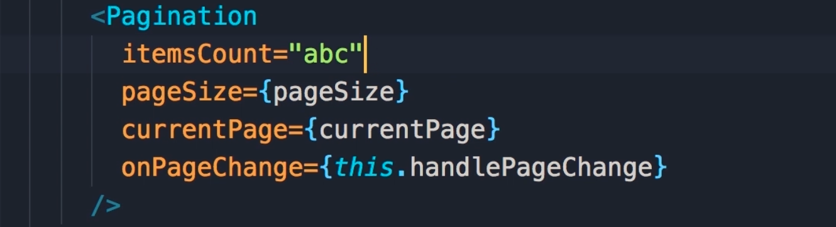

Note: passing abc as itemCount won’t throw any error and then it’s hard to debug

We get only a single page, but we have 9 movies

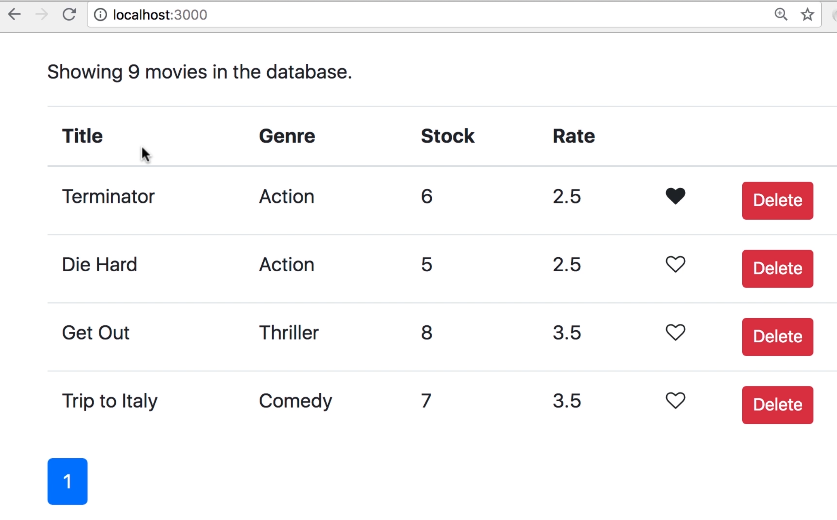

in the console, there is no error as well

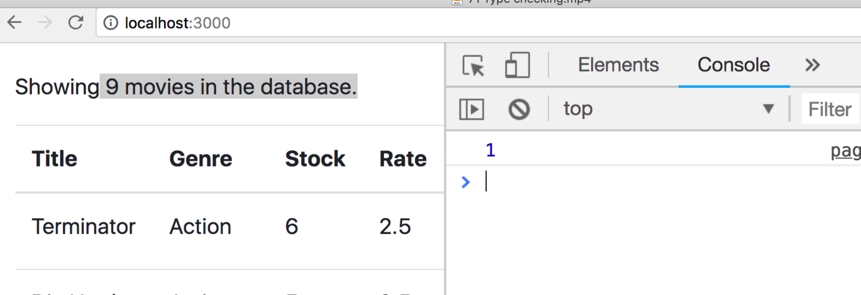

Note: React.PropTypes has moved into a different package since React v15.5. Please use the prop-types library instead.

Installing prop-types for checking type



This is the way we use propTypes

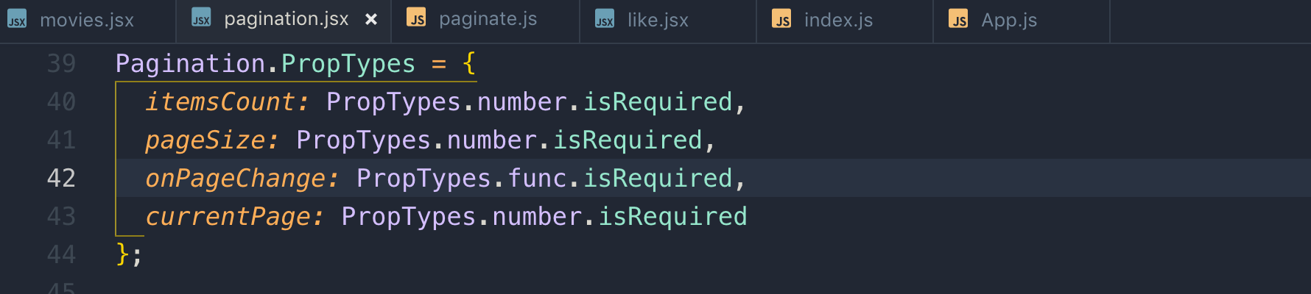

if we failed to pass required types then it will throw warnings. These warning will only popup in the development mode.

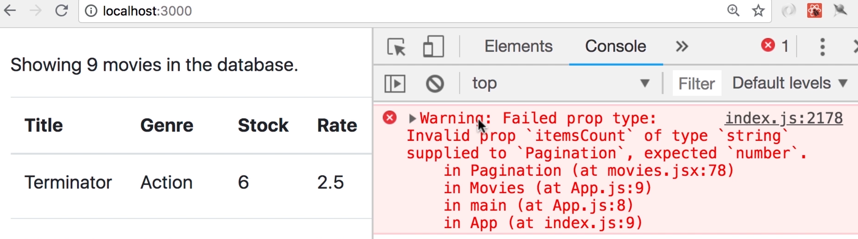

so if you use reusable component, it’s a good practice to use propTypes to catch bugs related to type checking

72 Exercise

We will use bootstrap list-group

73 Exercise

Note: whenever you are creating a component, you should think about the interface of that component and the best way is to use that component is to that before actually implementing that like this

src/common/listgroup.jsx

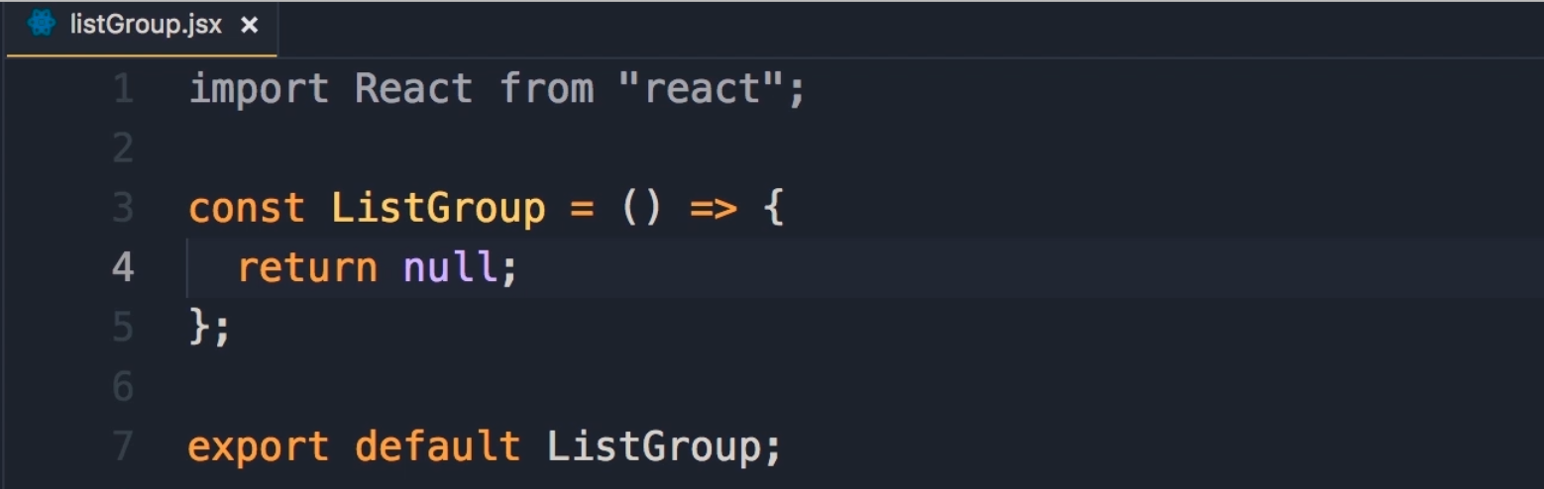

We need to divide the page into 2 sections, so we will use Bootstarp row with columns 2 like this.

Emmet shortcut to create 2 divs one with 2 columns and next to that is div which takes the rest of the columns

div.col-2+div.col

We initialized movies and genres with empty array as fetching data from the service will take time and it may throw run-time error.

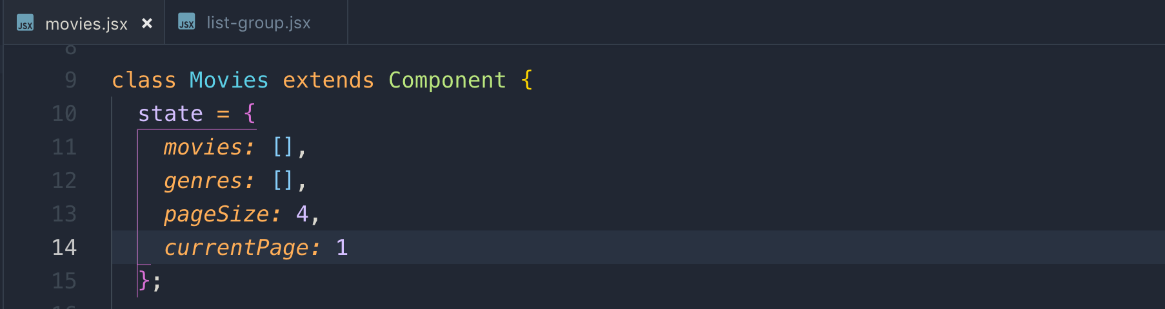

movies.jsx

this is the interface if this ListGroup component. Interface means, what data to be passed and what event should be raised.

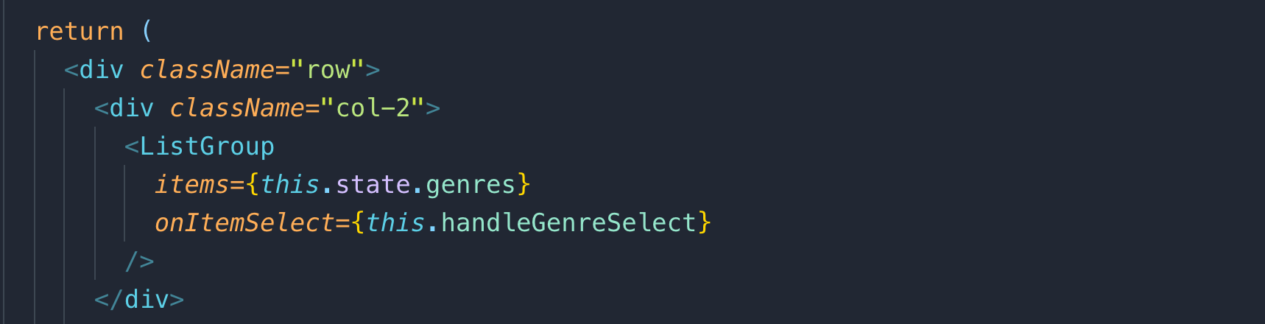

To initialize the data of movies and genres are now coming from API service and we used ComponentDidMount() lifecycle method to call API

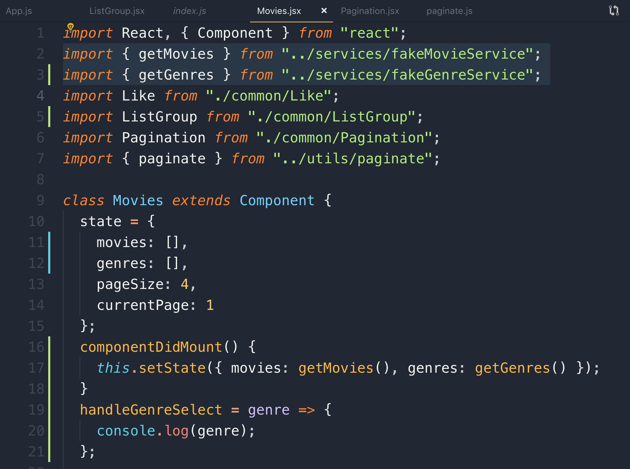

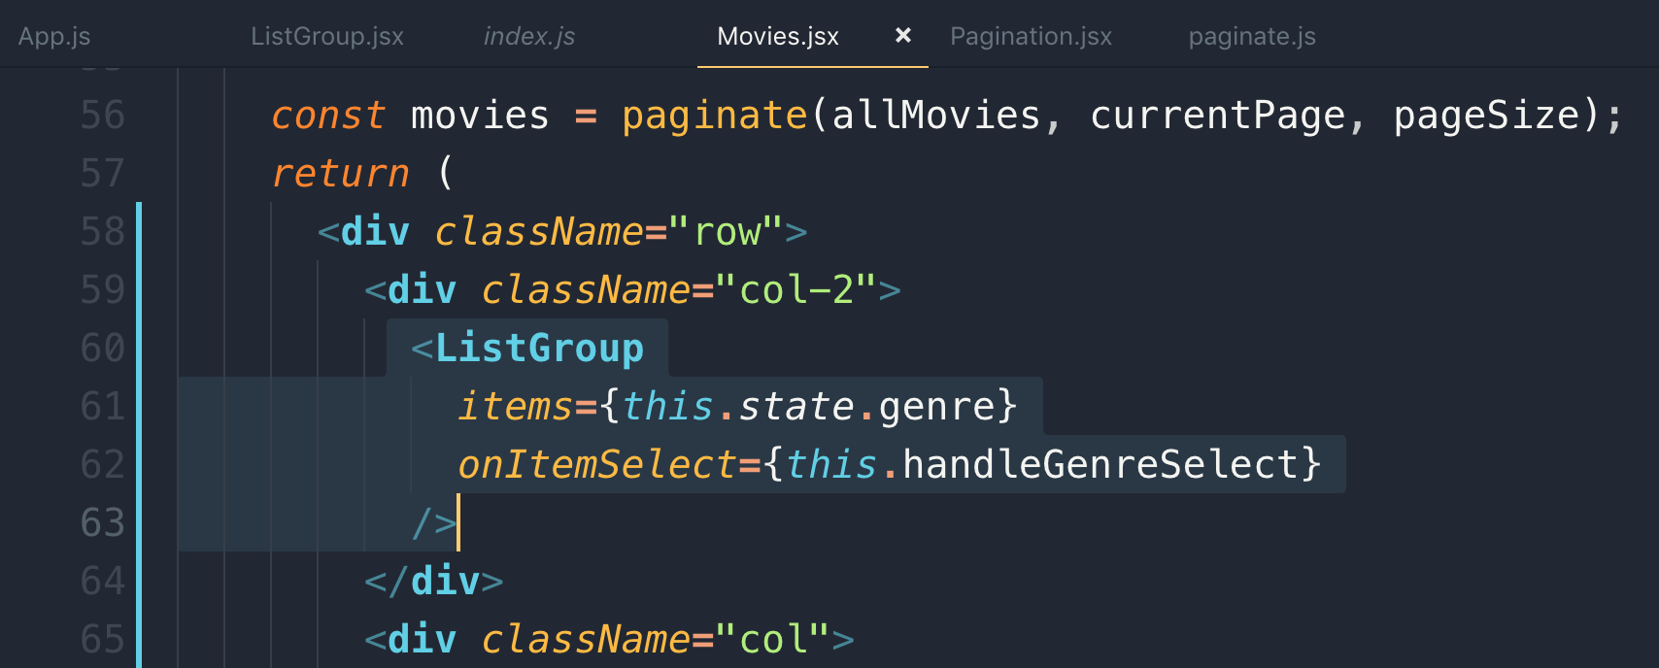

Above we have defined the interface of the <ListGroup> component

74 Displaying Items

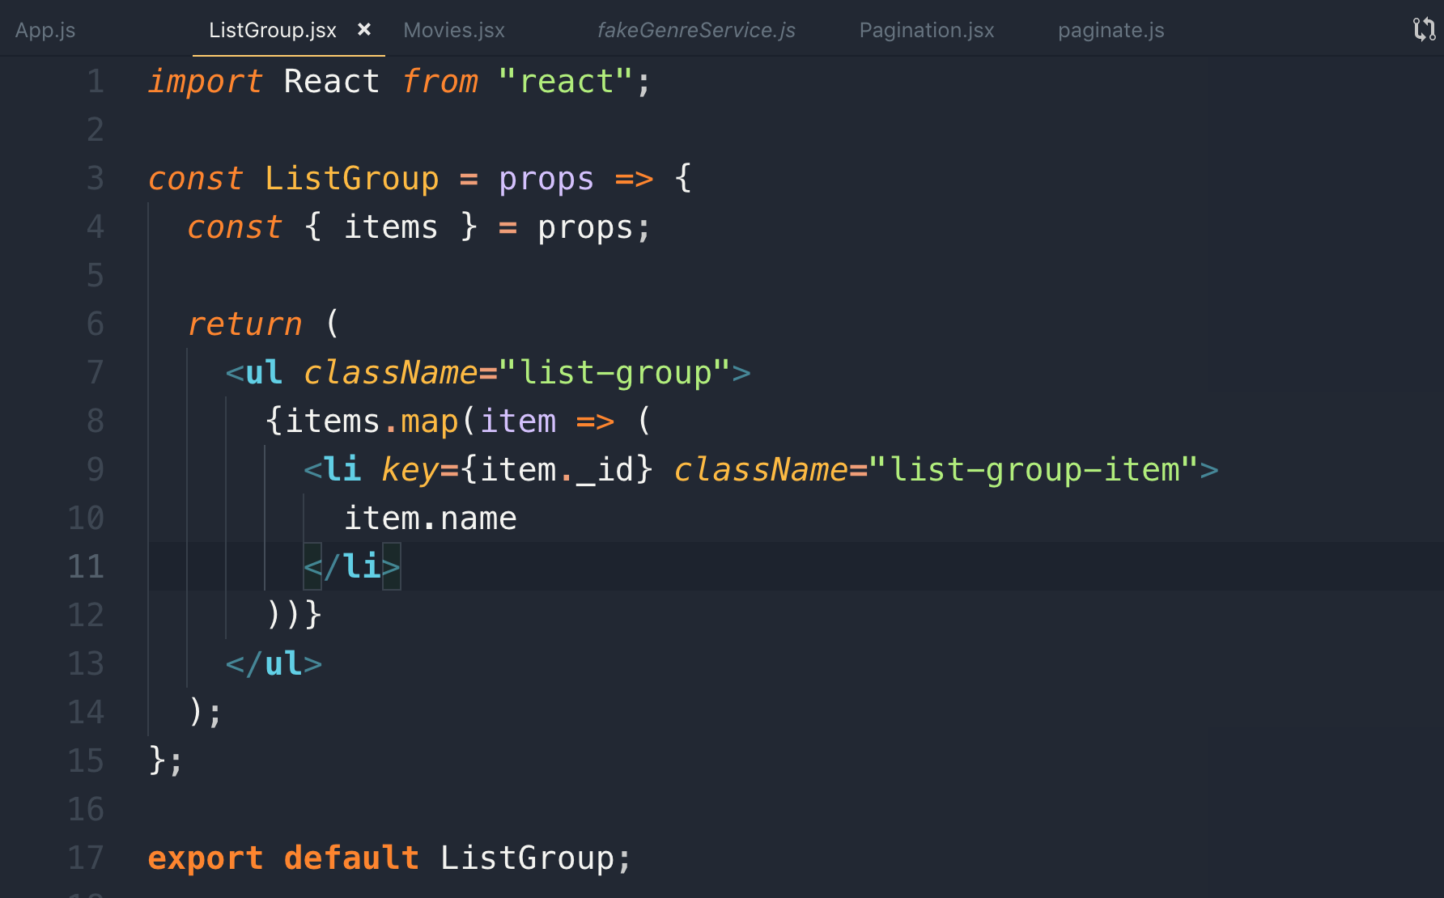

Above we have created independent <ListGroup> component, but there is an issue with this is that we have to always use “item.name”, but the data can be “item.value” .

To make the <ListGroup> component independent, we are passing some additional values as props

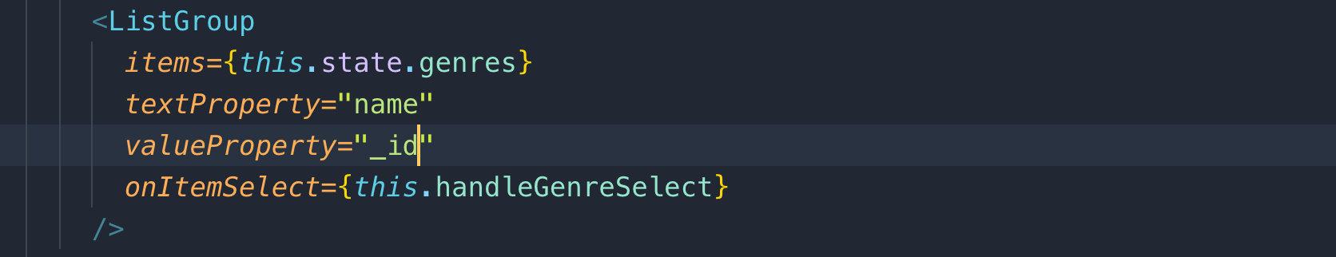

now the <ListGroup> component is independent, and we don’t need to remember the object property to display.

With this change, we are no longer couple to genres and we can reuse this list-group with any kind of list.

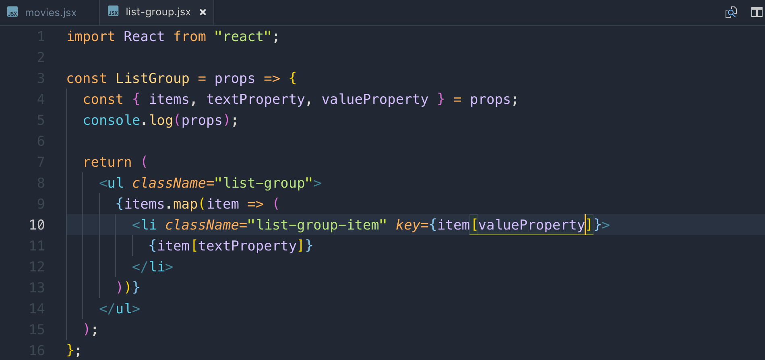

75 Default Props - filtering

Note: The fewer props to pass to a component, the easier it is to use that component.

Instead of passing props to a component like above, we can use default props.

if in the future, we are working with different object that doesn’t these 2 properties as set above, we can overwrite the default values.

Now by using default properties, we no longer need to pass these props. This simplifies list-group interface

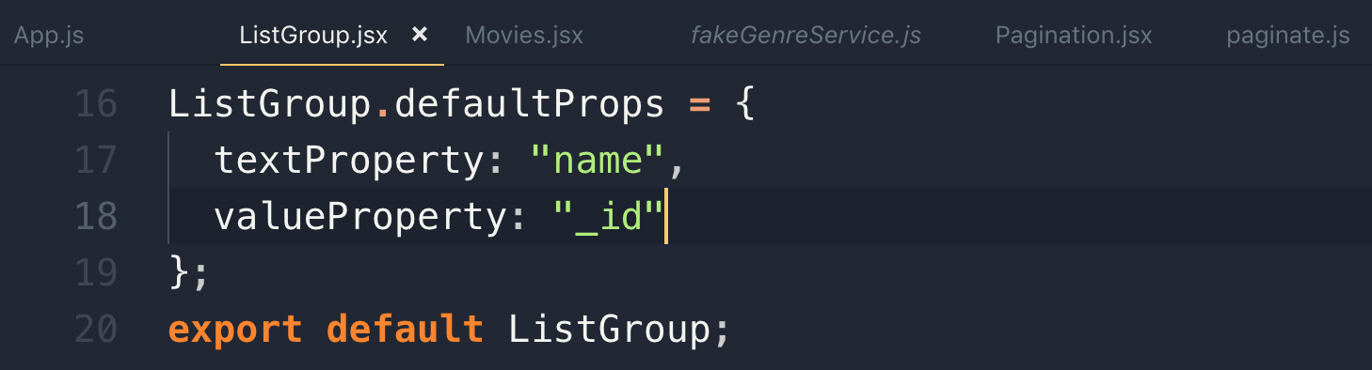

As we are passing the default props in the <ListGroup> component we can remove these props from <ListGroup> where we are consuming it like this

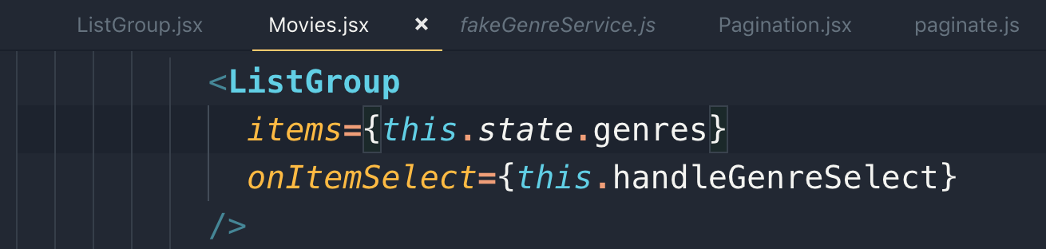

76 Filtering Handling selection

We need to add “onItemSelect” to <ListGroup> to raise an event to get the clicked genre and we also need to make it highlight using active class.

To get the clicked genre, we will store the clicked/selected genre we will store it into state in Movies.jsx

Note: You can set property without initializing it in the state object.

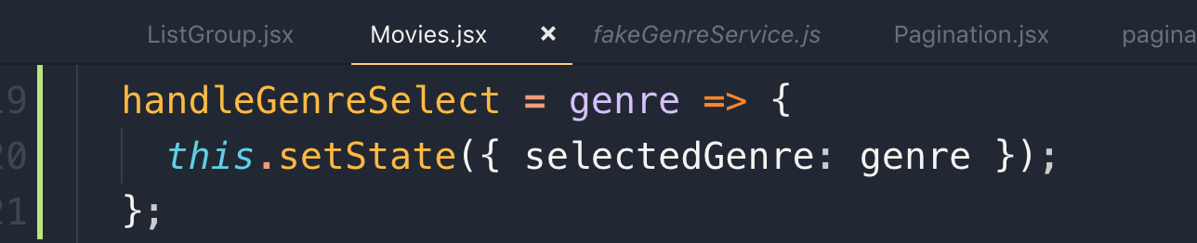

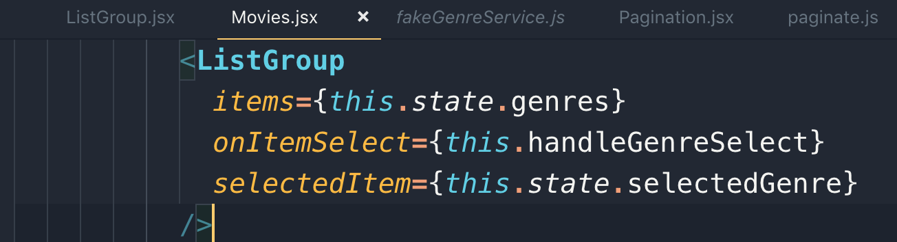

Note: always pay great attention to the naming convention. Mind naming convention used in the above <LIstGroup> component

“onItemSelect”

“selectedItem”

Note: This is how we can use conditional css class

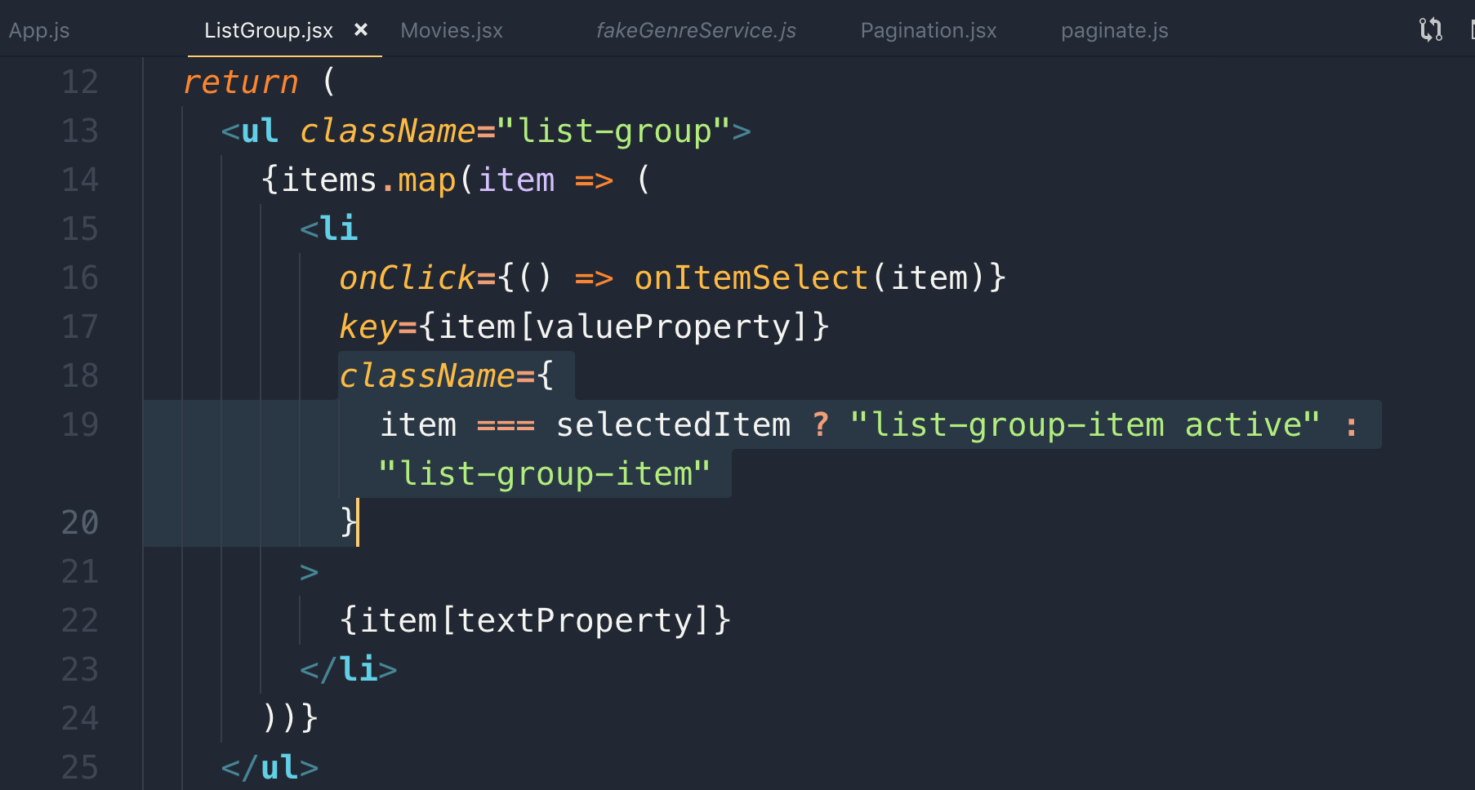

77 Implementing Filtering

We need to filter the Movie state object on the base of selected genre so before doing pagination, we will filter the Movie object

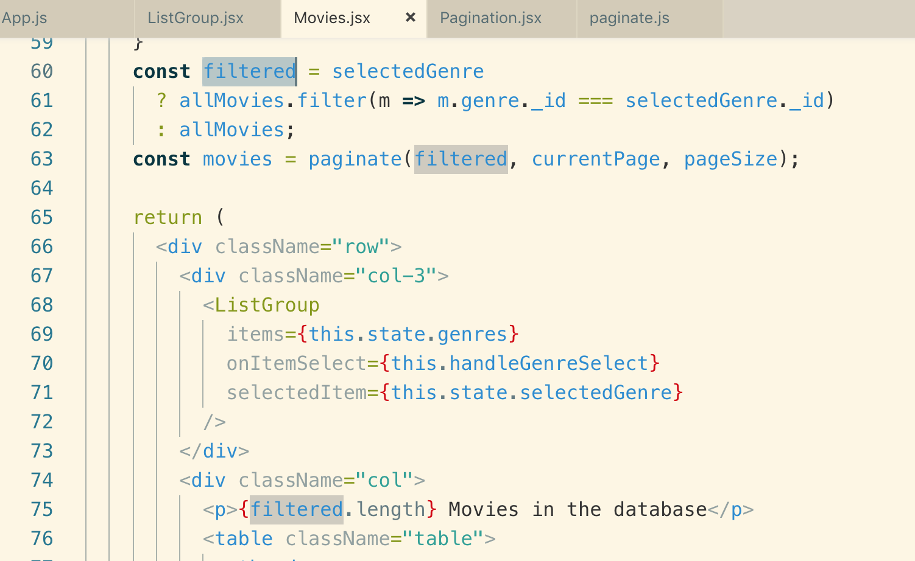

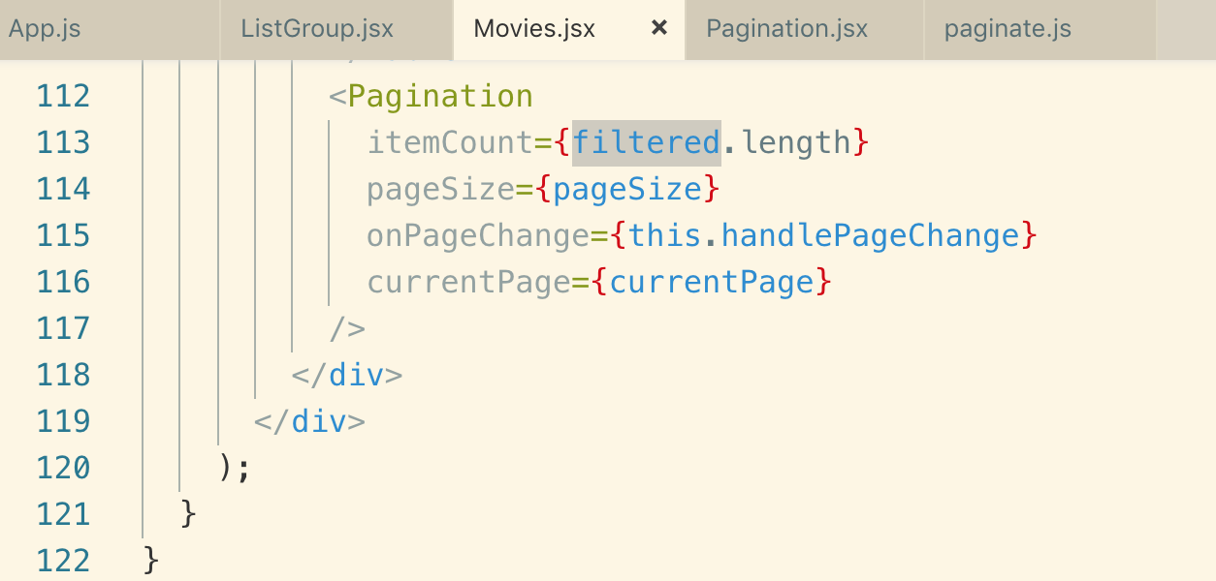

78 Adding All Genres

Note: Manually we are adding only “name key” in the genre object

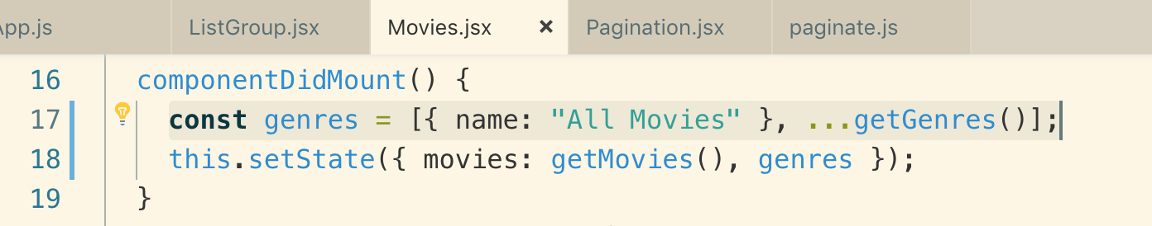

With the above logic, if the selected genre doesn’t have _.id key, it means all genre is selected and we need to show all the movies.

Note: we also need to reset the current page while selecting genre to make pagination work.

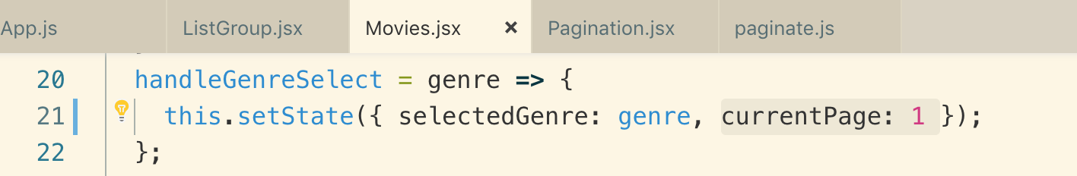

79 Extracting MovieTable

We just extracting the table into <MoviesTable> component

80 Raising The Sort Event

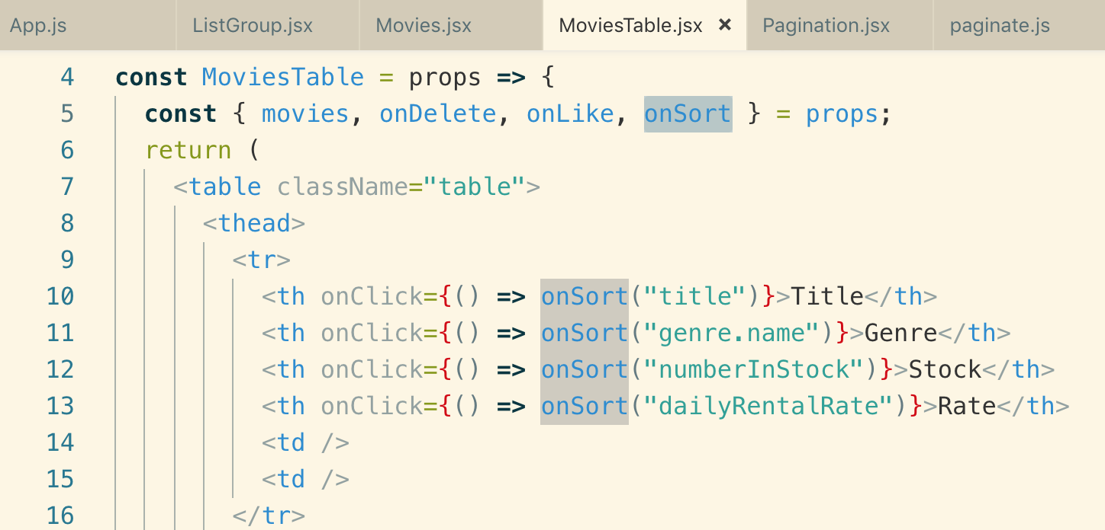

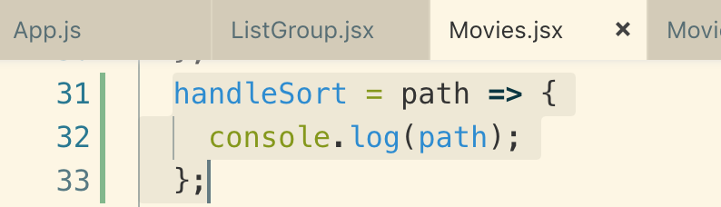

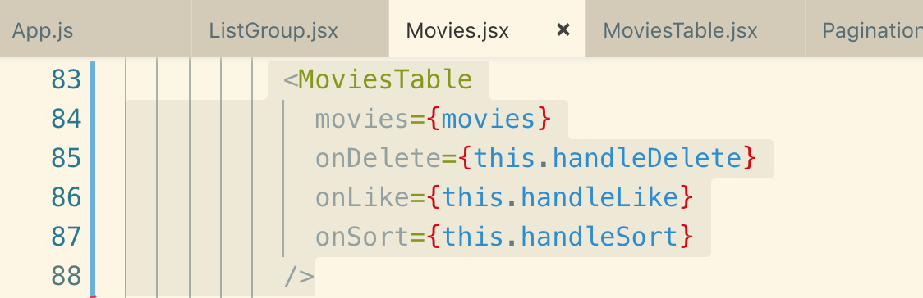

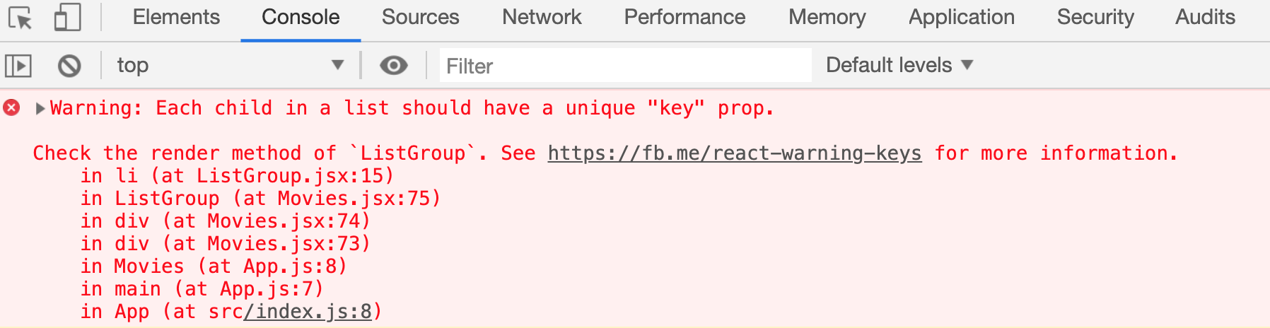

There is one issue that is we will get the above warning error because we need unique Id while rendering all movies, but we only added name earlier so to remove the key warning, we need to add blank id like this

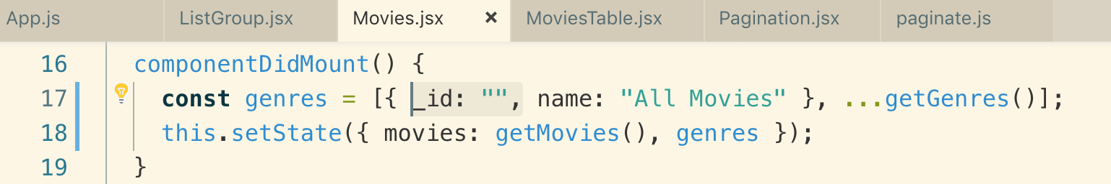

81 Implementing Sorting

The operation order that we follow for the data to display is:

1. filter data
2. sort data
3. pagination

We will initialize “sortColumn” in the state so when the page loads we know how we are sorting our movies

path = > column name

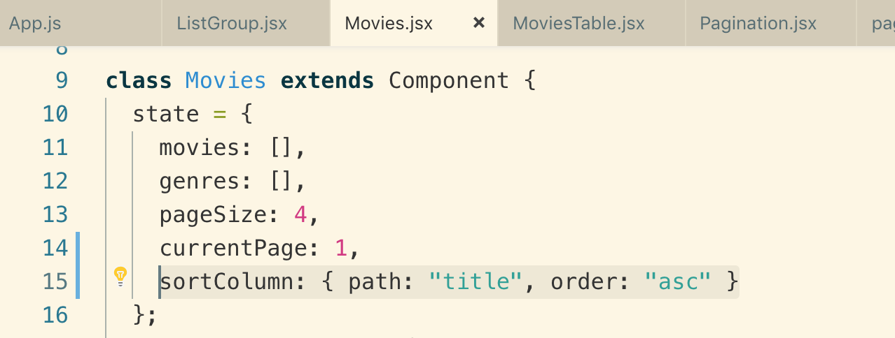

so on sorting, we will get the which column to sort and in which order so we update the state and the will re-render the page with given sorting order

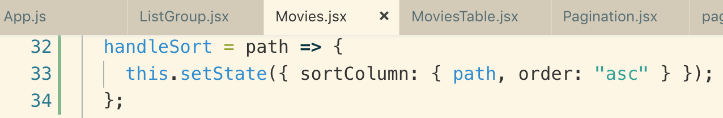

We will use “lodash”’ function to sort the data

Example:

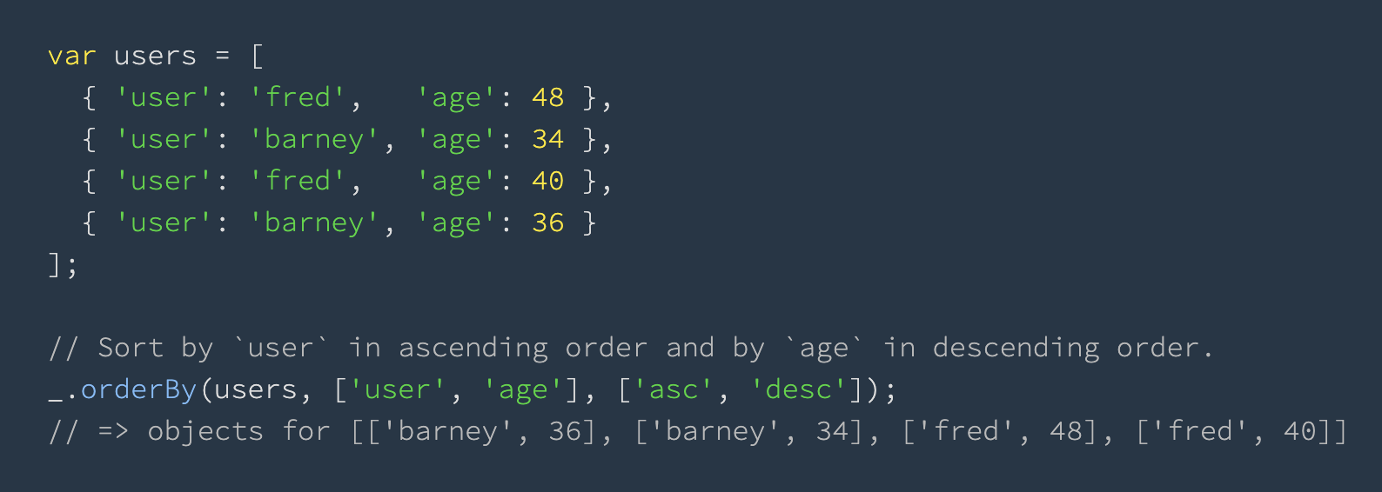

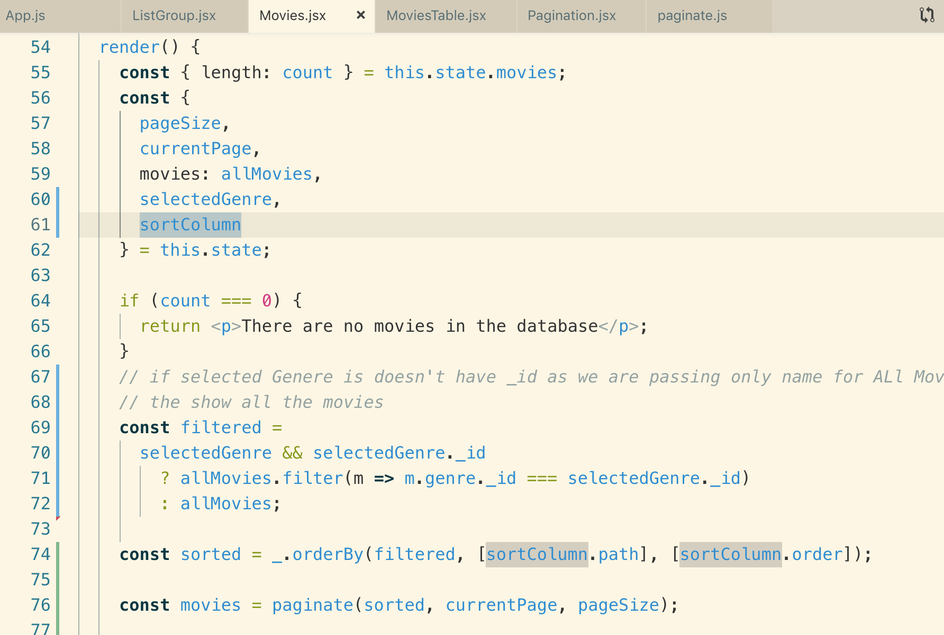

This is the way we handle reverse order

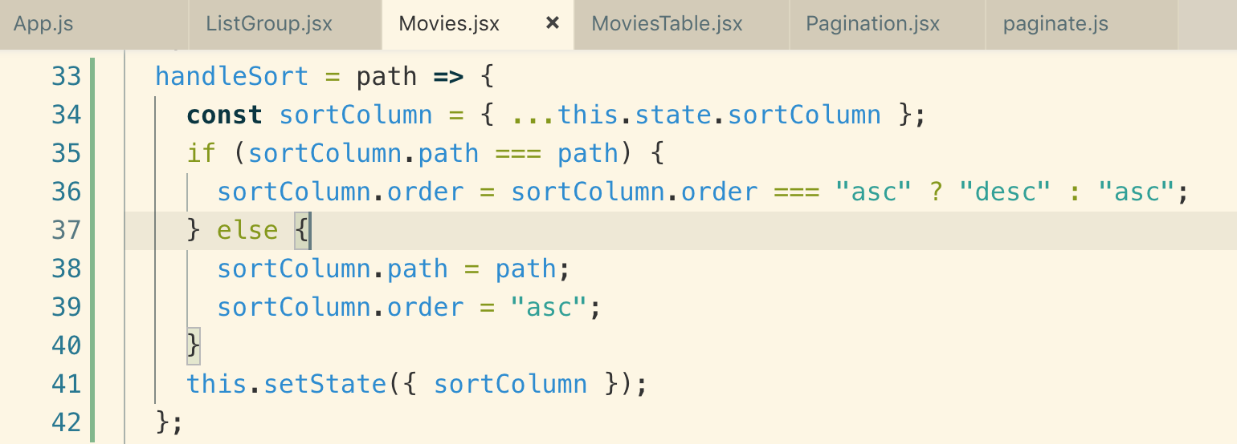

82 Moving The responsibility

if you reuse the <MoviesTable> and when this table raises an event you have to duplicate all the logic of

handleSort() function as it is in the <Movies>, but it belongs to <MoviesTable>

We are converting <MoviesTable> component into class component because we need to add a method in that class for determining the sort order.

We moved our sort method to <MoviesTable>

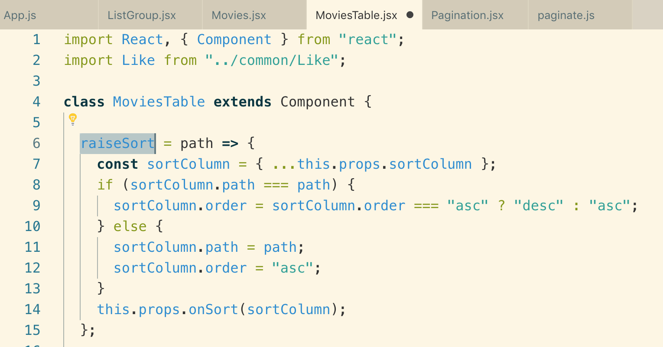

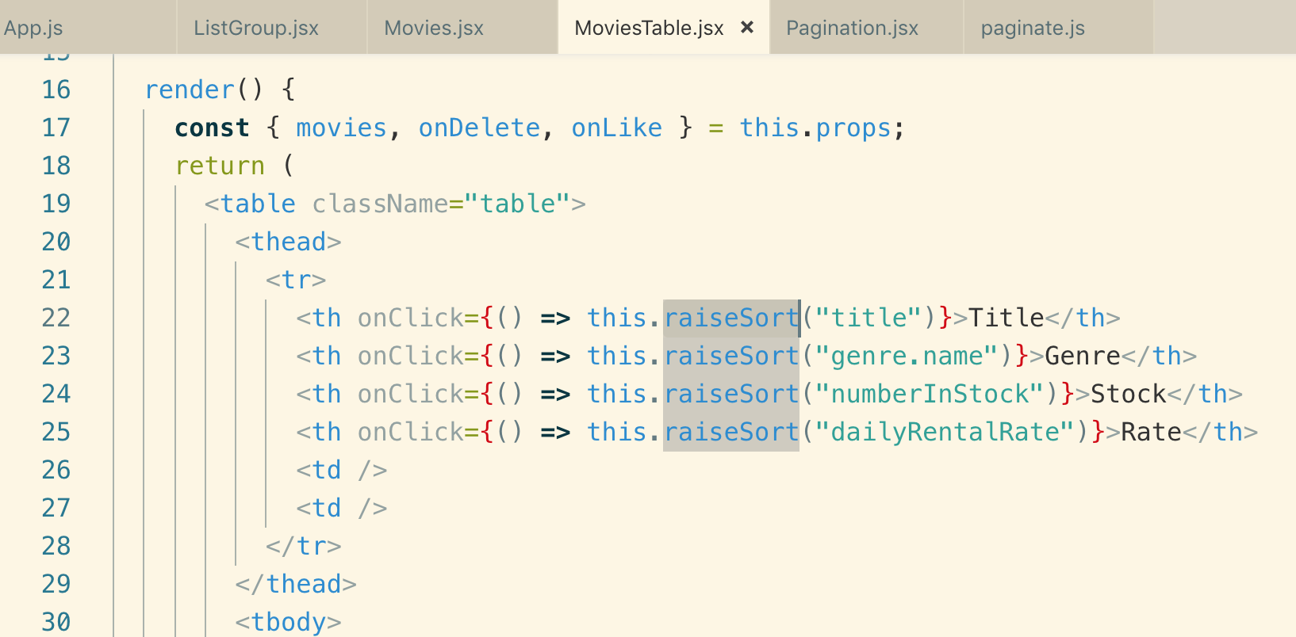

now on <Movies> component we will get the sortedColumn

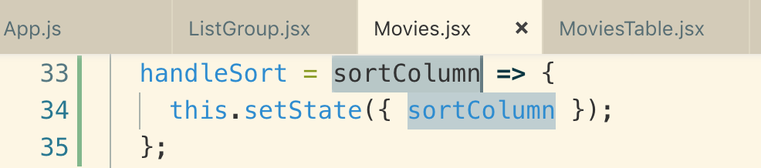

We also passed sortColumn to sort the list on the first load

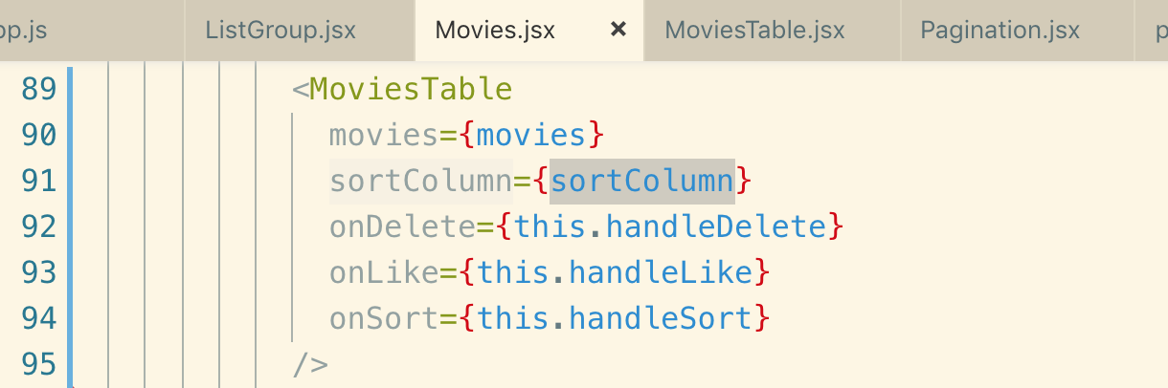

83 Extracting Table Header

if we need another <table> like customer table, we need to duplicate the below logic so we need to extract the <table> header

The interface of the <TableHeader> component is it should get columns as an array and onSort function and sortColumn which is an object

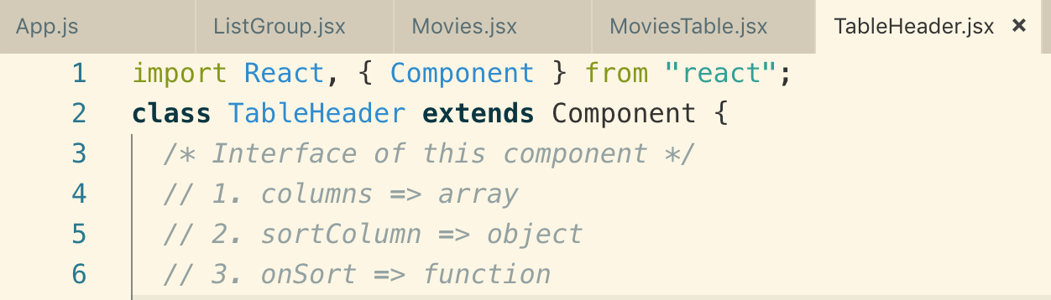

raiseSort => when we click on any column, it will sort column.

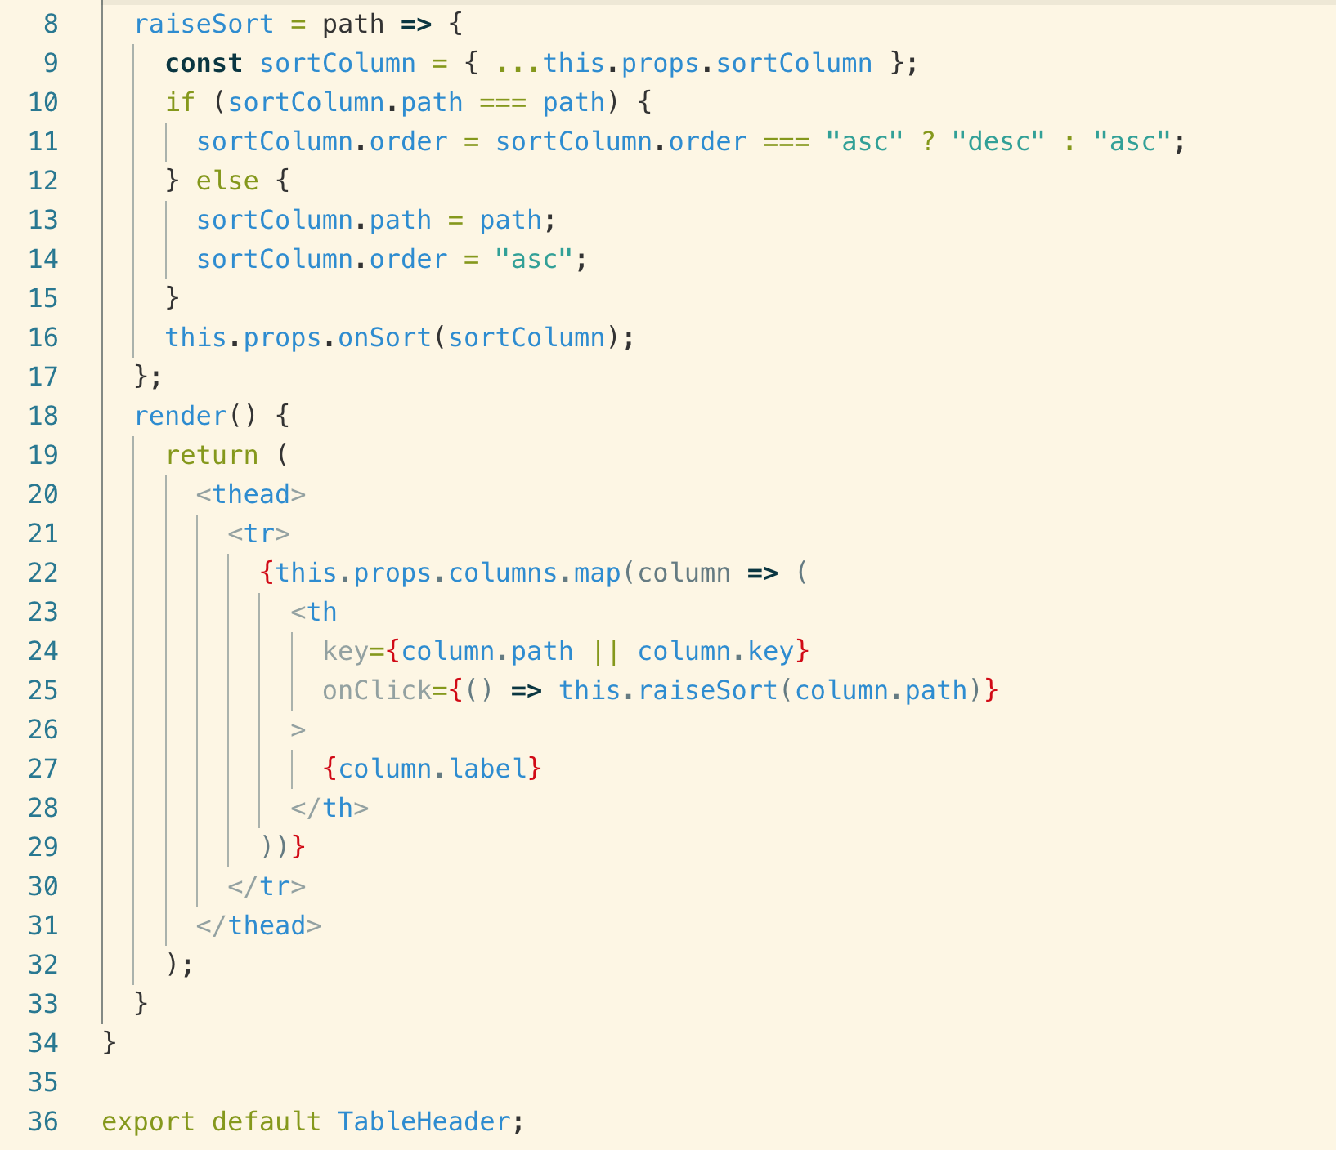

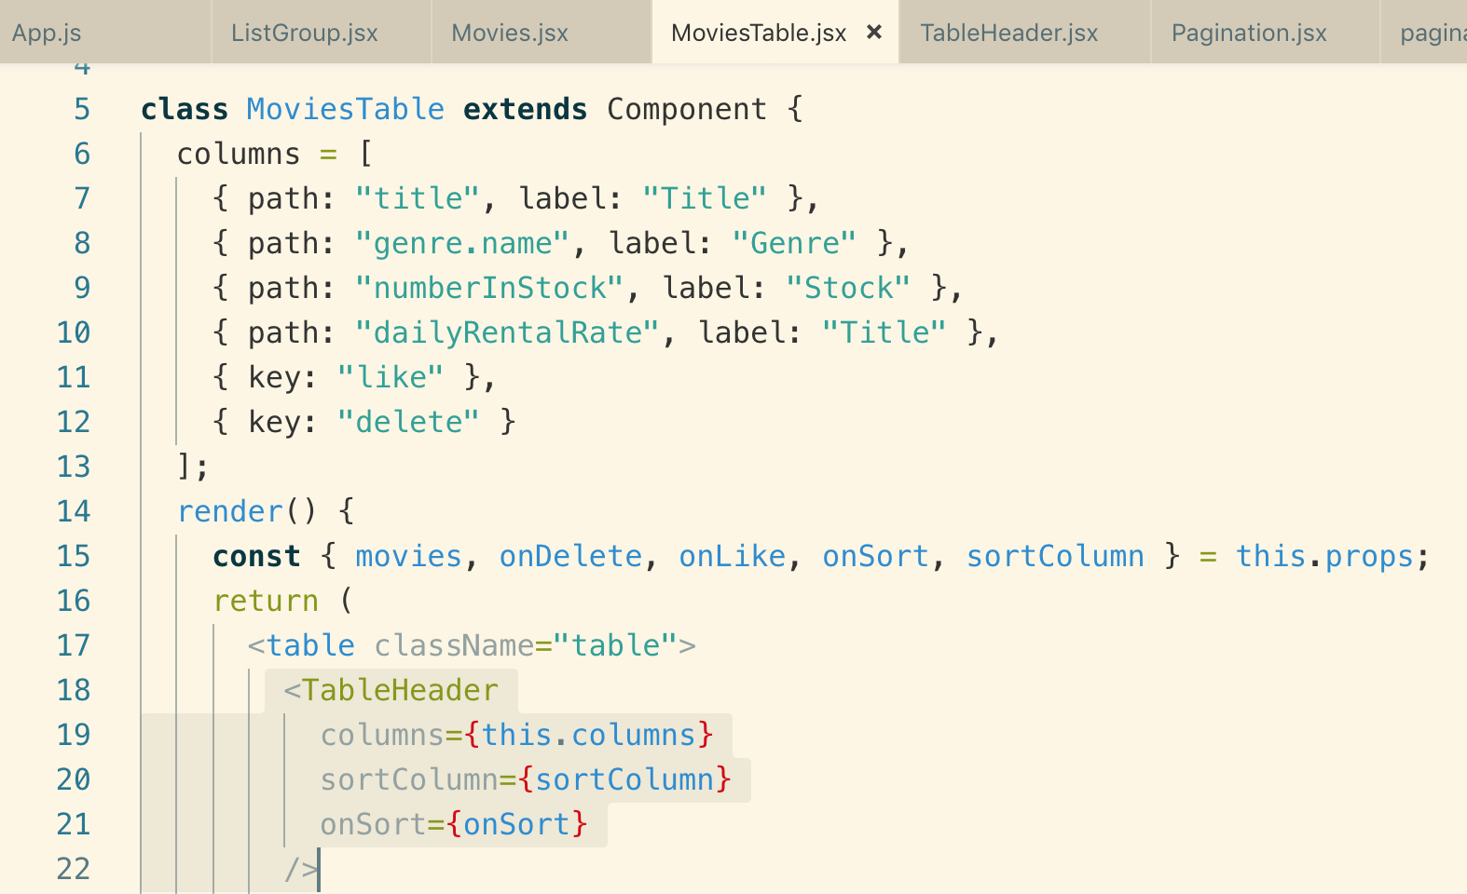

84 Extracting TableBody

As we have extracted <TableHeader>, we will extract <TableBody>

To remove the “mixed level of abstraction” the

Note: We pass the props as “data” because we want this component to decoupled from movies.

Thi is the way we used <TableBody>

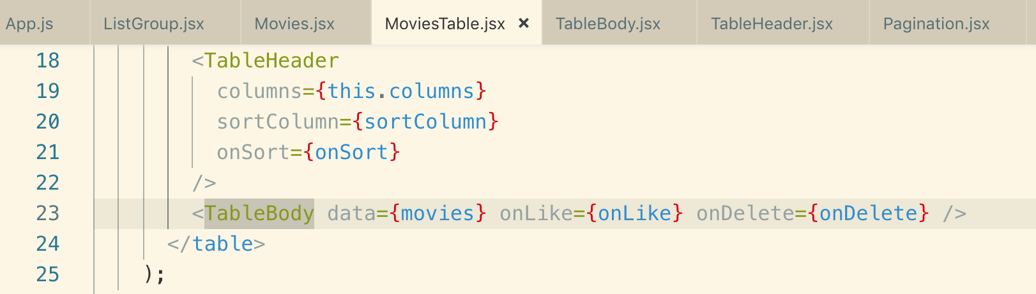

The entire code of the <TableBody> component

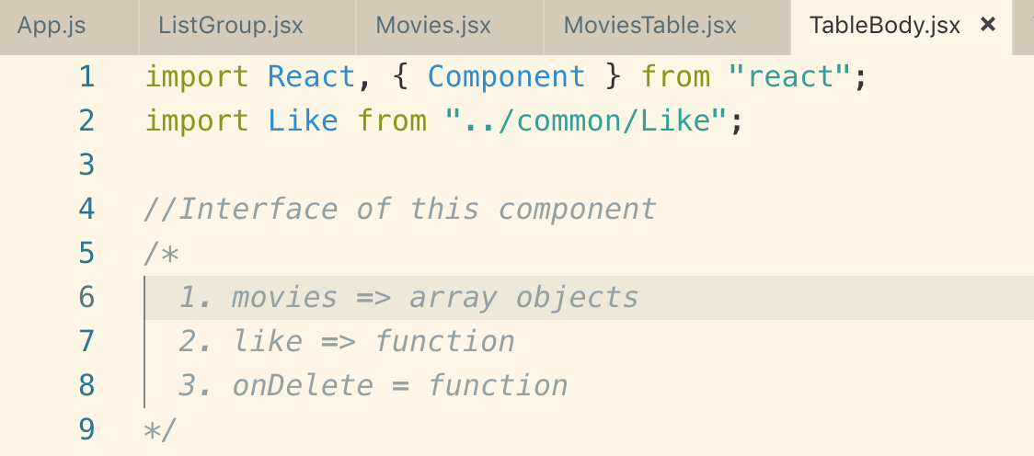

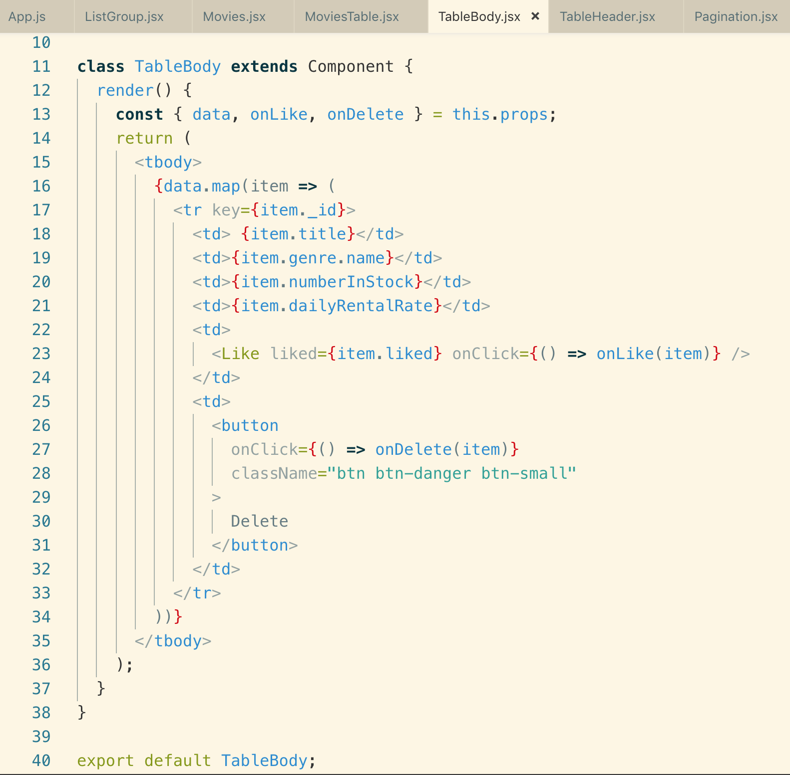

85 Rendering cell content

140 Creating Data

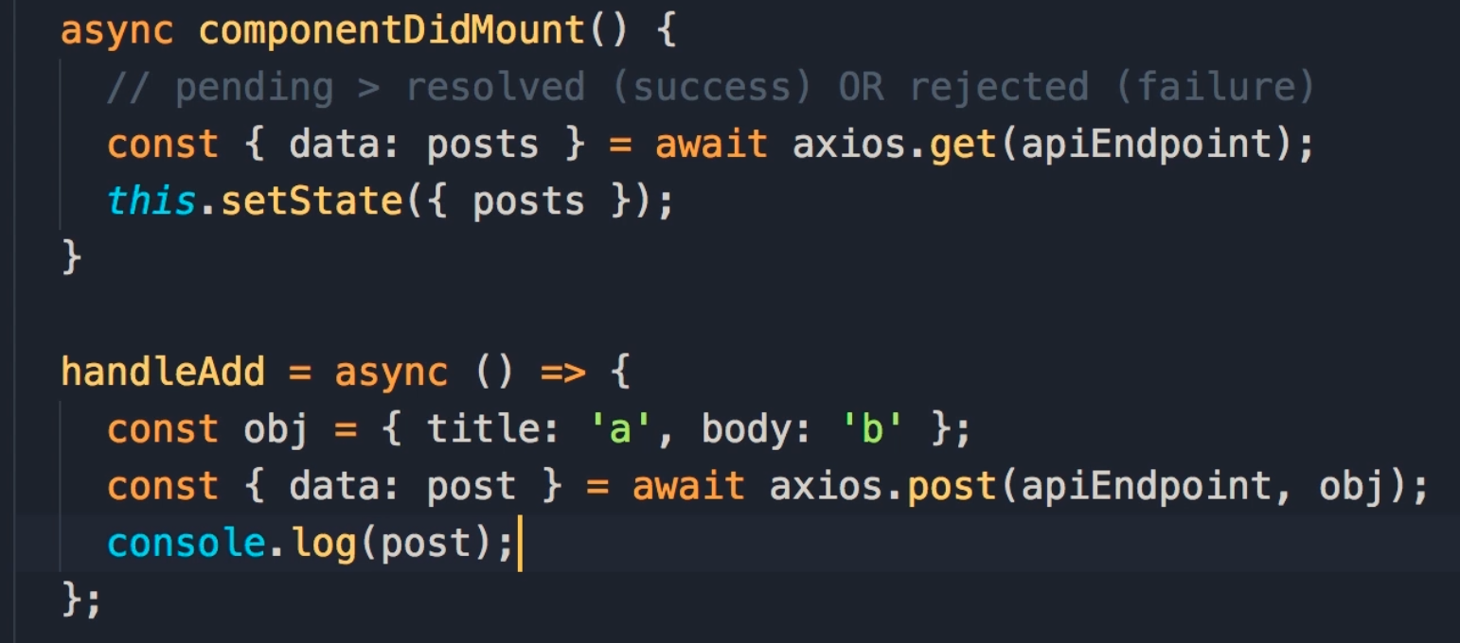

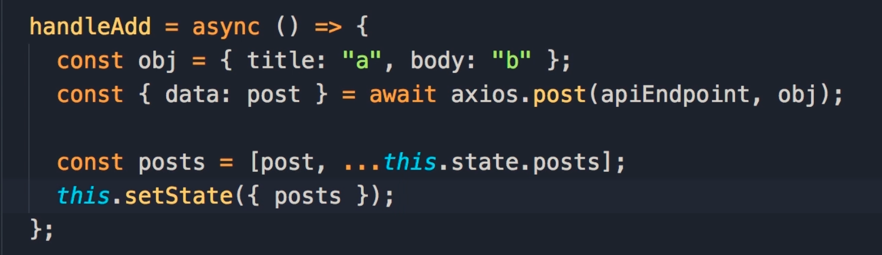

142 Lifecycle of a request

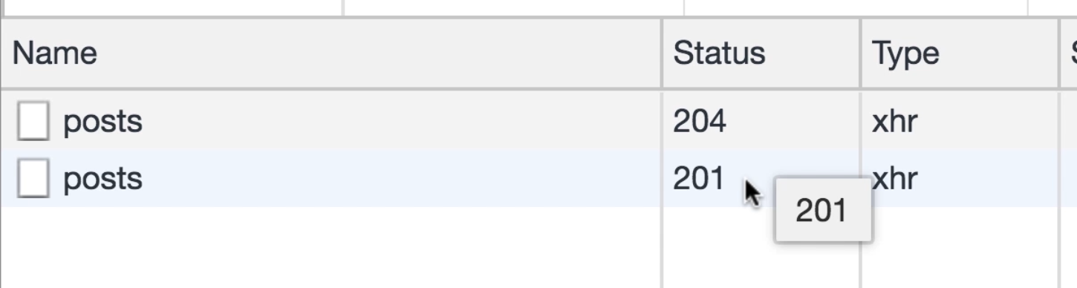

Request method to post is “OPTIONS”

The reason we have “OPTIONS” request here is that is because this application is hosted on localhost, but the backend is hosted somewhere else

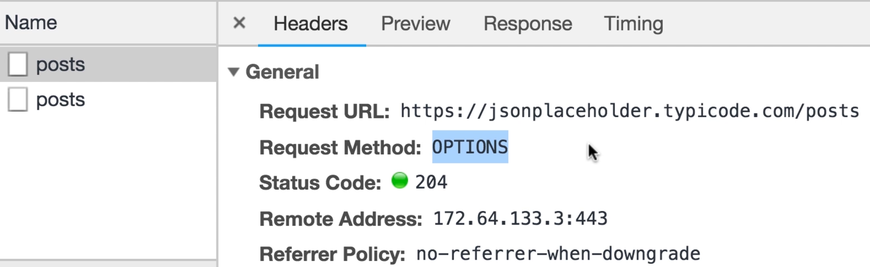

Localhost and jsonplaceholder are 2 separate domains so for security reasons whenever an application sends an Ajax request to different

domain, the browser always sends an “OPTIONS” request

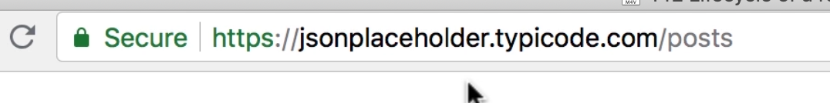

status : 201 => resource is created

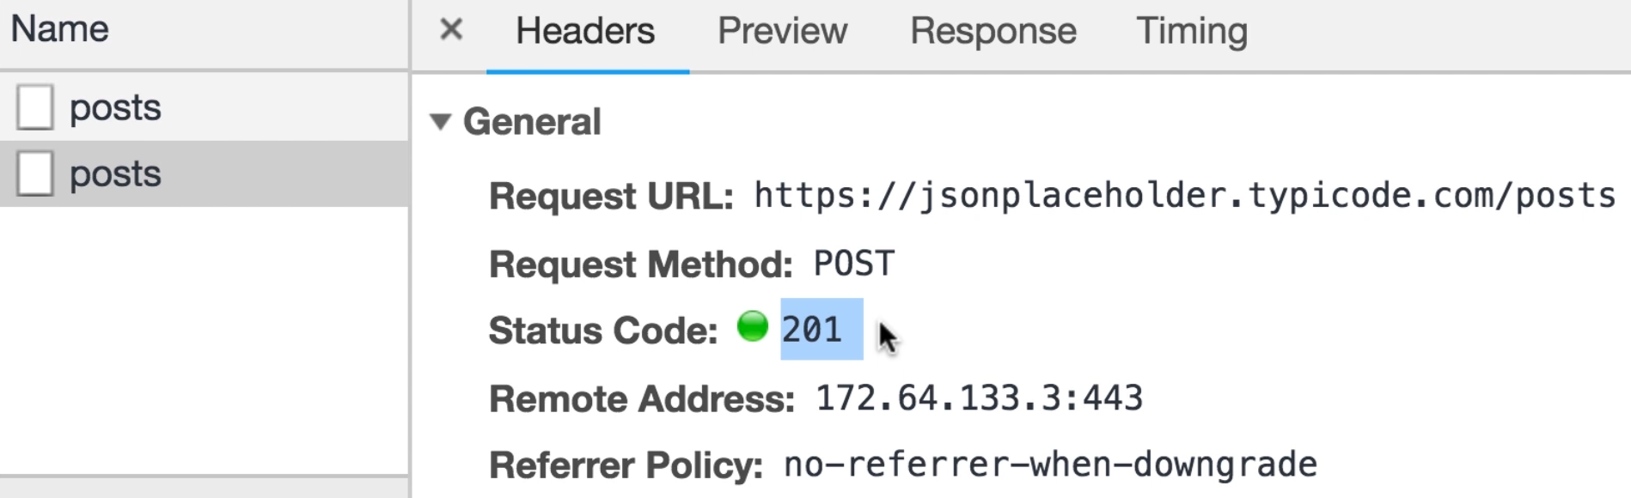

The object that we sent to the server

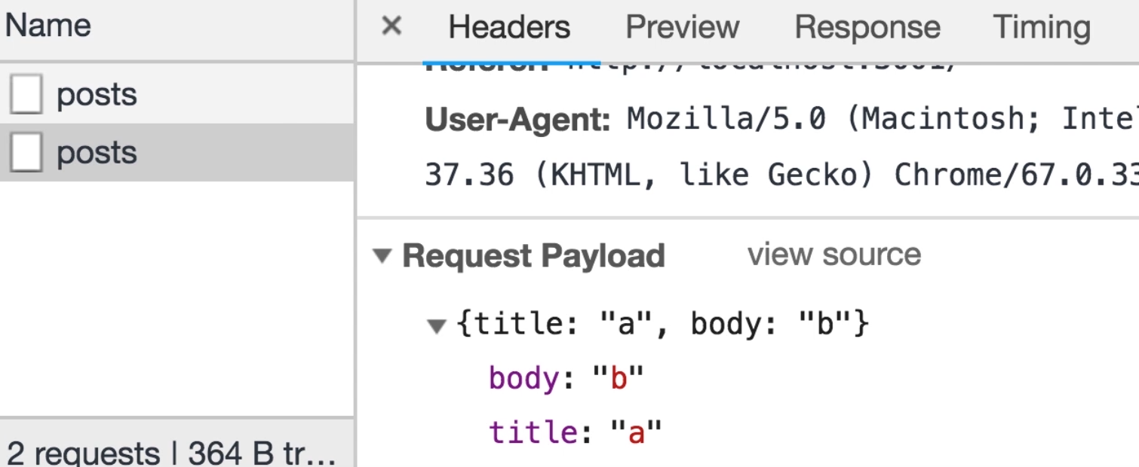

Axios wraps the below object in a “response obj” and this response object has data property and that we picked using object de-structuring

like this

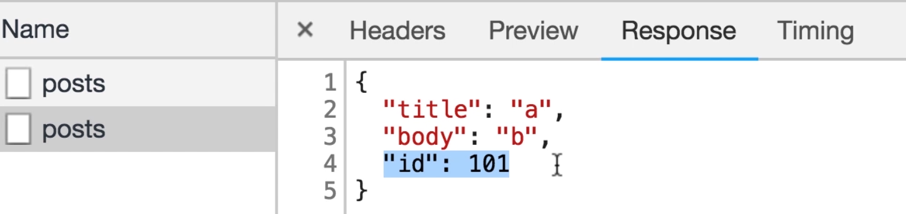

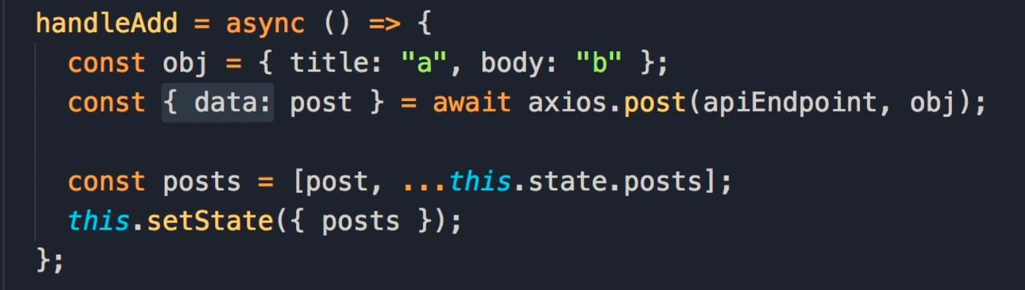

142 Updating Data

We have to 2 request methods to update the data

PUT and PATCH

PATCH => to update 1 or more properties

PUT => to update all properties

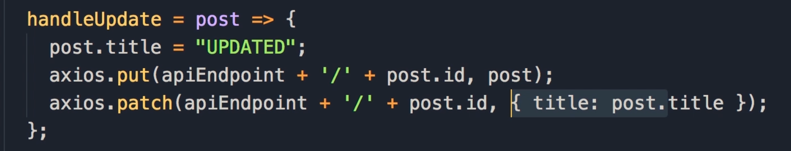

Let first use PUT request

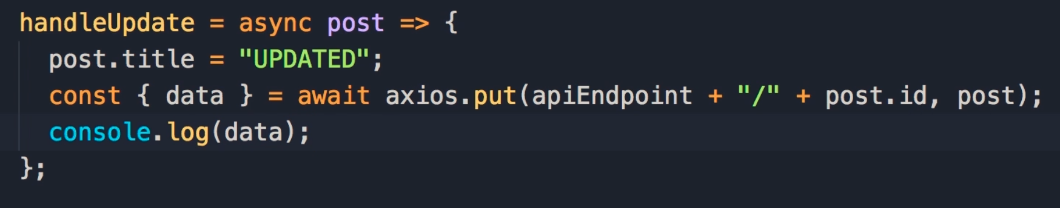

Response object

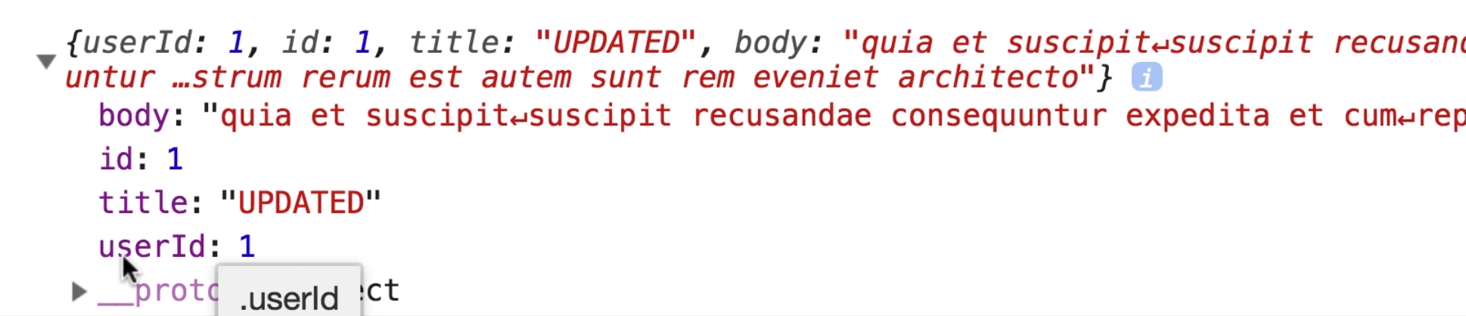

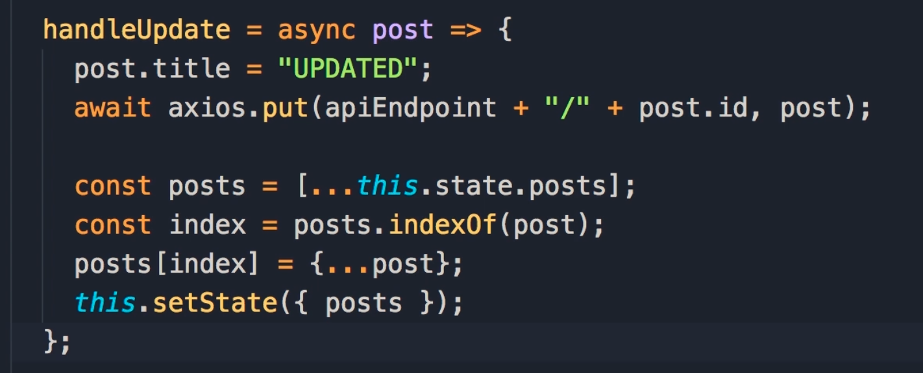

143 Deleting Data

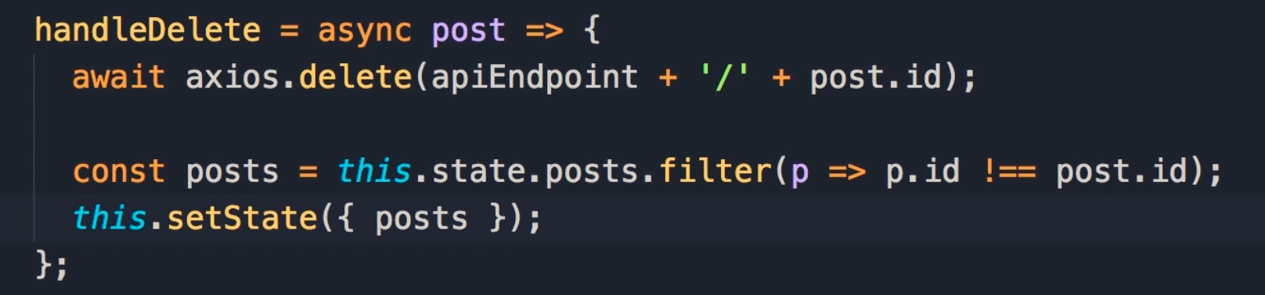

144 Optimistic vs Pessimistic Updates

Pessimistic approach: we call the API first get the response and then update the UI

Optimistic approach: “update the UI first” then call the server if the server fails then we revert back the update

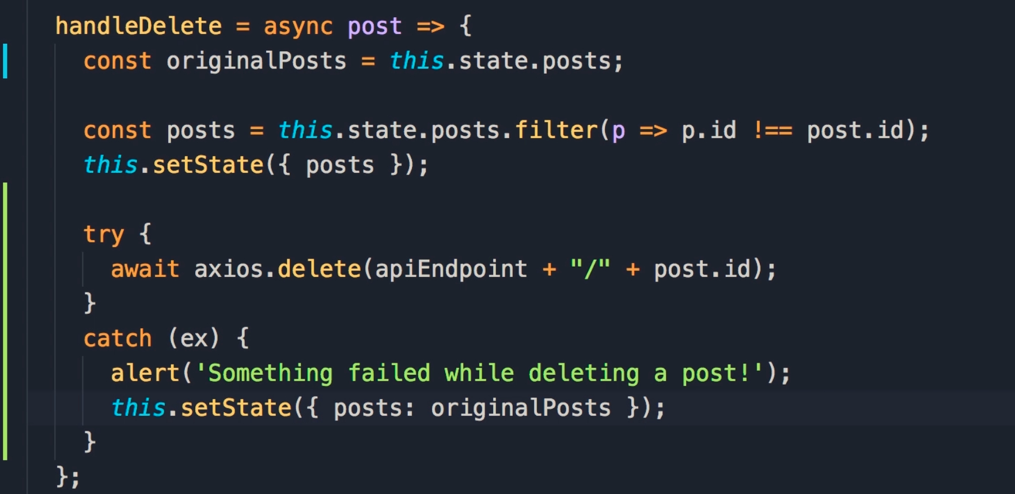

To check how it will behave when error will occur we need to throw fake error like this

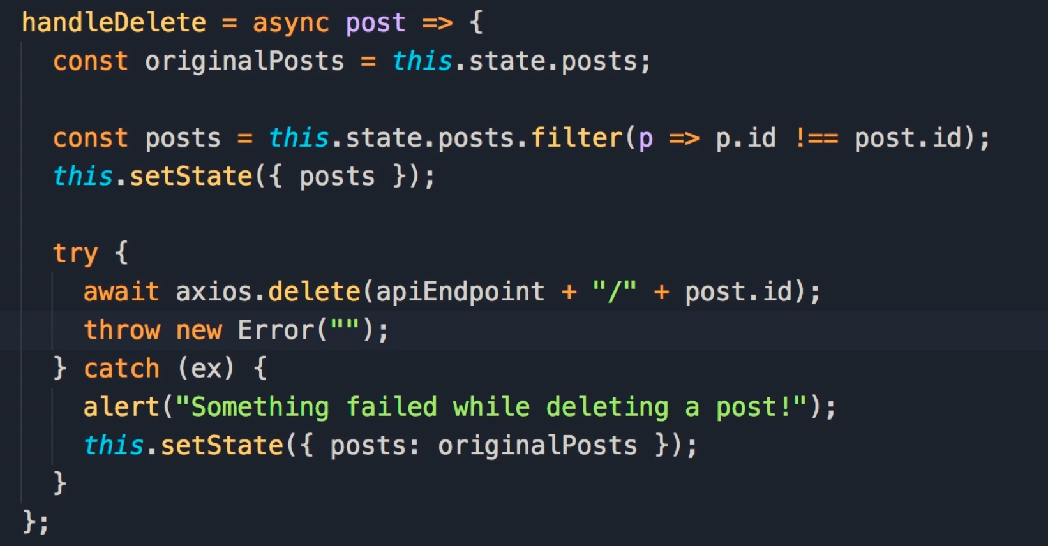

145 Expected and Unexpected Errors

first we need to expected and unexpected errors

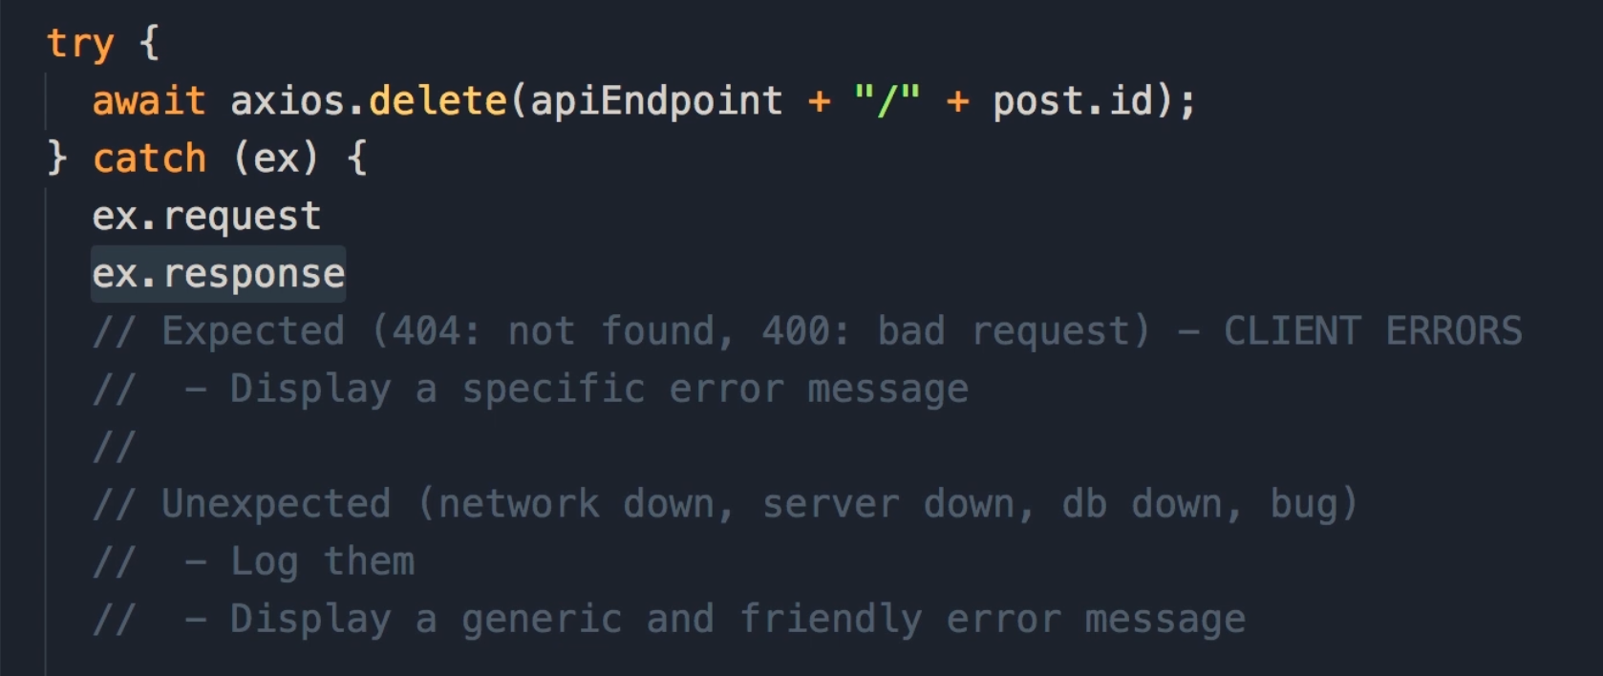

Expected Errors : Which API end-points predicts and return

Example:

1. if we try to delete a pot with an invalid ID, the server will return a response with 404 which means not found
2. 400 => bad request and this happened when we try to submit a form with invalid data.

Note: 400 range error happens because the client did something wrong

401 => if he tries to delete a post which does not exist, 401 will occur and we should tell the user, hey this post is already deleted or post could not be found

401 => in the case of “401” we should tell the user what fields in the form were invalid

UnExpected Errors : These are the errors that technically should not happen under normal circumstances

Example:

1. if the network is down, we won’t be able to call the server
2. Server is down
3. database is down
4. we may have a bug in our application code

We need to log these UnExpected Errors for future reference

we should generic and friendly error message to the user

To check if the error is an expected error we have 2 properties on the “Exception obj”

ex.request => Thi will be set if it has successfully submitted the request to the server, otherwise it will be null

ex.response => this property is set if it gets response successfully from the server, otherwise this property will be null

